

THE COLUMNS

September 2022, Volume 60, Issue 9

First Presbyterian Church, Waynesboro, VA

*First Presbyterian Church of Waynesboro is a community-minded congregation living out the love of Christ as we serve one another with humility, gentleness, and patience through God’s grace.*

**A Message from the Interim Pastor**

A Point of Personal Privilege.

*After five months, we have received word from the Medical Examiner regarding our son's death. What follows is our reflection.*

There was a time when our son was *incandescent.* When he was born, Connall's hair was blonde, almost shockingly white; his smile was guileless and infectious, and his presence could outshine the world around him. As a toddler, his brilliance was clearly evident, his capacity to understand and remember a little spooky. He remembered *everything* - the cars everyone drove to church, the Presidents of the United States *in order,* the arcane details of Pokemon. His temper could be volcanic, especially in competition - with his sisters, in board games or sporting events. Even after his sisters were born, forcing him to share the spotlight, we joked he lived in *a Connall-centric world,* a world in which the singsong phrase, "Connall always wins" was not just the boast of an arrogant, self-centered kid, but a commentary on his extraordinary intellect, his guile, and the luck that seemed to follow him through so many experiences.

In his teenage years, that light began to take on a glare. With puberty came the chemical changes which turn the mind on itself, and Connall began to experience something he was ill-equipped to comprehend: *failure.* His innate abilities still served him well at school, where his grades were always good, despite never studying, but there were thoughts and emotions he simply could not process - he just couldn't figure out what was going on in his own mind, nor was he able to communicate with us what was happening. Gradually, this inability led to frustration, and later, anxiety; he sought relief in alcohol and marijuana, which became his medication of choice for several years. The prospect of attending college, which had once been exciting, became a source of worry and fear, prompting him at the last minute to abandon his plans to go to UVA, instead choosing to join his friends at Virginia Tech. *Continued*

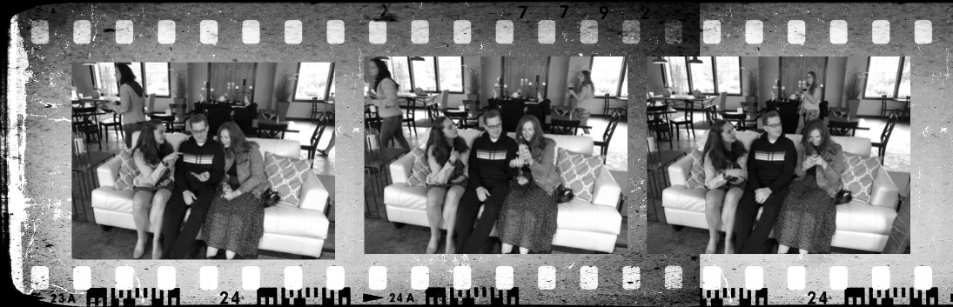

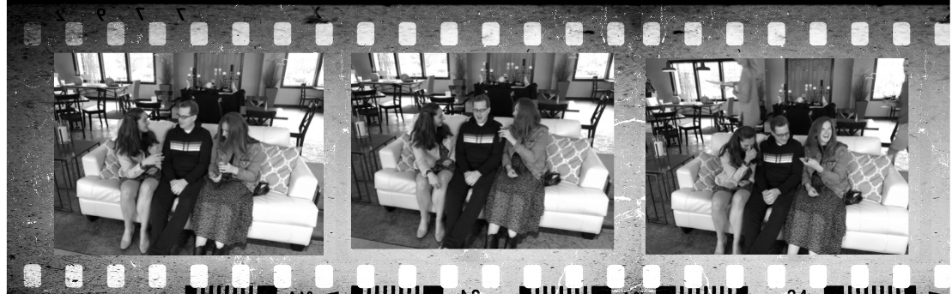

After less than a semester at VT, Connall had a breakdown. We brought him home and finally began to catalog in his behavior what would later be diagnosed as Bi-Polar, Type 2, in which the elevated moods (mania) are less intense than with Bi-Polar 1, but the episodes of depression are more common and protracted. It was during this time at home that Connall was first arrested, and first hospitalized; but it was also the time when his work with the clients of the ARC of Augusta revealed the deep reservoir of love and compassion with which he had been gifted.

Connall's years shuttling between home and Blacksburg in many ways felt like a strobe light: alternately blindingly bright and disorientingly dark. As with so many mental disorders, finding the right combination of medications was more art than science, and this, too became like a failure to him; it's difficult to be patient through the side effects of medication after that doesn't work for you. His presence could overwhelm, as hypomania overtook him; his absences, both figurative and literal, told of depression he couldn't articulate. There were many low points: the paranoia of heavy marijuana use; hospitalizations and psychiatric holds; arrest and incarceration; harsh words, spoken and heard; incommunicado periods which chilled our hearts.

There came a time when we had to face the truth: we could not save Connall. He had become an adult, legally responsible to himself and society, and our attempts to protect him from himself had all proven pointless, or worse. As parents have done since the beginning of time, we commended him to God, and charted boundaries to protect us and our daughters. We didn't give up, though.

Gradually, he began to rise from the rock bottom where he found himself. Thanks to the providential intervention of a Commonwealth's Attorney, he avoided the ignominy and complications of a felony conviction, serving what must have been a record number of weekends in the Montgomery County jail. He enrolled in community college, where he excelled, and was eventually readmitted to Virginia Tech, where he was graduated in 2017. He helped organize actions and policies to protect the ecology of the New River Valley. He took seriously his psychiatric and psychological care, and became a more engaged and compliant patient. And he worked hard to mend his relationships with those who loved him. After years of helplessness, we became allies in his struggle to live a 'normal' life.

But normality eluded him, even as he turned his life around. While he enjoyed his work, and looked forward to a future in the solar energy industry, anxiety would often overwhelm him. Panic attacks incapacitated him. Depression would descend, and seem intractable. His medications were only partially effective, and the side effects were difficult to navigate. He often couldn't sleep, and intrusive thoughts would render him unable to function. We know Connall continued to search for relief in other places; homeopathic remedies, exercise, and what one might call *supplemental medication* - an extra dose of Klonopin here, some weed there, the occasional night of drinking. *Continued*

The last weekend Connall was alive started great. He came to the house, where he dug a hole for a backyard project, relaxed with the dogs, and made guacamole for one of Brigid's closest friends, who was preparing for her wedding reception. Despite his discomfort with crowds, he appeared at the party, joining us at table as we ate and drank in celebration. But then something went wrong.

We will never know exactly what happened. While anxiety and even panic would often prompt him to call us, and even spend the night at the house, depression would isolate Connall. He often needed space and would go silent for a few days at a time. When he didn't call us, or respond to our texts we didn’t initially think anything of it. By Tuesday evening, however, things felt different. I drove to his apartment on Wednesday morning, to discover this incomparable light had been extinguished.

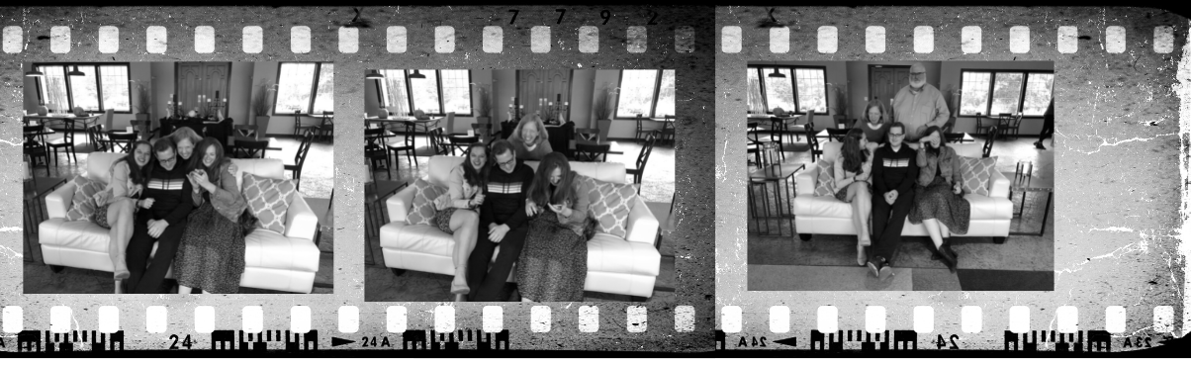

We believe he was searching for peace, for a good night's rest, for a reprieve from anxiety and depression. We also know Connall thought he could handle anything *except* the anxiety and depression - which is why he thought he could handle a fatally dangerous combination of drugs. In addition to his prescription medications (which are dangerous in and of themselves), the medical examiner reported *Codeine and Fentanyl* in his system.

*Codeine* is an opioid long used to relieve mild to moderately severe pain while *Fentanyl* is a synthetic opioid created in 1959. Approximately 100 times more potent than morphine and 50 times more potent than heroin, Fentanyl was originally used as an anesthetic, but it is now prescribed as an analgesic for severe pain relief. Unfortunately, Fentanyl is also used surreptitiously to enhance the potency of many illicitly produced narcotics; it is often the main ingredient used to counterfeit more common narcotics, such as Heroin or Oxycodone. These powerful painkillers, themselves extremely dangerous, interacted with Connall's prescription medications, first putting him to sleep, then bringing his heart to a stop. Our son, brilliant and troubled, compassionate and so very deeply in pain, was gone. *Continued*

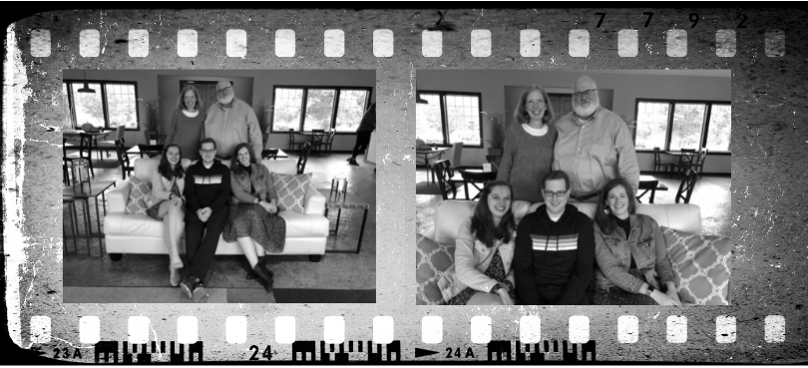

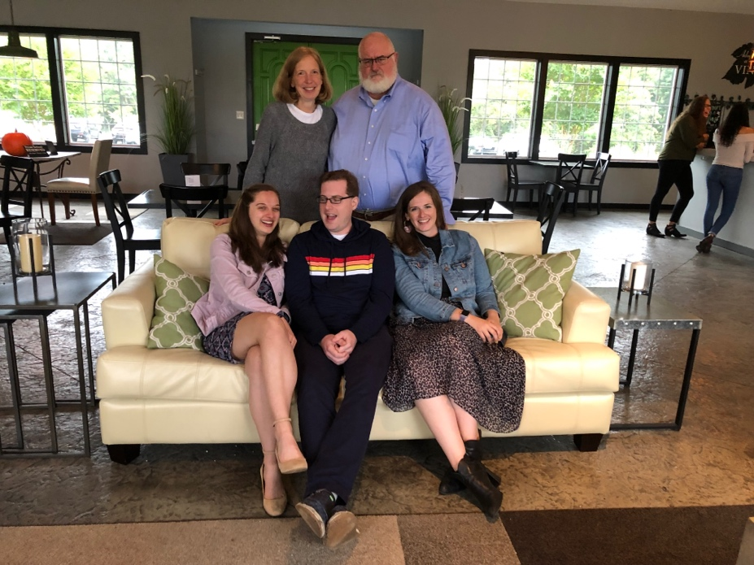

When Connall died, we were extended so many kindnesses, so many expressions of sympathy and care. Among them was the simple phrase, *there are no words*. It is true: there are no words to take away our grief, no turn of phrase which allows us to escape the hard fact: *Connall is dead*.

Death is something we work hard to soften. We say people have *passed,* or *gone to sleep, or joined the Church Triumphant* because those phrases seem gentler - kinder. But our loss is not gentle or kind. Connall’s life was hard. Connall’s death, while blessedly peaceful, is still a reflection of deep pain; any attempts to soften it feel dishonest.

Our daughters Mairéad and Brigid helped us come to this sense of honesty. Both the obituary, written by Mairead, and the remembrance, written by Brigid and shared at his Memorial Service, gave voice to Connall’s complicated life, to all that was amazing and troubling about our family’s journey. Connall was always one to get straight to the point, to make himself at home, to do what he wanted to do. It’s appropriate that as we continue to come to grips with his last act, we also speak plainly and say what is true.

Connall’s light has been extinguished, and now our work is to see what he left for us, to remind each other of who he was, to say what is true when it comes to us, and to love each other as fiercely as we were loved by our son and brother.

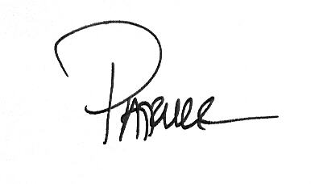

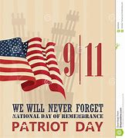

 “If we learn nothing else from this tragedy, we learn that life is short and there is no time for hate.”

*— Sandy Dahl, wife of Flight 93 pilot Jason Dahl.*

**HIGHLIGHTS**

**of the Highlights of the 194th Stated Meeting of the Shenandoah Presbytery**

The meeting was held by Zoom on Saturday, August 27, 2022.

The presbytery voted to allow the McDowell congregation to deed back land that includes Clover Creek Chapel to the McClung family which gave the land in 1891.

Welcomed to the Presbytery were the Rev. Julia Burkley, associate pastor Opequon; the Rev. Andrew Ditzel, pastor Lexington; and the Rev. Jacqueline Smith Patman, interim pastor Hermitage.

The General Assembly commissioners gave their report.

Kes Amena from Ethiopia will be visiting November 13-28.

An Administrative Commission was formed to assist the session and congregation at First Staunton.

The AC for the Halltown congregation recommended the transfer of property of the Halltown church to Jefferson County Community Ministries to be used for the cold weather shelter.

The BIG EVENT is September 10, 2022, at Massanetta Springs.

A plan is underway to strengthen our campus ministry with James Madison University.

The next meeting is Tuesday, November 15, in person at Massanetta Springs.

**SESSION HIGHLIGHTS**

Session held a Stated Meeting on August 9, 2022.

Since this was the first meeting after the election of new elders, Rev. Pettit conducted a brief period of Elder Training.

Committee Chair assignments were made: Administrative/Preschool – Jean Hashagen; Christian Ed/Congregational Care – Joan Berry; Mission/Outreach – Cynthia Hoover; P&M – Colleen Cash; Worship – Mike Cunningham.

A new custodial team has been hired which is doing an excellent job.

Betsy Ruehl was elected Clerk of Session for a one-year term.

Session voted to extend Rev. Pettit’s Interim Contract for an additional one-year term from September 1, 2022, to September 1, 2023. (This contract may be terminated earlier.)

Betsy Ruehl reported on the activities of the Small Churches group. They participated in the Waynesboro Public Schools “Back to School Bash” on July 31 at Kate Collins by distributing free hot dogs, chips, and bottled water. The group has adopted the logo “Better Together – Presbyterians in Action”. FPC contributed toward the expenses. Many of the foodstuffs were donated.

The meeting was opened and closed with prayer.

--Betsy Ruehl, Clerk of Session

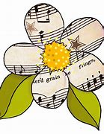**MUSIC NOTES**

The month of September opens with the resumption of the *First Friday Organ Recitals and Light Luncheons.* Roger will play his 25th (!) program on Friday 2 September. We are grateful to Susan Johnson for providing the light refreshments following the recital. All are welcome to hear the program at 12:15 and to enjoy fellowship afterward in the Barksdale Room.

The first Sunday of the month includes three well-known hymns. The music for the opening hymn, *How Happy Are the Saints of God*, was composed by William Knapp (1698-1768). He named the tune Wareham in honor of his birthplace in England. Like many musicians (of his time and ours), Knapp worked other jobs while serving as an organist in both Wareham and Poole. Knapp was a glover by trade and also served as the parish clerk in Poole. He published the tune in 1738, along with many others, in *A Set of New Psalm Tunes and Anthems.*

The month of September, like every month at FPC, opens with a communion service. The special music for this week’s service is the spiritual, *Let Us Break Bread Together.* Miles Mark Fisher notes in *Negro Slave Songs in the United States (*1953), that originally, the hymn “relates hardly at all to holy communion. It seems to have been a signal song of Virginia slaves during the eighteenth century who used it and similar ones to convene their secret meetings.”

The text to the closing hymn, *Take Up Your Cross, the Savoir Said,* is set to music by Freeman Lewis (1780-1859). The American composer compiled and published a book of camp meeting hymns and other sacred pieces in 1813 called *The Beauties of Harmony*. Lewis was also a traveling school teacher, writer and surveyor. Among his projects was helping find a route for the Chesapeake and Ohio Canal.

September 11 falls on the second Sunday of the month, and we will sing hymns that reflect on our nation – and provide a balm for our souls. The opening hymn will be *For the Healing of the Nations* and the closing hymn will be *This Is My Song*, set to *Finlandia* by Jan Sibelius (1865-1957).

The remaining Sundays in September feature beloved hymns, including *Praise to the Lord, the Almighty, Great Is Thy Faithfulness* and *Blessed Assurance.*  These hymns connect us to our past and bring reassurance that God’s abiding love is always with us.

We remain thankful for FPC’s continuing support of the music program.

With gratitude –

Roger and Kimberlea Daggy

**DOES WONDER HAVE A SHELF-LIFE?**

**Musings on wow-fade**

By Ken Rummer

Does wonder have a shelf-life?

Does it come with a best-if-used-by date?

Just to be clear, we don’t have mountains in Iowa. Our elevation leader, Hawkeye Point, only makes it up to 1670 feet. We have bluffs, we have knolls, we have hills. But no mountains.

So massive granite pressing into cloud above the tree line—that gets my attention. As it did on a recent trip to Alaska.

The Rockies from an airplane porthole. Mt. Rainier out the hotel window. Denali through the curved glass of the train car.

Jaw drop.

And the sightings continued. Saw-toothed peaks. Mist-shrouded heights. Big mountains still wearing snow in mid-summer. Likely places, a la Moses, for a rendezvous with God.

Amazing.

Mountains embracing glaciers. Mountains with their feet in the sea. Mountains behind other mountains catching the orange light of late evening.

Wow.

But somewhere along the way, about day twelve of the trip, I realized I was losing interest in tall peaks. Astonishing views started to look like just more snowy mountains. Not that unusual anymore. Not that exciting. The mountains were fading into the background like wallpaper you’ve lived with a little too long.

Did the wonder reach its expiration date?

I once saw a man sitting in his driveway. Just beyond his back yard, Lake Huron stretched to the horizon looking blue and beautiful. But the man wasn’t looking at the big water. He was facing the street out front, reading a newspaper.

I’ve judged that stranger rather harshly over the years, but now I’m realizing that he and I share the same affliction. We both suffer from the waning of wonder. As the once-astounding becomes commonplace, we no longer notice the wow-worthy, even in our own backyard.

But maybe that can change.

The poet T. S. Eliot wrote: *We shall not cease from exploration*

*And the end of our exploring*

*Will be to arrive where we started*

*And know the place for the first time.* (Little Gidding, 1942)

I arrive where I started my mountain tour, at home. What would it be like to see this place, this life, as if for the first time

Taking a look around, I’m finding a few wonders that have gotten lost in the wallpaper:

Flesh and bone turning food into energy and breath into life.

Light leaving distant stars ages and ages ago, only just arriving.

The snapping turtle laying her eggs on the bank above the creek.

Tiny factories in every green leaf making tree food out of sunshine.

The marvelous human being stlll sharing life and love with me.

The way I’ve come to see it, newness fades but wonder remains, waiting for rediscovery by eyes that see anew.

What are you noticing? Is there something wow-worthy you want to reclaim from the invisibility of the everyday? Drop it into the comments and add it to the list.

(Ken Rummer, PCUSA Teaching Elder, honorably retired, writes about life

and faith from the middle of Iowa by the High Trestle Trail.)



Dear Congregation,

Summer Camp has come to its conclusion and boy was it fun. The children enjoyed learning about animals from all over the world, space exploration, dinosaurs, camping and many other interesting themes. They also had a blast at water day. The end of summer also means goodbyes to many students who will be starting grade school. But where there is an end there is another beginning.

We will be starting off the school year with full enrollment in both the 4-year-old and 3-year-old classes. At orientation we met all the new children and can’t wait for them to start on the 6th of September!

God Bless,

Nate Rudin

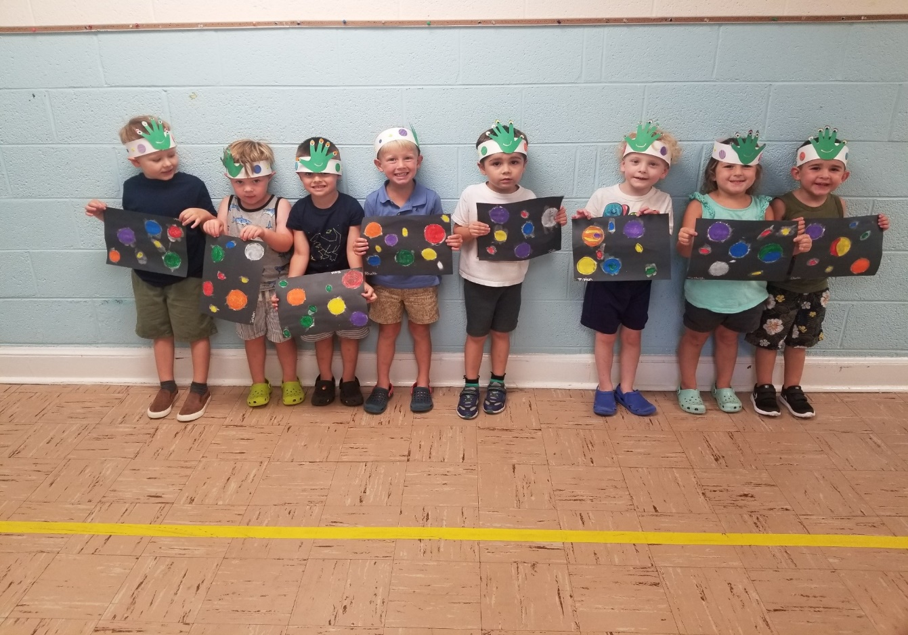Director



In August another Early Childhood Education grant was

received for over $12,000.00. A big thank you to Nate for his research in making this happen.

**MISSION COMMITTEE REPORT**

The Waynesboro East Augusta CROP Walk is September 25, 2022, at 2 p.m. First Presbyterian Church has a team registered for the event. Please consider joining our team to walk. Join our team online at crophungerwalk.org. Twenty-five percent of the CROP funds remain in our community to support local hunger-fighting organizations. Seventy-five percent of donations will be used by Church World Service to support global hunger, humanitarian aid, and disaster response programs in 30+ countries.

If you cannot join the walk, please support our team. Donations may be made to team members or online at [www.crophungerwalk.org/waynesboro.org](http://www.crophungerwalk.org/waynesboro.org).

First Presbyterian Church received a grant for $3,545 used to purchase a new commercial grade freezer. It has been installed in the Food Bank and is in active use. We are still collecting school supplies: crayons, markers, pens, notebook paper, glue sticks and spiral notebooks. The parents of school aged children are especially thankful.

First Presbyterian Church served lunch at Disciples’ Kitchen on August 30. If you can assist packing lunches in the future, please contact me at 540-255-9616.

--Cynthia Hoover, Mission Chair



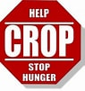

**Sept 3 Kathy Brown**

**Sept 4 Rubye Schwab**

**Sept 9 Joan Berry**

**Sept 10 Ruth Kelley**

**Sept 11 Danny Leech**

**Sept 14 Polly Bare**

**Sept 24 Branch Hammock**

**Sept 29 Jo Pannill**

**Sept 29 Joe Earhart**

 **Sept 1 Buck & Margie Hartley**

**Sept 14 Mike & Cathy Cunningham**



**Liturgists**

Sept 4 Warner Sandquist

Sept 11 Jim Leech

Sept 18 Jen Jones

Sept 25 Joan Berry

**Mailing Address**

P. O. Box 877

Waynesboro, VA 22980

**Phone**

540.949.8366

**Fax**

540.949.5750

**E-mail**

church@firstpresway.com

**Website**

www.firstpresway.org

**Church Office Hours**

Monday-Wednesday

8 a.m. – 2:30 p.m.

Thursday

8 a.m. – 4:30 p.m.

**Interim Pastor**

Rev. Patrick S. Pettit

pspettit@gmail.com

**Administrative Assistant**

Mrs. Colleen Cash

ccash@firstpresway.com

**Preschool Director**

Mr. Nate Rudin

preschool@firstpresway.com

**Director of Music**

Mr. Roger Daggy

[firstpreswaymusic@gmail.com](mailto:firstpreswaymusic@gmail.com)

**Music Associate**

Mrs. Kimberlea Daggy

[firstpreswaymusic@gmail.com](mailto:firstpreswaymusic@gmail.com)

**Audio/Visual Technician**

Mr. Craig Cavanaugh

**Maintenance Technician**

Mr. Michael Griffith

**Thursday, September 1**

6-8 PM Food Bank

**Friday, September 2**

12:15 PM First Friday Organ Concert with Lite Lunch

**Sunday, September 4**

11:00 AM Worship Service

**Monday, September 5**

Labor Day Office Closed

**Tuesday, September 6**

7-9PM Symphony -Fellowship Hall

**Thursday, September 8**

2-4 PM Food Bank

**Sunday, September 11**

11:00 AM Worship Service

**Tuesday, September 13**

**2:30 PM** Session Room 212

7-9PM Symphony -Fellowship Hall

**Thursday, September 15**

6-8 PM Food Bank

**Sunday, September 18**

11:00 AM Worship Service

**Tuesday, September 20**

7-9PM Symphony -Fellowship Hall

**Thursday, September 22**

2-4 PM Food Bank

**Sunday, September 25**

11:00 PM Worship Service

Crop Walk

**Tuesday, September 27**

7-10 PM Symphony Sanctuary

**TRIVIA 😊**

**From a 2022 Major Holiday Calendar**

Daily September holidays and special days

2. - VJ Day WW II

5. - Labor Day (first Monday)

11 - 911 Remembrance

11 - Grandparents Day (first Sunday after Labor Day)

17. - Constitution Day

17. - Oktoberfest begins in Germany

21. - International Peace Day (UN)

22 - Autumnal Equinox

23. - Native American Day (4th Friday of the month)

25. - Rosh Hashanah (begins at sundown)