SIXTEENTH SUNDAY AFTER PENTECOST September 25, 2022

PRELUDE Fantasia in B-flat Muffat (1683-1770)

WELCOME & ANNOUNCEMENTS

INTROIT Alleluia Milburn (b. 1963)

CALL TO WORSHIP Joan Berry
Leader: Jesus Christ is King of kings and Lord of lords.
People: Jesus Christ, ruler of all things, gathers us in love.
Leader: Jesus Christ is King of kings and Lord of lords.
People: Jesus Christ, Ruler of all things, deserves our praise and thanksgiving!
Leader: Let us worship God.

MORNING PRAYER

OPENING HYMN 757 Today We All Are Called to be Disciples Kingsfold

CALL TO CONFESSION

PRAYER OF CONFESSION
God of justice, you lift up the lowly and fill the empty; yet we adore the high and the mighty. You reach out to the poor, while we ceaselessly pursue wealth. You tell us about treasure in heaven, but we want money in our accounts right now. Forgive us, Lord, this and all our sin. Correct our lack of generosity, and free us from senseless striving.
Help us tend to things that matter and find our life in Jesus Christ.

SILENT PRAYER

ASSURANCE OF PARDON

*GLORIA PATRI 581 Greatorex

FIRST SCRIPTURE READING 1 Timothy 6:6-19 p. 965

ANTHEM Fight the Good Fight Gardner (1917-2011)
(text can be found in hymn 846)

SECOND SCRIPTURE READING Luke 16:19-31 p. 851

SERMON Nice Things. Terry Crickenberger

*AFFIRMATION OF FAITH (See Insert)

PRAYERS OF THE PEOPLE & THE LORD’S PRAYER

*CLOSING HYMN 298 Lord, You Give the Great Commission Abbot’s Leigh

*CHARGE and BENEDICTION

POSTLUDE Fugue in B-flat Muffat

*Please stand if able

Today’s link is : https://youtu.be/BPjlpmaTL-M
Hearing devices are available for your convenience.
Please be aware that they do not function until after the service begins.

After Worship Today

Choice Rehab (Avante) Tom Bellamy, Room 110

The Legacy: Mary June Cook

Regency at Augusta: Edie Lawrence

Shenandoah Nursing Home: Rubye Schwab

Summit Square: Lillian Hryshkanych

Home: Dick Huff, Nancy Garber, Mary Ultee, Mary Ann Maupin, Walt Flora, Warner & Linda Sandquist. Mike Cunningham, Ruth and Lewis Kelley.

Friends and Family: Erwin Berry (Joan), Bill Bromley, Ron Buckalew, Jean Custen, Jerry Hughes, Sally McNeel, Bill Metzel (Joyce Tipton), Col. Stuart Roberts (Mark Henderson), Danny Smith (Nancy Hypes), Paul Watts (Colleen Cash).

Military: Carson Craig

Missionaries: Elmarie & Scott Parker, PC (USA) Regional Liaisons to Iraq, Syria & Lebanon

MARK YOUR CALENDARS: There will be a Covered Dish Luncheon Sunday, October 9, immediately following worship. Details will follow.

The Augusta Regional Clinic will hold a free dental clinic day – Dentalpalooza – for eligible uninsured residents of Augusta County ages 18+. A third of Augusta County residents do not have dental insurance, and the clinic is the only dental office that offers affordable dental care options within a 30-40 miles radius. More than 15 volunteers from local dental practices will reinforce the Clinic’s staff to provide general dentistry services (consultations, fillings, extractions and cleanings) for 70 patients at the event. The generosity of a dozen sponsors, including the Central Blue Ridge Community Foundation and the Virginia Association of Free and Charitable Clinics helps keep these appointments free of charge. This outreach was important to Dr. Mark Hammock, and in his memory, FPC will make a donation to Dentalpalooza.
The Session has set a goal of $500.00; checks can be made out to the church, with 'Dental' on the memo line. For more information, visit augustafreeclinic.org. or call the office.

FIRST PRESBYTERIAN CHURCH
WAYNESBORO, VIRGINIA

A community-minded congregation living out the love of Christ as we serve one another with humility, gentleness, and patience through God’s grace.

September 25, 2022 11:00 AM

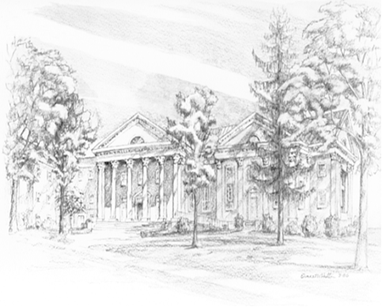

P.O. Box 877
249 South Wayne Avenue
Waynesboro, Virginia
(540) 949-8366
Church Website: www.firstpresway.org
Preschool Website: www.firstprespre.org
Email: church@firstpresway.com

P.O. Box 877
249 South Wayne Avenue
Waynesboro, Virginia
(540) 949-8366
Church Website: www.firstpresway.org
Preschool Website: www.firstprespre.org
Email: church@firstpresway.com

