Seventeenth Sunday after Pentecost October 2, 2002

PRELUDE Prelude, Op. 50, no. 5 Foote (1853-1937)

WELCOME & ANNOUNCEMENTS

INTROIT Let All the World Routley (1917-1982)

CALL TO WORSHIP Bill Pannill
Leader: Write the vision; make it plain for all to see:
People: God longs to gather all the peoples of the earth.
Leader: Our faith may be small,
People: But God’s power is great.
Leader: Let us worship God.

MORNING PRAYER

*OPENING HYMN 396 Brethren, We Have Met to Worship Holy Manna

CALL TO CONFESSION

PRAYER OF CONFESSION
God of grace, we confess the seed of faith within us is small. Hope is often absent; love is frequently inconvenient. Our sin keeps us separate, unable to respond to you and our neighbors. Forgive us, lord, this and all our sin. Tend to us in mercy, that we may grow in the ways of faith, hope, and love, after the example of Jesus Christ.

SILENT PRAYER

ASSURANCE OF PARDON

*GLORIA PATRI #581 Greatorex

FIRST SCRIPTURE LESSON Romans 8:31-34 p. 919

ANTHEM In Remembrance Red (1936-2013)
(text can be found in hymn 521)

SECOND SCRIPTURE LESSON Luke 15:5-6 p. 850

SERMON If… Rev. Patrick Pettit

*AFFIRMATION OF FAITH The Apostles’ Creed Hymnal p. 35

THE LORD’S SUPPER
Invitation
Great Thanksgiving
Communion of the People

PASTORAL PRAYER

*CLOSING HYMN 546 Lord, Dismiss Us With Your Blessing Sicilian Mariners

*CHARGE & BENEDICTION

POSTLUDE Postlude in C Foote

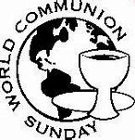

*PLEASE STAND IF ABLE.

Link for this week’s service is: https://youtu.be/lY5Jxu_Aiak

Audio aids are available for your convenience.
Please be aware that they do not function until after the service begins.

The Legacy: Mary June Cook

Regency at Augusta: Edie Lawrence

Shenandoah Nursing Home: Rubye Schwab

Summit Square: Lillian Hryshkanych

Home: Dick Huff, Nancy Garber, Mary Ultee, Mary Ann Maupin, Walt Flora, Warner & Linda Sandquist. Mike Cunningham, Ruth and Lewis Kelley.

Friends and Family: Erwin Berry (Joan), Bill Bromley, Ron & Sarah Buckalew, Jean Custen, Jerry Hughes, Sally McNeel, Bill Metzel (Joyce Tipton), Col. Stuart Roberts (Mark Henderson), Danny Smith (Nancy Hypes), Paul Watts (Colleen Cash).

Military: Carson Craig

Our Christian Sympathies to the family of Tom Bellamy who died on September 25, 2022.

Waynesboro Symphony will have its first concert of the season here today at 3PM

First Friday Organ Concert with Lite Lunch, October 7, 12:15 PM

Potluck lunch Sunday October 9 after Worship; 3 PM concert United States Air Force wind quintet

FIRST PRESBYTERIAN CHURCH
WAYNESBORO, VIRGINIA
October 2, 2022

A community-minded congregation living out the love of Christ as we serve one another with humility, gentleness, and patience through God’s grace.

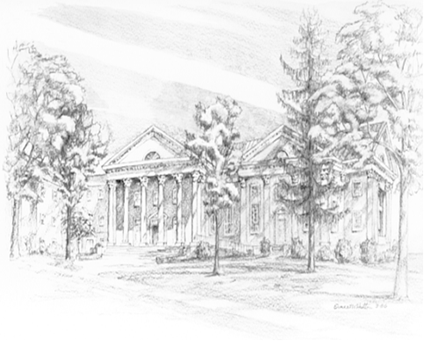

P O Box 877
249 South Wayne Avenue
Waynesboro, Virginia
(540) 949-8366
Church Website: www.firstpresway.org
Preschool Website: www.firstprespre.org
Email: church@firstpresway.com

