NINETEETH SUNDAY AFTER PENTECOST October 16, 2022

PRELUDE Prelude in g, BWV 535 Bach (1685-1750)

WELCOME & ANNOUNCEMENTS

INTROIT Let All the World Routley (1917-1982)

CALL TO WORSHIP Linda Sandquist
Leader: We lift up our eyes to the hills; from where will our help come?
People: Our help comes from the Lord, who made heaven and earth.
Leader: In praise and with thanksgiving, we gather as one body, with song and with prayer.
People: The Lord will keep our going out and our coming in from this time and forevermore.
Leader: Let us worship God.

MORNING PRAYER

OPENING HYMN 45 I To The Hills Will Life My Eyes Dundee

CALL TO CONFESSION

PRAYER OF CONFESSION
Grace-filled God, we pursue our own needs, while neglecting the needs of others. We pursue our own desires, while slowly destroying the gifts of your creation. We deflect the call to ministry, ignoring the cries of those in need. Forgive us, Lord, this and all our sin. Draw us in to proclaim the Gospel, whatever the time or wherever we are, that we may fully embody your love and justice for the world.

SILENT PRAYER

ASSURANCE OF PARDON

*GLORIA PATRI 581 Greatorex

FIRST SCRIPTURE READING Psalm 121 p. 498

SPECIAL MUSIC Elijah: Lift Thine Eyes Mendelssohn (1809-1847)

SECOND SCRIPTURE READING Luke 18:1-8 p. 853

SERMON Expectation & Persistence Patrick Pettit, Interim Pastor

*AFFIRMATION OF FAITH The Apostles' Creed Hymnal p. 35

PRAYERS OF THE PEOPLE & THE LORD’S PRAYER

*CLOSING HYMN 175 Seek Ye First Lafferty
*CHARGE and BENEDICTION

POSTLUDE Fugue in g, BWV 535 Bach

*Please stand if able

Today’s link is : https://youtu.be/pzwDP6IIpmQ

Hearing devices are available for your convenience.
Please be aware that they do not function until after the service begins.

The Legacy: Mary June Cook

Regency at Augusta: Edie Lawrence

Shenandoah Nursing Home: Rubye Schwab

Summit Square: Lillian Hryshkanych

Home: Dick Huff, Nancy Garber, Mary Ultee, Mary Ann Maupin, Walt Flora, Warner & Linda Sandquist. Mike Cunningham, Ruth and Lewis Kelley.

Friends and Family: Erwin Berry (Joan), Bill Bromley, Ron Buckalew, Jean Custen, Jerry Hughes, Sally McNeel, Bill Metzel (Joyce Tipton), Col. Stuart Roberts (Mark Henderson), Danny Smith (Nancy Hypes), Paul Watts (Colleen Cash).

Military: Carson Craig

Missionaries: Elmarie & Scott Parker, PC (USA) Regional Liaisons to Iraq, Syria & Lebanon

Our Christian Sympathies to the family of Branch Hammock. A Celebration of Life service will be held, Friday, October 21, 2022 at 2PM, followed by a Reception in the Barksdale Room.

The Augusta Regional Clinic will hold a free dental clinic day – Dentalpalooza – for eligible uninsured residents of Augusta County ages 18+. A third of Augusta County residents do not have dental insurance, and the clinic is the only dental office that offers affordable dental care options within a 30-40 miles radius. More than 15 volunteers from local dental practices will reinforce the Clinic’s staff to provide general dentistry services (consultations, fillings, extractions and cleanings) for 70 patients at the event. The generosity of a dozen sponsors, including the Central Blue Ridge Community Foundation and the Virginia Association of Free and Charitable Clinics helps keep these appointments free of charge. This outreach was important to Dr. Mark Hammock, and in his memory, FPC will make a donation to Dentalpalooza.
The Session has set a goal of $500.00; checks can be made out to the church, with 'Dental' on the memo line. For more information, visit augustafreeclinic.org. or call the office.

FIRST PRESBYTERIAN CHURCH
WAYNESBORO, VIRGINIA

A community-minded congregation living out the love of Christ as we serve one another with humility, gentleness, and patience through God’s grace.

October 16, 2022 11:00 AM

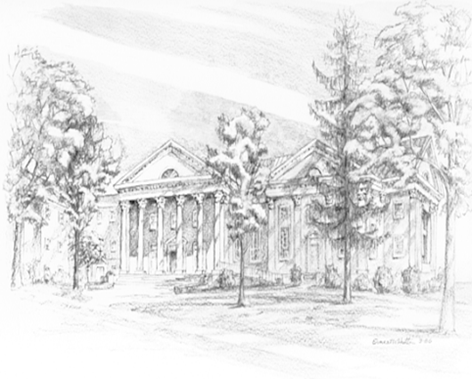

P.O. Box 877
249 South Wayne Avenue
Waynesboro, Virginia
(540) 949-8366
Church Website: www.firstpresway.org
Preschool Website: www.firstprespre.org
Email: church@firstpresway.com

P.O. Box 877
249 South Wayne Avenue
Waynesboro, Virginia
(540) 949-8366
Church Website: www.firstpresway.org
Preschool Website: www.firstprespre.org
Email: church@firstpresway.com

