TWENTIETH SUNDAY AFTER PENTECOST October 23, 2022

PRELUDE Erhalt uns Herr bei deinem Wort Dietrich Buxtehude (1637-1707)
(Keep Us Lord, Faithful to Your Word)

WELCOME & ANNOUNCEMENTS
Minute for Mission Cynthia Hoover

INTROIT Minuet J. S. Bach (1685-1750)

CALL TO WORSHIP Sandi Henderson
Leader: How lovely is the house of the Lord!
People How beautiful to be gathered in the presence of God.
Leader: How lovely is the dwelling place of the Lord. How beautiful is the image of
God we behold in one another.
People: You have restored the good fortune of Jacob.
Leader: You have forgiven the iniquity of your people;
People: You have blotted out all our sins.
Leader: Righteousness shall go before you;
People: Peace shall be a pathway for your feet.
Leader: Let us worship God.

MORNING PRAYER

OPENING HYMN 81 Glorious Things of Thee Are Spoken Austrian Hymn

CALL TO CONFESSION

PRAYER OF CONFESSION
Loving God, too often we hide beneath the veil of religion, or trust too much in the good things we do. Smug and safe in our pews, we look down on those not here, thankful we are not like them. Shatter us with the truth that all have sinned, even us. Cleanse us and restore us, that we might live as the people you call us to be for the sake of Jesus, our Savior.

SILENT PRAYER

ASSURANCE OF PARDON

*GLORIA PATRI 581 Greatorex

FIRST SCRIPTURE READING Psalm 84:1-7 p. 472

SPECIAL MUSIC Pastorale Domenico Zipoli (1688-1726)

SECOND SCRIPTURE READING Luke 18: 9-14 p. 853

SERMON Be humble…..or not! Terry Crickenberger

*AFFIRMATION OF FAITH The Apostles' Creed Hymnal p. 35

PRAYERS OF THE PEOPLE & THE LORD’S PRAYER

*CLOSING HYMN 465 What a Friend We Have in Jesus Converse

*CHARGE and BENEDICTION

POSTLUDE Allegro in C Major from Suite #5 Purcell (1659-1695)

*Please stand if able

Today’s link is : https://youtu.be/KJPFpkA1wKk

Hearing devices are available for your convenience.
Please be aware that they do not function until after the service begins.

The Legacy: Mary June Cook

Regency at Augusta: Edie Lawrence

Shenandoah Nursing Home: Rubye Schwab

Summit Square: Lillian Hryshkanych

Home: Dick Huff, Nancy Garber, Mary Ultee, Mary Ann Maupin, Walt Flora, Warner & Linda Sandquist, Ruth and Lewis Kelley.

Friends and Family: Erwin Berry (Joan), Bill Bromley, Ron Buckalew, Jean Custen, Jerry Hughes, Sally McNeel, Bill Metzel (Joyce Tipton), Col. Stuart Roberts (Mark Henderson), Danny Smith (Nancy Hypes), Paul Watts (Colleen Cash).

Military: Carson Craig

Missionaries: Elmarie & Scott Parker, PC (USA) Regional Liaisons to Iraq, Syria & Lebanon

Today we welcome Terry Crickenberger as Worship Leader and Preacher, Rev. Pettit is enjoying a family vacation.
Diane Kingsburg is serving as Organist while Roger and Kimberly also enjoy family time.
We are grateful to both these faithful servants who frequently share their talents with our congregation.

Trick or Treating at the Preschool
Wednesday, Oct 26 at 10:45
Please bring your treats

FIRST PRESBYTERIAN CHURCH
WAYNESBORO, VIRGINIA

A community-minded congregation living out the love of Christ as we serve one another with humility, gentleness, and patience through God’s grace.

October 23, 2022 11:00 AM

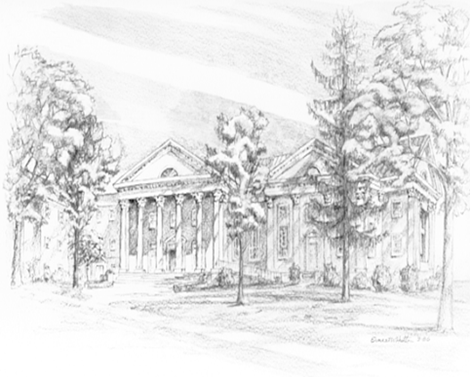

P.O. Box 877
249 South Wayne Avenue
Waynesboro, Virginia
(540) 949-8366
Church Website: www.firstpresway.org
Preschool Website: www.firstprespre.org
Email: church@firstpresway.com

P.O. Box 877
249 South Wayne Avenue
Waynesboro, Virginia
(540) 949-8366
Church Website: www.firstpresway.org
Preschool Website: www.firstprespre.org
Email: church@firstpresway.com

