EIGHTEENTH SUNDAY AFTER PENTECOST October 9, 2022

PRELUDE Andante religioso Mendelssohn (1809-1847)

WELCOME & ANNOUNCEMENTS

INTROIT Alleluia Milburn (b. 1963)

CALL TO WORSHIP Danny Leech
Leader: Give thanks to the Lord with your whole heart.
People: Great are the works of the Lord!
Leader: The fear of the Lord is the beginning of wisdom;
all those who practice it have a good understanding.
People: God's praise endures forever!
Leader: Let us Worship God.

MORNING PRAYER

OPENING HYMN 610 O For a Thousand Tongues to Sing Azmon

CALL TO CONFESSION

PRAYER OF CONFESSION
Compassionate God, you send us to cure the sick, but we blame the sick for their choices. You ask us to restore the unclean, but we separate them into high-risk pools. You compel us to raise the dead, but we insist some are beyond help. Forgive us, Lord, this and all our sin. Teach us to reach out without condition and help without limitation.
Enable us to love one another as you love us, that we may freely shower care upon all people.

SILENT PRAYER

ASSURANCE OF PARDON

*GLORIA PATRI 581 Greatorex

FIRST SCRIPTURE READING Psalm 66:1-12 p. 459

ANTHEM At the Name of Jesus Vaughan Williams (1872-1958)
(text can be found in hymn 264)

SECOND SCRIPTURE READING Luke 17:11-19 p.852

SERMON It’s about gratitude. Patrick Pettit, Interim Pastor

*AFFIRMATION OF FAITH The Apostles' Creed Hymnal p. 35

PRAYERS OF THE PEOPLE & THE LORD’S PRAYER

*CLOSING HYMN 625 How Great Thou Art How Great Thou Art
(stanzas 1 and 4)

*CHARGE and BENEDICTION

POSTLUDE Concerto in G: Presto BWV 592 Ernst (1696-1715)
Bach (1685-1750)

*Please stand if able

Today’s link is : https://youtu.be/lfCAsArNAG4

Hearing devices are available for your convenience.
Please be aware that they do not function until after the service begins.

After Worship Today

Lunch after service in Barksdale Room

3 PM Concert
USAF Heritage of America Band

The Legacy: Mary June Cook

Regency at Augusta: Edie Lawrence

Shenandoah Nursing Home: Rubye Schwab

Summit Square: Lillian Hryshkanych

Home: Dick Huff, Nancy Garber, Mary Ultee, Mary Ann Maupin, Walt Flora, Warner & Linda Sandquist. Mike Cunningham, Ruth and Lewis Kelley.

Friends and Family: Erwin Berry (Joan), Bill Bromley, Ron Buckalew, Jean Custen, Jerry Hughes, Sally McNeel, Bill Metzel (Joyce Tipton), Col. Stuart Roberts (Mark Henderson), Danny Smith (Nancy Hypes), Paul Watts (Colleen Cash).

Military: Carson Craig

Missionaries: Elmarie & Scott Parker, PC (USA) Regional Liaisons to Iraq, Syria & Lebanon

The Augusta Regional Clinic will hold a free dental clinic day – Dentalpalooza – for eligible uninsured residents of Augusta County ages 18+. A third of Augusta County residents do not have dental insurance, and the clinic is the only dental office that offers affordable dental care options within a 30-40 miles radius. More than 15 volunteers from local dental practices will reinforce the Clinic’s staff to provide general dentistry services (consultations, fillings, extractions and cleanings) for 70 patients at the event. The generosity of a dozen sponsors, including the Central Blue Ridge Community Foundation and the Virginia Association of Free and Charitable Clinics helps keep these appointments free of charge. This outreach was important to Dr. Mark Hammock, and in his memory, FPC will make a donation to Dentalpalooza.
The Session has set a goal of $500.00; checks can be made out to the church, with 'Dental' on the memo line. For more information, visit augustafreeclinic.org. or call the office.

FIRST PRESBYTERIAN CHURCH
WAYNESBORO, VIRGINIA

A community-minded congregation living out the love of Christ as we serve one another with humility, gentleness, and patience through God’s grace.

October 9, 2022 11:00 AM

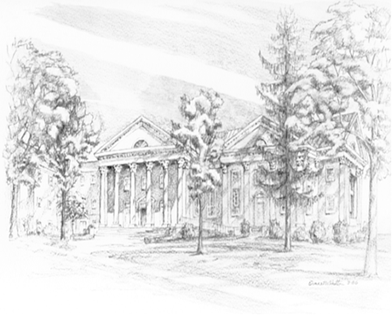

P.O. Box 877
249 South Wayne Avenue
Waynesboro, Virginia
(540) 949-8366
Church Website: www.firstpresway.org
Preschool Website: www.firstprespre.org
Email: church@firstpresway.com

P.O. Box 877
249 South Wayne Avenue
Waynesboro, Virginia
(540) 949-8366
Church Website: www.firstpresway.org
Preschool Website: www.firstprespre.org
Email: church@firstpresway.com

