

THE COLUMNS

October 2022, Volume 60, Issue 10

First Presbyterian Church, Waynesboro, VA

*First Presbyterian Church of Waynesboro is a community-minded congregation living out the love of Christ as we serve one another with humility, gentleness, and patience through God’s grace.*

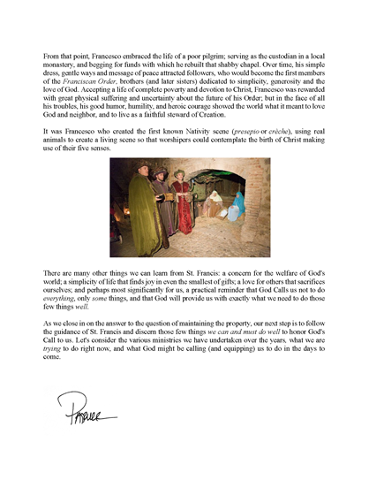

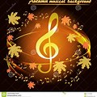

**MUSIC NOTES**

It’s finally here – the sensational burst of colors that is autumn. With cooler temperatures and slanting sunshine, we celebrate the glories of the season and bask in the warmth of God’s love.

For the first Sunday of October, the anthem will be *In Remembrance of Me,* with text by Ragan Courtney (b. 1941) and music by Buryl Red (1936-2013). It is a musical setting of Jesus’ charge to his disciples at the Last Supper: heal the sick, feed the hungry and pray for the time that God’s will is done.

The prelude and postlude were composed by Arthur Foote (1853-1937), a Massachusetts native who studied at the New England Conservatory of Music and what was then Harvard College. Foote also received a Master of Arts degree in music from Harvard, the first such degree conferred in America. He was the first noteworthy American composer to be trained entirely in the United States. Foote was one of the founders of the American Guild of Organists, which he served as president for three years.

The first Sunday of October also opens the season for the Waynesboro Symphony Orchestra. The ensemble-in-residence at FPC will play a free concert in the Sanctuary at 3pm. It is the first of three concerts at FPC in a week!

Roger will play a First Friday program on 7 October. The free concert at 12:15 will be followed by a light luncheon. We are grateful to Susan Johnson for providing the delightful repast!

On Sunday 9 October, the US Air Force Heritage of America Band will play a free concert at FPC. The ensemble, comprised of ten wind players who are all members of the Air Force, will play five concerts in western Virginia, including programs in Luray, Chester, Louisa and Augusta. The free concert will be at 3pm in the Sanctuary and all are cordially invited!

Throughout the rest of October, we will continue to choose hymns based on the Scripture readings of the week, including songs of praise and thanksgiving.

We are delighted to welcome Diane Kingsbury on Sunday 23 October. Diane has, on numerous occasions, made her talents and pleasant demeanor available to us on Sunday mornings when Roger and Kimberlea are away.

Finally, we express our sincere condolences to the Bellamy/Brown family on the loss of Tom. His positive attitude in the choir always brought smiles to our faces. Tom, Sandy and Kathy’s participation in the choir added most substantially to our choral praises. He will be sorely missed.

Blessings –

Roger and Kimberlea

**THIS IS THE WAY**

**Reading Sidewalks as a Spiritual Practice**

By Ken Rummer

Fortune tellers read palms. Ancient Etruscans read the livers of sheep. I’ve been reading sidewalks.

Dark purple spatters? Evidence of a mulberry tree nearby. BB-sized rounds crunching under foot? Choke cherry pits. And that gray, leaf-shaped stain, like the shadow of an object vaporized by a space alien’s destructo-beam? The calling card of a silver maple tree.

When I tripped on the sidewalk as a child, adult voices admonished, “Watch where you are going.” It’s still good advice. And not just for hazards like shifted slabs and abandoned scooters. Watching where I’m going helps me notice other things, too.

That dark spot of dirt centered on a sidewalk crack means an ant colony is living and working under the concrete. That bright line of yellow spray paint warns of a gas line passing beneath the walk. And that scattering of cracked corn says the neighbor has put out fresh feed for the wild ducks.

In my youth, Simon and Garfunkel sang about finding prophetic words written on subway walls (“The Sound of Silence,” 1964). Could the same thing be possible with sidewalks?

I’ve seen words chalked on the walk, cheers of encouragement for the distance runners who train on this path. Are there any messages here for me?

I think I’m seeing, not in chalk but in Spirit marker, “This is the way. Walk in it.”

The words seem vaguely familiar. Something from the Bible? As it turns out, yes. The words echo a prophetic oracle preserved in the Book of Daniel. They show up there as a future whisper in the ear.

“This is the way. Walk in it.” (Isaiah 30:21 NRSV).

A person facing a big decision might hear that as an answer-to-prayer word of guidance. But in my situation, it feels more like a blessing, a confirmation of decisions already made.

I think back to the choices around retirement, like when is it time, and where will we live, and how much will it cost, and what will I do if I’m not doing what I’ve been doing for forty years. Big decisions.

But now, five-and-a-half years into retirement, I find that those decisions have lived well. My life has settled into a pace and a direction along mostly familiar paths, but with enough detours and adventures to keep things interesting. And I am feeling at home in this new territory, unexpectedly content.

“This is the way,” and I am on it. As an old Celtic journey-prayer puts it, “I on Thy path O God. Thou O God, in my steps.” (Esther De Waal, *The Celtic Way of Prayer).*

I offer that prayer to you for wherever you find yourself on your journey. It’s a prayer for help in finding God’s path and a prayer for God to walk with you, so closely as to leave but one set of footprints together.

“I on Thy path O God. Thou O God, in my steps.”

(Ken Rummer PCUSA Teaching Elder, honorably retired, writes about life

and faith from the middle of Iowa by the High Trestle Trail.)

**DENTALPALOOZA FALL 2022**

**The Augusta Regional Dental Clinic** in Fishersville will hold a **free**

Dental Clinic Day on October 22, 2022. 70 appointments are available.

Patients will receive consultations, cleanings, fillings and extractions

at no out-of-pocket cost.

The event will be held in memory of its late Dental Director,

**Dr. Mark Hammock.**

Support the “Dr. Mark Hammock Memorial Fund” to provide

financial aid to patients. FPC has pledged (at least) $500 to this fund.

Make out checks to “First Presbyterian Church” with “Dental” on the memo line.



**2022 CROP HUNGER WALK**

**Ending Hunger One Step at a Time**

The Waynesboro-East Augusta CROP Walk was held September 25. 25% of the CROP funds remain in our community to support local hunger-fighting organizations. 75% of donations are used by Church World Service to support global hunger, humanitarian aid, and disaster response programs in 30+ countries.

Walkers from First Pres were Cynthia Hoover, Jean Hashagen, Joe Earhart, Terry Crickenberger accompanied by their canine Winston. Donations to support this worthy venture are welcome through October. Send a check made out to CWS/CROP to the church or consider donating online: www.crophungerwalk.org/waynesboro.org.

Event at Westminster

Presbyterian

**SESSION HIGHLIGHTS**

Session held a Stated Session Meeting on September 13, 2022.

* Mike Cunningham reported on the Zoom Presbytery Meeting August 27, 2022.
* Rev. Pettit updated Session about ongoing dialogue with Fishburne Military School.
* A potluck will be held after worship on Sunday, October 12, in the Barksdale Room.
* The annual CROP Walk will be held September 25.
* FPC provided 46 meals for Disciples’ Kitchen on September 20; Weasie’s Kitchen donated coleslaw.
* FPC has set a minimum goal of $500 to support the “Dr. Mark Hammock Memorial Fund” to aid patients at Augusta Regional Dental Clinic, in particular the October DENTALPALOOZA FALL 2022.
* Session approved a free concert in our sanctuary on October 9 by the USAF Heritage of America Bands.
* Session renewed the Memorandum of Understanding with the Waynesboro Symphony.
* In August an Early Preschool Education grant was received by our Preschool for over $12,000.

All Session meetings are opened and closed with prayer.

Betsy Ruehl, Clerk of Session

**COMING EVENTS**

**WAYNESBORO SYMPHONY CONCERT**

**FPC SANCTUARY**

**Sunday, October 3 – 3:00 p.m.**

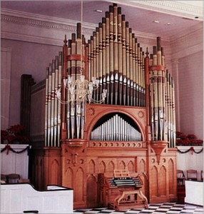

**FIRST FRIDAY ORGAN CONCERT**

**FPC SANCTUARY by ROGER DAGGY**

**Friday, October 7 – 12:15 p.m.**

**Lite Lunch to follow**

**U.S. AIR FORCE HERITAGE OF AMERICA BAND CONCERT**

**featuring ten U.S. AIR FORCE WIND PLAYERS**

**Free Concert in Sanctuary**

**Sunday, October 9 – 3:00 p.m.**

**(potluck after Worship in Barksdale Room )**

October will be loaded with Fun and Learning

Waynesboro Fire

Dept Display

Oct 10

Field Trip

 Oct 10

Officer and

K-9 Companion

 Oct 27

Oct 26

Officer Leech

Oct 11 Come & join our party

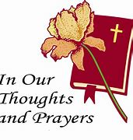

**IN MEMORIAM**

***Thomas “Tom” Leroy Bellamy***

August 26, 1940 – September 25, 2022

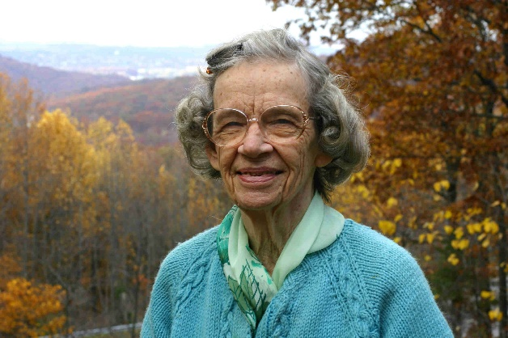Dear friends and members of the First Presbyterian Church of Waynesboro,

My brother, Charles, and I wanted to let you all know that in July we held a private (immediate family only) interment service for the ashes of our dear mother LaVelle Pool. It was a spiritually uplifting ceremony for all involved.

When we had this service, we were planning to have a public memorial service for LaVelle later in the year, at the church, where she was a member for most of her adult life. But due to the continuing presence of the covid pandemic, which is currently surging in Augusta County, as well as the current problems and stresses of travel for family members, we felt that having just the private burial would be best. LaVelle was a very private person; at 99 years old she had outlived most of her contemporaries and had withdrawn from church attendance in her last years due to the effects of Alzheimer's disease. We believe she would be happy with our private goodbye.

Instead, I'd like to invite each of you, friends and loved ones of LaVelle, to visit with me at your convenience, now or in the future. I will continue to live here in our home on Afton Mountain where I grew up, where my Mom lived for more than 70 years, and where I lived the last 15 years of my Mom's life in order to help her as she aged. I am surrounded by wonderful memories and mementos of my parents and family. So, I invite you all to visit with me here in this homestead; we can share stories and memories of LaVelle and our families, as well as updates of our present lives. At your convenience, call or text me at 540-836-7533, and we can arrange a visit. I'd be delighted to see you... I am now retired and living here alone, and would enjoy the company, the conversation, and sharing memories.

With much love,

Eddie Pool



**October 6 Jeannie Curry**

**Mary Ann Maupin**

**October 10 Charles Simpkins**

**Nancy Geer**

**October 11 Shirley Straka**

**October 15 Lorain Kent**

**October 17 Susan Elder**

**October 18 Jennifer Jones**

**October 21 Kevin Henkel**

**October 22 Kimberlea Daggy**

**October 26 Mark Henderson**

**October 30 Anne Wood**



**October 16**

**Paul and Phyllis Poluito**

 **Liturgists**

October 2 Bill Pannill

October 16 Linda Sandquist

October 23 Sandi Henderson

October 30 Danny Leech

**Sunday, October 2**

**Mailing Address**

P. O. Box 877

Waynesboro, VA 22980

**Phone**

540.949.8366

**Fax**

540.949.5750

**E-mail**

church@firstpresway.com

**Website**

www.firstpresway.org

**Church Office Hours**

Monday-Wednesday

8 a.m. – 2:30 p.m.

Thursday

8 a.m. – 4:30 p.m.

**Interim Pastor**

Rev. Patrick S. Pettit

pspettit@gmail.com

**Administrative Assistant**

Mrs. Colleen Cash

ccash@firstpresway.com

**Preschool Director**

Mr. Nate Rudin

preschool@firstpresway.com

**Director of Music**

Mr. Roger Daggy

[firstpreswaymusic@gmail.com](mailto:firstpreswaymusic@gmail.com)

**Music Associate**

Mrs. Kimberlea Daggy

[firstpreswaymusic@gmail.com](mailto:firstpreswaymusic@gmail.com)

**Audio/Visual Technician**

Mr. Craig Cavanaugh

**Maintenance Technician**

Mr. Michael Griffith

11:00 AM Worship Service World Communion Sunday

3 PM Waynesboro Symphony

**Thursday, October 6**

6-8 PM Food Bank

**Friday, October 7**

12:15PM First Friday Organ Concert with Lite Lunch

**Sunday, October 9**

11:00 AM Worship Service

Covered Dish Luncheon

3:00 PM USAF Heritage of American Bands Concert

**Tuesday, October 11**

2:30 PM Session Room 212

**Thursday, October 13**

3-4 PM Fishburne NHS Practice

2-4 PM Food Bank

**Friday, October 14**

10 AM Fishburne NHS Induction

**Sunday, October 16**

11:00 AM Worship Service

**Tuesday, October 18**

**7**-9 PM Symphony -Fellowship Hall

**Thursday, October 20**

6-8 PM Food Bank

**Sunday, October 23 Terry Crickenberger**

11:00 AM Worship Service

**Tuesday, October 25**

7-9 PM Symphony -Fellowship Hall

**Thursday, October 27**

2-4 PM Food Bank

7-10 PM Symphony -Sanctuary

**Sunday, October 30**

11:00 PM Worship Service

TRIVIA 😊

From a 2022 Major-Holiday Calendar

Daily October holidays and special days

1 – International Day for the Elderly

3 – World Communion Sunday

3 – Oktoberfest ends in Germany

4 – Yom Kippur

7- World Smile Day (first Friday of month)

10 – Columbus Day (observed on second Monday)

10 – Indigenous People Day (second Monday of month)

10 – Thanksgiving Day in Canada (2nd Monday)

15 – Sweetest Day (3rd Saturday)

17 – Boss’s Day (weekday closest to October 16)

22 – Make a Difference Day (4th Saturday)

24 – United Nations Day

31 - Halloween