TWENTY-THIRD SUNDAY after PENTECOST November 13, 2022

PRELUDE My Heart Leaps with Joy Walcha (1907-1991)

WELCOME & ANNOUNCEMENTS

INTROIT Alleluia Milburn (b. 1963)

CALL TO WORSHIP Jean Hashagen
Leader: Surely God is our salvation;
People: we will trust, and will not be afraid.
Leader: The Lord God is our strength and our might;
People: God has become our salvation.
Leader: Let us worship God.

MORNING PRAYER

OPENING HYMN 641 When in Our Music God is Glorified Engelberg

CALL TO CONFESSION

PRAYER OF CONFESSION
Majestic Lord, we fail to believe we reflect your image, or behave as those who belong to you. We turn from your path of sacrificial love, toward our personal preferences. We forget your call to righteousness and ignore our need for you. Forgive us, Lord, this and all our sin. Relieve the burden of our regrets by the power of your patient love.

SILENT PRAYER

ASSURANCE OF PARDON

*GLORIA PATRI 581 Greatorex

FIRST SCRIPTURE READING Psalm 98 p. 480

SPECIAL MUSIC Sonata in A-flat, H. 31: I Bach, CPE (1714-1788)

SECOND SCRIPTURE READING 2 Thessalonians 3:6-13 p. 962

SERMON Work, work, work. Patrick Pettit, Interim Pastor

*AFFIRMATION OF FAITH The Apostles' Creed Hymnal p. 35

PRAYERS OF THE PEOPLE & THE LORD’S PRAYER

*CLOSING HYMN 545 Lord, Bid Your Servant Go in Peace Land of Rest

*CHARGE and BENEDICTION

POSTLUDE Sonata in B-flat, Op. 65, no. 4: I Mendelssohn (1809-1847)

*Please stand if able

Today’s link is : https://youtu.be/aDBIULLpDjk

Hearing devices are available for your convenience.
Please be aware that they do not function until after the service begins.

Harvest Brunch
After Worship November 20
Barksdale Room
RSVP, please

The Legacy: Mary June Cook

UVA: Bird Heuchert

Regency at Augusta: Edie Lawrence

Shenandoah Nursing Home: Rubye Schwab

Summit Square: Lillian Hryshkanych

Home: Dick Huff, Nancy Garber, Mary Ultee, Mary Ann Maupin, Walt Flora, Warner & Linda Sandquist, Ruth and Lewis Kelley.

Friends and Family: Erwin Berry (Joan), Bill Bromley, Ron Buckalew, Jean Custen, Jerry Hughes, Sally McNeel, Bill Metzel (Joyce Tipton), Col. Stuart Roberts (Mark Henderson), Danny Smith (Nancy Hypes), Paul Watts (Colleen Cash).

Military: Carson Craig

First Friday Concerts

Volunteers needed to assist with set up, serving and clean up at the reception
Please contact Susan Johnson, 540-476-1697.

FIRST PRESBYTERIAN CHURCH
WAYNESBORO, VIRGINIA

A community-minded congregation living out the love of Christ as we serve one another with humility, gentleness, and patience through God’s grace.

November 13, 2022 11:00 AM

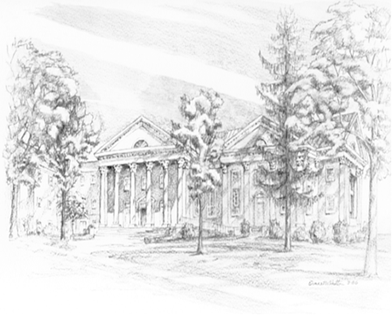

P.O. Box 877
249 South Wayne Avenue
Waynesboro, Virginia
(540) 949-8366
Church Website: www.firstpresway.org
Preschool Website: www.firstprespre.org
Email: church@firstpresway.com

P.O. Box 877
249 South Wayne Avenue
Waynesboro, Virginia
(540) 949-8366
Church Website: www.firstpresway.org
Preschool Website: www.firstprespre.org
Email: church@firstpresway.com

