First Presbyterian Church, Waynesboro, VA

*First Presbyterian Church of Waynesboro is a community-minded*

*congregation living out the love of Christ as we serve one another with*

*humility, gentleness, and patience through God’s grace.*

THE COLUMNS

In earliest Christian communities, the death of a martyr (that is, one who chose to sacrifice their life rather than renounce their Christian faith) was celebrated on the day they became a saint (or, one whose entire life is consecrated to God) - the anniversary of their death. But as the church continued to grow, the number of saints also grew; by the time the emperor Diocletian had abdicated the throne in 305 and his persecution of Christians came to an end, there were so many martyrs it was hard to keep them all straight, let alone give each the attention warranted their sacrifice. All Saints’ Day was established as a sort of catch-all celebration, to honoring all martyrs, known and unknown. Originally a part of the Easter celebrations, All Saints’ Day has been celebrated on November 1 since the year 835, followed since the 11th century by All-Souls Day on November 2.

November 2022, Volume 60, Issue 11

In many places, All Saint's Day remains a public holiday, with unique traditions.

In France, the day is known as *La Toussaint*, and flowers and wreaths, chrysanthemums in particular, adorn tombs or graves.

In Germany, the day is known as *Allerheiligen.* In many of the federal states, such as Bavaria, *Allerheiligen* is, by law, a silent day (Stiller Tag) when only serious public entertainments are permitted.



*Couronnes de Toussaints*

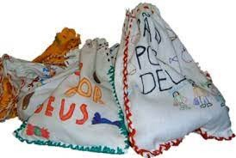Likewise, in Portugal, Dia de Todos os Santos is a national holiday with religious observances and visits to cemeteries. Portuguese children celebrate the tradition of Pão-por-Deus, going door-to-door, to receive cakes, nuts, pomegranates, sweets and candy.

All Saints' Day in Mexico inaugurates the celebrations of Día de Muertos. November 1st commemorates children who have died (Dia de los Inocentes), while November 2nd (All Soul's Say) celebrates all deceased adults. Traditions include honoring the deceased using *calaveras,* (skulls), aztec marigold flowers (*cempazúchitl*), and ofrendas (offerings) of their favorite foods and beverages.

It is also common to give gifts - candy sugar skulls, and the traditional *pan de muerto -* and to write light-hearted and often irreverent mock epitaphs for living friends and acquaintances, a literary form known as *calaveras literarias.*

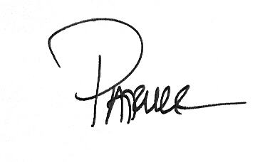As in many cultures, the focus of All Saints’ Day is expanded for those of us in the Reformed Tradition. We remember with thanks not just the 'great' women and men of Church history but celebrate the saintliness (or sanctification) of the whole people of God- the 'cloud of witnesses' referred to in Hebrews 12. We give glory to God for the ordinary, holy lives of the believers in this and every age - in particular, those who have died in the past year.

**SESSION HIGHLIGHTS**

Session held a Stated Meeting on October 11, 2022.

* Session approved the transfer of Sandy Bellamy and Kathy Bellamy Brown to Second Presbyterian Church in Waynesboro.
* As a church we need to address a Budget – Where It Comes From and Where It Goes.
* A Harvest Brunch has been scheduled after worship on Sunday, November 20, in lieu of a Thanksgiving Dinner.
* A detailed report on Mission/Outreach appears elsewhere in this newsletter.
* A fence at the back of the Preschool has been completed.
* Preliminary discussion has been held regarding the Saturday Christmas Eve and Sunday Christmas Day services.

All Session Meetings are opened and closed with prayer.

--Betsy Ruehl, Clerk of Session

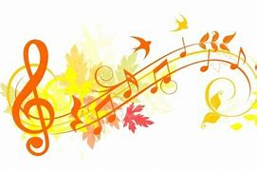**MUSIC NOTES**

November is upon us, and we begin the month marking Veterans Day. We honor those who serve our country with the hymns *Eternal Father Strong to Save* and *O God Our Help in Ages Past.* (And remember to set your clock back one hour to luxuriate in the extra hour of sleep!)

The final Sunday of the church year is November 20, when we raise up Christ the King. The service will open with *Crown Him with Many Crowns,* the sparkling hymn known as DIADAMATA. Since it is also the Sunday before Thanksgiving, the service will conclude with *Now Thank We All Our God,* one of Martin Luther’s most enduring hymns*.* The postlude is based on the same hymn, a glorious piece written by Sigfrid Karg-Elert (1877-1933).

The last Sunday in November is actually the first Sunday of the church year, when we “prepare for the way of the Lord.” The anthem for the first Sunday of Advent will be Johann Sebastian Bach’s (1685-1750) setting of the chorale, *Zion Hears the Watchman Calling.*

November also opens with another *First Friday* organ program. This month, Roger will be joined by our daughter, Celia, currently Principal Viola of the Virginia Symphony Orchestra. Celia and Roger will play the *Romance* by Max Bruch (1838-1920) and two *Preludes* by George Gershwin (1898-1937). We look forward to seeing you at the program on Friday 4 November at 12:15, followed by a delightful repast generously provided by Susan Johnson.

Thank you for your continued support of the music ministry here at First Presbyterian Church!

Blessings and peace be with you,

Roger and Kimberlea

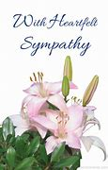

**IN MEMORIUM**

***Branch Reed Hammock***

**September 8, 1929 – October 8, 2022**

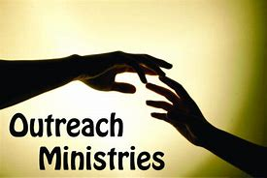

**MISSION/OUTREACH**

Do not underestimate what one small church can do. In August, First Presbyterian Church sent 30 hygiene kits to be distributed in Kentucky after severe flooding. That month, we served 46 individuals at the Disciples’ Kitchen. In September, we raised $1,520 for the CROP Walk. CROP Walk funds help support the Blue Ridge Area Food Bank, Salvation Army, and VPAS (meals-on-wheels). We donated $530 to the Dr. Mark Hammock Dental Palooza on October 22.

Currently we are collecting items for school kits and hygiene kits. The Presbyterian Disaster Assistance program requested these kits in response to destruction in Florida following Hurricane Ian. The kits were assembled in the Barksdale Room following the service on October 30.

Second Presbyterian Church has requested donations of socks, hats and gloves to be distributed at the Disciples’ Kitchen. We will collect items during November. The clothing needs to be turned in by December 12. We will serve a meal in Disciples’ Kitchen on December 13. Please contact Cynthia Hoover if you wish to volunteer.

The Food Bank volunteers have been busy in the last few weeks. The Food Bank served 157 individuals in September.

Thank you for your continued support of ministries vital to our community. First Presbyterian Church may not have many members, but we have dedication to serving those in need.

Sincerely submitted, Cynthia Hoover

**ADVENT BEGINS NOVEMBER 27, 2022**

Advent – name adopted from the Latin word “adventus” meaning “coming arrival” translating the Greek word “Parousia”.

The four Sundays of Advent proclaim aspects of our divine nature – **hope and faith, peace, love and joy.** These traditional themes of Advent allow us – through meditation, prayer and affirmation – to contemplate ways to share our deepest gifts.

Dear Lord, be with us, as we walk through these pathways of love.

**FINDING GOD IN THE JUNK DRAWER**

**A much-need reminder to “watch for God”**

by Donna Frischknecht Jackson

God spoke to me the other day.

I wasn’t standing on some mountaintop. Nor was I lying prostrate on the floor. I wasn’t even kneeling in the quiet of the old sanctuary of the little rural church I serve. There were no candles flickering nor Georgian chanting in the background setting the stage in which to hear the Divine One speak.

There was nothing holy going on at all when God spoke to me….in my kitchen, while standing in front of the junk drawer.

You know the junk drawer. That drawer filled with items you don’t want to throw away because, hey, you just never know when you night need that lone screw that came from something you have yet to discover is wobbly and missing one.

God spoke to me the other day.

In my kitchen at the junk drawer where squished in the back corner of the drawer I found a relic from a Vacation Bible School from years gone by.

It was a rubber bracelet with the message “Watch for God.” Every year at Vacation Bible School, the program chosen for the children gave the option of ordering these bracelets. I was always supportive of spending the extra money on them because the message to watch for God was one I wanted the children to be constantly reminded of.

The extra cost was worth it. The kids loved the bracelets and even after Vacation Bible School was a fading memory, I would spot the children out and about on the football field, practicing the latest cheers, kicking a soccer ball, heading to school with backpacks burdening their little backs, wearing the “Watch for God” bracelets.

Every now and then a child would spot me, smile and wave, and then point to the bracelet and give me a thumbs up. I would return the thumbs up and if the child was in earshot I would say, “Keep on watching!”

Keep on watching for the God moments are all around.

I believed what I said to the kids. But lately, I have forgotten to keep my eyes wide open to how beautiful life can be. I’m not talking about watching for the beauty on the surface of things. I’m talking about how I have forgotten to watch for the beauty amid the ugly. Watch for the strength to come in the moment of incredible weakness. Watch for glimmers of a bright future in an aging congregation. Watch for ways in which God is calling us to be a new kind of church. Watch for moments of grace when a Sunday service just doesn’t go as planned. Watch for the multiplication of fish and loaves when the church treasurer laments there just isn’t enough.

God spoke to me.

In my kitchen. From my junk drawer.

God reminded my anxious heart to keep watch; all will be well. God reminded me to look up and smile; greater things are yet to come.

I slipped the bracelet on my wrist.

Thank God for junk drawers.

(Rev. Frischknecht Jackson, interim editor of *Presbyterians Today,* is a former NYC

magazine editor who traded in her heels for a good pair of barn boots when

she was called to serve First United Presbyterian Church in rural Salem, New York.)

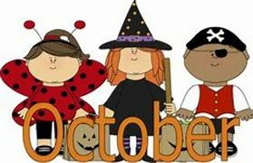

Dear Congregation,

October was full of spooky fun! We received a visit from both the Fire Department and the Police Department. The children enjoyed sitting in the vehicles and seeing the K9. On the 26th we celebrated Halloween with the annual Preschool Trick or Treat. Let’s just say, they will be eating candy for a while. Thank you to the parents as well as Colleen, Cynthia, Elizabeth, and Jean for attending.

In November we will celebrate Thanksgiving. The children will be taught the importance of family and friends as well as the importance of giving. As cold weather starts taking hold, everyone please pray that these children remain healthy, so they don’t miss a fun day this month.

God Bless,

Nate Rudin

Director

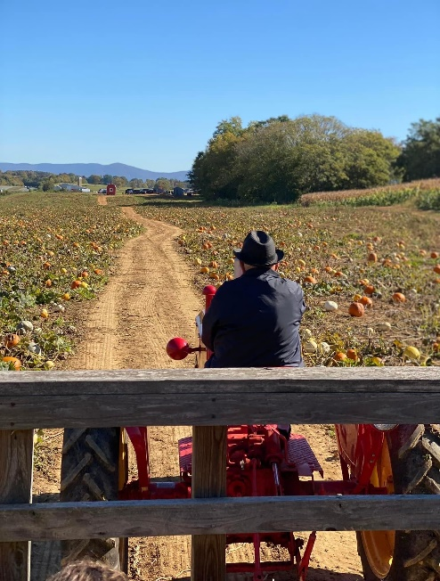

**FIRST FRIDAY CONCERT**

**November 4, 12:15 p.m.**

**Roger Daggy, Organist, joined by**

**daughter Celia Daggy on the Viola**

***Romance* by Max Bruch and**

**Two *Preludes* by George Gershwin**

**Followed by a delight repast**

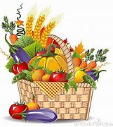

**HARVEST BRUNCH**

**Following Worship in the Barksdale Room**

**Sunday, November 20, 2022**

**All Welcome!**

**Birthdays**

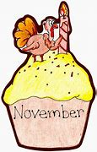

Betty Johnson November 6

Max Daggy November 9

Richard Curry November 29

Mitch Lawrence November 30

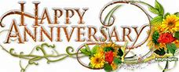

Terry & Joe November 30

**Liturgists**

11/8 Anne Wood

11/13 Jean Hashagen

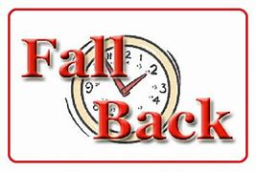11/ 20 Mark Henderson

11/27 Cynthia Hoover

Saturday, November 6

**VETERANS DAY**

Veterans Day is observed annually on November 11, honoring all military veterans who served in the U.S. Armed Forces.

**Why Veterans Day is Important**

**It’s a chance to thank people for risking their lives to defend America.**

An estimated 20% of veterans of Iraq and Afghanistan suffer from post-traumatic-stress disorder or major depression, according to government statistics. You’d be surprised at how much it means to veterans to feel valued by civilians for their service and sacrifice.

**It’s a chance to reflect on the importance of peace.**

While our military is often thought of in a war context, most veterans will tell you that they risked their lives to defend our fundamental freedom and that they value peace much more highly than war. Very few who have seen horror of war are anxious to rush into it. Veterans Day encourages of us to reflect on the value of harmony in our daily interactions and lives.

**It draws attention to the challenge facing many veterans.**

Veterans face disproportionate rates of homelessness, deficiency in educational achievement, a struggle to find employment and often have to deal with devastating wounds. In many cases PTSD makes it hard for them to reintegrate into regular society. By understanding these challenges, we can all reach across this divide and make sure veterans have the best possible chance of having a healthy and fulfilling life after service.



**Mailing Address**

P. O. Box 877

Waynesboro, VA 22980

**Phone**

540.949.8366

**Fax**

540.949.5750

**E-mail**

church@firstpresway.com

**Website**

www.firstpresway.org

**Church Office Hours**

Monday-Wednesday

8 a.m. – 2:30 p.m.

Thursday

8 a.m. – 4:30 p.m.

**Interim Pastor**

Rev. Patrick S. Pettit

pspettit@gmail.com

**Administrative Assistant**

Mrs. Colleen Cash

ccash@firstpresway.com

**Preschool Director**

Mr. Nate Rudin

preschool@firstpresway.com

**Director of Music**

Mr. Roger Daggy

[firstpreswaymusic@gmail.com](mailto:firstpreswaymusic@gmail.com)

**Music Associate**

Mrs. Kimberlea Daggy

[firstpreswaymusic@gmail.com](mailto:firstpreswaymusic@gmail.com)

**Audio/Visual Technician**

Mr. Craig Cavanaugh

**Maintenance Technician**

Mr. Michael Griffith

**Tuesday, November 1**

7-9 PM Symphony - Sanctuary

**Thursday, November 3**

6-8 PM Food Bank

7-9PM Symphony - Sanctuary

**Friday, November 4**

12:15 PM First Friday Organ Concert with Lite Lunch

**Saturday, November 5**

**Set Clocks Back**

**Sunday, November 6**

11:00 AM Worship Service

**Tuesday, November 8**

2:30 PM Session Room 212

7-9 PM Symphony -Fellowship Hall

**Thursday, November 10**

2-4 PM Food Bank

**Sunday, November 13**

11:00 AM Worship Service

3 PM Waynesboro Symphony

**Thursday, November 17**

6-8 PM Food Bank

**Sunday, November 20**

11:00 AM Worship Service

Harvest Brunch

**Thursday, November 24 Thanksgiving**

**Office closed**

**Tuesday, November 29**

7-9PM Symphony -Fellowship Hall

November Holidays and Special Days

*From a 2022 Major-Holiday Calendar*

1. - All Saints’ Day

1-2 - Dia de los Muertos (Day of the Dead)

1. - All Souls’ Day (usually on the 2nd)

6 - Daylight Savings time ends (gain 1 hour sleep)

8 - U.S. General Election Day

11 - Veterans Day

13 – Caregiver Appreciation Day

13 - Sadie Hawkins Day

17 - General American Smokeout. (3rd Thursday)

20 - Universal Children’s Day

24 - Thanksgiving Day (4th Thursday)

25 - Black Friday (Day after Thanksgiving)

26 - Small Business Saturday

27 - Advent begins