Twenty Second Sunday after Pentecost November 6, 2022

PRELUDE Préambule, Op. 31, no. 1 Vierne (1870-1937)

WELCOME & ANNOUNCEMENTS

INTROIT God of the Ages Warren (1828-1902)

CALL TO WORSHIP
Leader: Great is the Lord and greatly to be praised.
People: For the Lord is gracious and merciful.
Leader: Great is the Lord and greatly to be praised.
People: For the Lord is slow to anger and abounding in steadfast love.
Leader: Let us worship God.

MORNING PRAYER

*OPENING HYMN 8 Eternal Father, Strong to Save Melita

CALL TO CONFESSION

PRAYER OF CONFESSION
Gracious God, you call us to faithful living: to give ourselves to you and to one
another after the example of Jesus. Yet sin prevents us from following your directions.
We pursue our own goals, worship our own gods, and place our hope in things that
cannot last. Forgive us, Lord, this and all our sin. Wash us anew; forgive us again.
Give us ears to hear your call and faith to follow wherever Christ leads.

SILENT PRAYER

ASSURANCE OF PARDON

*GLORIA PATRI #581 Greatorex

FIRST SCRIPTURE LESSON Psalm 17:1-9 p. 431

ANTHEM A Hymn of Glory, Let Us Sing Deo Gracias (circa 1415)
(text can be found in hymn 258)

SECOND SCRIPTURE LESSON Luke 20:27-38 p. 855

SERMON A small heaven. Patrick S. Pettit, Interim Pastor

*AFFIRMATION OF FAITH The Apostles’ Creed Hymnal p. 35

THE LORD’S SUPPER
Invitation
Great Thanksgiving
Communion of the People

PASTORAL PRAYER

*CLOSING HYMN 687 O God, Our Help in Ages Past St. Anne

*CHARGE & BENEDICTION

POSTLUDE Fanfare Soler (1729-1783)

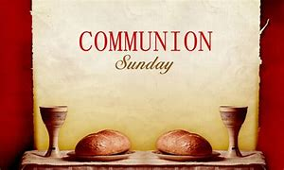

*PLEASE STAND IF ABLE.

Link for this week’s service is: https://youtu.be/tuKwwnXSx_k

Audio aids are available for your convenience.
Please be aware that they do not function until after the service begins.

The Legacy: Mary June Cook

Regency at Augusta: Edie Lawrence

Shenandoah Nursing Home: Rubye Schwab

Summit Square: Lillian Hryshkanych

UVA : Mary Scott “Bird” Heuchert

Home: Dick Huff, Nancy Garber, Mary Ultee, Mary Ann Maupin, Walt Flora, Warner & Linda Sandquist, Ruth and Lewis Kelley.

Friends and Family: Erwin Berry (Joan), Bill Bromley, Ron Buckalew, Jean Custen, Jerry Hughes, Sally McNeel, Bill Metzel (Joyce Tipton), Col. Stuart Roberts (Mark Henderson), Danny Smith (Nancy Hypes), Paul Watts (Colleen Cash).

Military: Carson Craig

FIRST PRESBYTERIAN CHURCH
WAYNESBORO, VIRGINIA
November 6, 2022

A community-minded congregation living out the love of Christ as we serve one another with humility, gentleness, and patience through God’s grace.

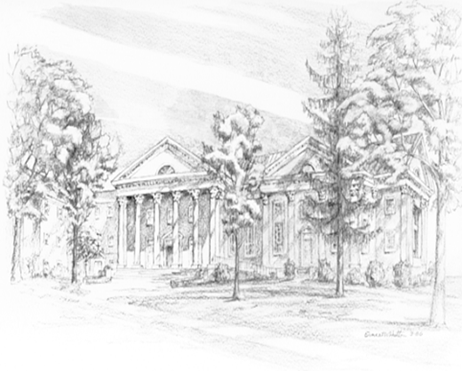

P O Box 877
249 South Wayne Avenue
Waynesboro, Virginia
(540) 949-8366
Church Website: www.firstpresway.org
Preschool Website: www.firstprespre.org
Email: church@firstpresway.com

