TWENTY-FIRST SUNDAY AFTER PENTECOST October 30, 2022

PRELUDE Antiphon, Op. 18, no. 3 Dupré (1886-1971)

WELCOME & ANNOUNCEMENTS

INTROIT I Sing a Song of the Saints of God Hopkins (1820-1891)

CALL TO WORSHIP
Leader: God is a hiding place.
People: Christ preserves us from trouble.
Leader: Take refuge in the triune God, to whom be all glory and honor this day!
People: We shall go to the altar of God, to the God of our joy and gladness.
Leader: Let us worship God.

MORNING PRAYER

OPENING HYMN 61 Your Law, O Lord, Is Perfect Christus, der ist mein Leben

CALL TO CONFESSION

PRAYER OF CONFESSION
Almighty God, we confess we cannot see your image in each and every one of our neighbors. We call one another “sinner”; while you call us by our names. We misjudge one another, we underestimate ourselves, and we undervalue creation. Forgive us, Lord, this and all our sin. Pardon us and reveal to us your vision for the world that we may see all people through eyes of care and hearts of compassion.

SILENT PRAYER

ASSURANCE OF PARDON

*GLORIA PATRI 581 Greatorex

FIRST SCRIPTURE READING Psalm 119:137-144 p. 496

ANTHEM The Summons arr. Bell (b. 1949)
(text can be found in hymn 726)

SECOND SCRIPTURE READING Luke 19:1-10 p. 854

SERMON Come on down! Patrick S. Pettit, Interim

*AFFIRMATION OF FAITH The Apostles' Creed Hymnal p. 35

NECROLOGY See insert

PRAYERS OF THE PEOPLE & THE LORD’S PRAYER

*CLOSING HYMN 738 O Master, Let Me Walk with Thee Maryton

*CHARGE and BENEDICTION

POSTLUDE For All the Saints Vaughan Williams (1872-1958)

*Please stand if able

Today’s link is : https://youtu.be/nwco0shIky4

Hearing devices are available for your convenience.
Please be aware that they do not function until after the service begins.

The Legacy: Mary June Cook

Regency at Augusta: Edie Lawrence

Shenandoah Nursing Home: Rubye Schwab

Summit Square: Lillian Hryshkanych

Home: Dick Huff, Nancy Garber, Mary Ultee, Mary Ann Maupin, Walt Flora, Warner & Linda Sandquist, Ruth and Lewis Kelley.

Friends and Family: Erwin Berry (Joan), Bill Bromley, Ron Buckalew, Jean Custen, Jerry Hughes, Sally McNeel, Bill Metzel (Joyce Tipton), Col. Stuart Roberts (Mark Henderson), Danny Smith (Nancy Hypes), Paul Watts (Colleen Cash).

Military: Carson Craig

Directly after Worship please meet in the Barksdale Room to assemble the School Bags for Hurricane Ian victims.

Don’t forget to FALL BACK Saturday night, November 5.

FIRST PRESBYTERIAN CHURCH
WAYNESBORO, VIRGINIA

A community-minded congregation living out the love of Christ as we serve one another with humility, gentleness, and patience through God’s grace.

October 30, 2022 11:00 AM

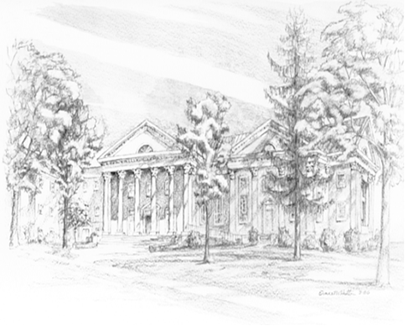

P.O. Box 877
249 South Wayne Avenue
Waynesboro, Virginia
(540) 949-8366
Church Website: www.firstpresway.org
Preschool Website: www.firstprespre.org
Email: church@firstpresway.com

P.O. Box 877
249 South Wayne Avenue
Waynesboro, Virginia
(540) 949-8366
Church Website: www.firstpresway.org
Preschool Website: www.firstprespre.org
Email: church@firstpresway.com

