First Presbyterian Church, Waynesboro, VA

*First Presbyterian Church of Waynesboro is a community-minded*

*congregation living out the love of Christ as we serve one another with*

*humility, gentleness, and patience through God’s grace.*

THE COLUMNS

**December 2022, Volume 60, Issue 12**

With the Advent of, well, *Advent,* we begin another year in the life of the church. The church year, like so many elements of life, is a cycle; from Advent to Christmas, Lent to Easter, Pentecost to Christ the King, we enact the life of Jesus Christ, even as we seek to grow in faith and wisdom, fellowship and compassion. Time and again, the Creation is marked by the cyclical. From the seasons of the year to the circle of life, there is a revolutionary quality to the world, and to our own existence.

A congregation also cycles through its existence. Sometimes, the cycle is enacted but once, with creation, growth, maturity, decline and dissolution clearly defined. Other times, the cycle begins again, with maturity giving way to new growth; decline giving way to re-creation. Neither is a success. Neither is a failure. Both are ways God uses us to address the needs of a particular time and place. Both inevitably lead to the life of the world to come.

As the year draws to a close, the session and I continue to work through the many details involved in forging an agreement with Fishburne that will free you to answer God's Call, wherever you find yourselves in that life cycle. Some of the details are exciting to contemplate, as we seek to do a new thing - in the presbytery, and indeed, in the PC(USA). Some are more mundane, such as legal language and procedure. Some are frankly difficult: remediating years of deferred maintenance in order to present the physical plant in the necessary condition for a transfer. But each week, we move closer and closer to the day when we will do a new thing, celebrate a new relationship, and look forward to the ministry to come.

As we prepare once again to celebrate the birth of our Lord, let us be reminded of the many cycles through which God's people lived before his Advent, and rejoice that we look forward to Anno Domini 2023 - a new year of our Lord.

**HIGHLIGHTS from**

**HIGHLIGHTS OF THE 195TH STATED MEETING OF SHENANDOAH PRESBYTERY**

**November 15, 2022 – in-person at Massanetta Springs Conference Center**

A report given by GP Bronwen Boswell and AGP Nancy Meehan Yao reminded the presbytery of the number of churches in transition and the difficulty in finding pastoral leadership. Also shared were the different trainings that are available to support the congregations of the presbytery.

It was wonderful to worship together, to sing, hear God’s Word, and to share communion with one another. The offering collected was for Presbyterian Disaster Assistance to be used where most needed.

CPM introduced Chance Snell, via zoom from Dubuque Seminary, moving him from Inquirer to Candidate.

Rev. Amena, from our partnership synod in Ethiopia, gave an update on the work of the church and conflict in the country, asking for continued prayers. We have been in partnership for 33 years.

Rev. April Cranford reported on the summer mission trip to Baja.

The Community Cup, a new worshipping community, should be opening sometime in December. The PNC is at work to find the pastor.

Rev. Karen Edwards and Rev. Rachel Hamburger were welcomed back to the presbytery.

CRM brought Commissioned Ruling Elders Mark Johnson – Buckton, David Omps – Bloomery and Bobby Spurgeon – Goshen/Rocky Spring for recommissioning to their churches and commissioned Stephanie Harris as a new CRE serving Mt. Olive. [Editor’s Note: Commissioned Ruling Elders are trained and commissioned by the presbytery to provide pastoral service to a particular church or churches.]

The next stated meeting will be in February by zoom.

**SESSION HIGHLIGHTS**

Session held a Stated Meeting on November 13, 2022.

* Jean Hashagen was elected Commissioner to the in-person meeting of Shenandoah Presbytery at Massanetta Springs Conference Center on November 15.
* Talks continue with Fishburne Military School.
* Session members will meet with the Preschool teachers for lunch on November 22.
* The Preschool Christmas Program will take place at 6:30 p.m. in the Fellowship Hall on December 15.
* Sunday morning transport to Worship from Summit Square is being investigated.
* November 26 is the date for decorating the church for Advent.
* Our service contract with Southern Air has expired. Other options are being explored. The bill with Columbia Gas has ranged from $99-$1100.
* The 2023 “Asking” from Presbytery has been received.
* A Lessons and Carol Service will be held Christmas Eve in the Sanctuary. Only an online service will be provided on Christmas Day (Sunday).
* Betsy Ruehl reported on the Better Together Churches Meeting on November 6. (Churches represented are Westminster, Hermitage, Second, Smyrna, Glen Kirk, Finley Memorial and First.)
* All Session Meetings are opened and closed with prayer. The next scheduled meeting is December 13, 2022. --Betsy Ruehl, Clerk of Session

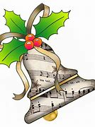

**MUSIC NOTES**

The season of Advent is upon us when we await the coming of our Lord and Savior. This month, we sing familiar carols and hear other seasonal pieces that help prepare our hearts and minds.

We opened the season with one of the most ancient of all Advent hymns, *O Come, O Come Emmanuel.* The tune has been sung for over a millennium, originally intoned by monks in the 8th century. It has been used by scores of composers ever since, including Ottorino Respighi (1879-1936), who quoted the melody in “The Gift of the Magi” movement of his *Three Botticelli Pictures.* The tune also found its way into Samuel Barber’s (1910-1981) *Die Natale.* More recent renditions include U2’s 2009 song, “White As Snow” and Kelly Clarkson’s version in her 2013 holiday album, *Wrapped in Red.*

For the second week of Advent, we will sing hymns that have been around for centuries. *Comfort, Comfort Now My People* dates back to the 16th century. Louis Bourgeois (c. 1510-1559) adapted the tune and published it in *The Genevan Psalter.* This collection of 126 melodies was composed and collected between 1539 and 1562 at the request of John Calvin for the Reformed churches in Geneva, Switzerland. The English version we sing this week was translated by Catherine Winkworth (1827-1878) and published in 1863 in the *Chorale Book for England*.

The closing hymn, *Bereden väg för Herran* (Make Way for the Lord), is a Swedish tune that has been sung since before the 16th century. It was first published in 1697 in a collection called *Then Swenska Psalmboken* (The Swedish Psalm Book). Franz Michael Franzén (1772-1847) paired the popular Swedish tune with the Advent text. The English text was adapted in 1958 by Augustus Nelson (1863-1949), a Swedish immigrant who settled in Minnesota in 1883 and was ordained as a Lutheran minister in 1898.

On the third Sunday of Advent, we will celebrate Mary’s joyful embrace of God choosing her to bear His son. There are scores of settings of the *Magnificat*, and we will hear works by Bach and the man he admired, Dieterich Buxtehude (1637-1707).

The anthem is part of Johann Sebastian Bach’s (1685-1750) setting of the *Magnificat,* which he composed in 1723 for the first Christmas he served as Kapellmeister at the Thomaskirche in Leipzig, Germany. *Quia fecit mihi magna* is written for two bass lines, one vocal and one instrumental. Bach shows, yet again, his mastery of musical counterpoint in the way he weaves the two parts around one another and how he sets the text, particularly *sanctum nomen* (holy name).

Also in the service will be the *Magnificat* set for organ by Buxtehude. Like Bach, Buxtehude was one of the finest organists of his generation. His *Magnificat* is filled with the jubilant energy that leaps out of Mary.

If you’re wondering when the service of Lessons and Carols will take place, look no further than Christmas Eve! We will celebrate the birth of Jesus with familiar carols and music sung by the choir.

We are also grateful to you for your continued support of the music program at First Presbyterian Church. May you have a blessed Advent and Christmas season!

Roger and Kimberlea Daggy

**PRAYER FOR CHRISTMAS**

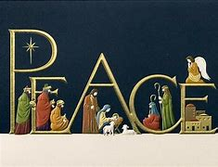

Holy God, all-glorious giver of grace,

you are light, shining in darkness;

you are life, the life of all people.

Fill us with the light and life of Christ,

through whom all things were made,

so that we may be faithful disciples,

bearing witness to your grace and truth;

through Christ, your Word made flesh.

John 1:1-14



**DECEMBER 11TH**

**DUE DATE FOR GIFTS FOR DISCIPLES’ KITCHEN**

**SOCKS, HATS AND GLOVES**



Dear Congregation,

November was spent learning about celebrating the gift of family and friendship. The children did various themed crafts and enjoyed a party before their brief departure for Thanksgiving break.

In December we will learn and celebrate the birth of Jesus and the important role Christmas plays in many families’ lives. On Dec 15th we will be having our annual Christmas Program in the Fellowship Hall. All members are welcome to attend. Seating is assigned so please follow up with Jean Hashagen, Colleen, or me so we can make sure there are enough chairs for everyone. There are 28 children. Small refreshments will be provided. Please let us know if you would be interested in making cookies for the celebration.

The Preschool will be closed from Dec 16th-Jan 2nd. We will resume on the 3rd.

Merry Christmas and God Bless,

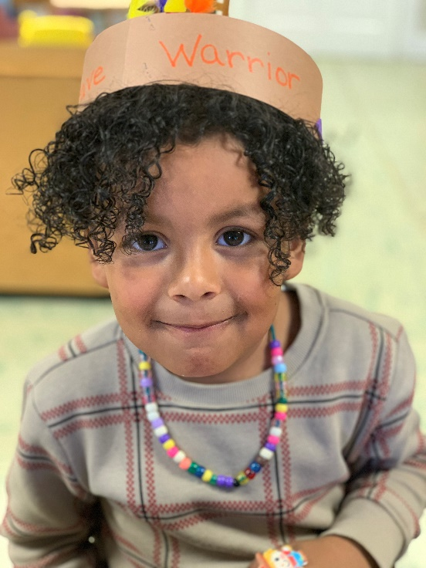Nate Rudin

Director



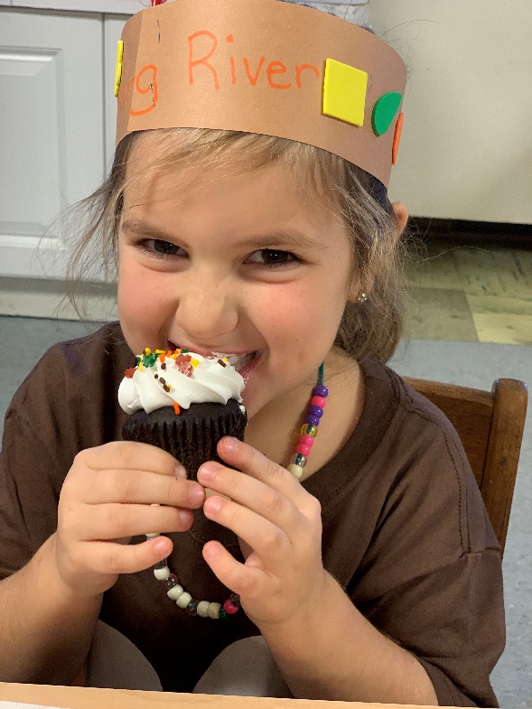

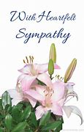

**IN MEMORIUM**

**Michael Stephen Doherty**

**March 9, 1948 - November 12, 2022**

**Liillian Wellner Hryshkanych**

**August 25, 1925 – November 17, 2022**





**Birthdays Anniversary**

**4 Jean Hashagen 28 Mitch & Edie Lawrence**

**10 Burnie Powers**

**12 Connie Sachlis**

**14 Nancy Garber**

**Roger Daggy**

**24 Joyce Tipton**

**27 Hunter Trimble**

**Judy Tomey**

**FIRST FRIDAY CONCERT**

**December 2, 2022**

**Roger Daggy, Organist**

**With light repast**

**DECEMBER GLOBAL HOLIDAYS LIST**

***ST. NICHOLAS DAY – December 5***

St. Nicholas sold all he owned and gave money to the people around him. He devoted his entire life to serving and caring for the sick and suffering people. Numerous countries in Europe celebrate St. Nicholas Day by distributing candies, chocolate letters, small gifts and riddles. Kids put out their shoes with carrots and hay, hoping St. Nicholas will exchange them for small gifts and treats.

***HANUKAH – November 28 to December 6***

This festival is an eight-day celebration. It is known by different names such as Chanukah, Chanukkah, Feast of Dedication, Festival of Lights, Feast of the Maccabees, or Jewish Festival. The common tradition of Hanukah is the ignition of a celebratory menorah. Families of the Jewish faith have menorahs in their homes. Menorahs are ignited with a candle first, and that candle is used to light an additional candle for each night with the singing of Judaic blessings before and during the lighting process.

***ST. LUCIA DAY – December 13***

St. Lucia is also named the festival of lights which is celebrated mainly in Sweden, Norway, and the Swedish-speaking areas of Finland. St. Lucia (St. Lucy), an early Christian martyr, was murdered after she was accused of providing food to Christians living and hiding in the mazes of underground tunnels below the city of Rome. This festival is celebrated as girls walk around dressed customarily with wreaths on their heads and candles. The oldest daughter dressed in white serves coffee and baked goods, such as saffron bread and ginger biscuits, to family and visitors. This winter holiday signifies light in the middle of long, dark Nordic winters.

***WINTER SOLSTICE – December 20-23***

The December solstice celebrates the shortest day north of the equator and the lengthiest day in the south. The December Solstice can occur on the 20th, 21st, 22nd or 23rd. Individuals light bonfires and candles to lure back the sun on this day. Some people can’t wait for the colder weather – snow, skiing and ice skating, curling up by a fire, and the holiday spirit. You will notice a peaceful silence when you walk through the woods – a muffled quiet.

***CHRISTMAS – December 25***

Christmas is a Christian festival commemorated on the birth of Jesus Christ, the son of God. People celebrate with parties, exchanging gifts, and attending church services. Children receive gifts from Santa Claus or Father Christmas. Christmas Day is a public holiday in Australia, Canada, the UK, and the United States.

***KWANZAA – December 26***

This 7-day festival of African-American culture and heritage begins December 26 and ends January 1. Millions of individuals in America and worldwide celebrate the spiritual holiday, created in 1966, by wearing traditional African clothing. They decorate their houses with fruits and vegetables and light a kinara (candle holder).

***OSAKA – December 31***

Osaka is celebrated in Japanese culture and is also named Japanese New Year. People cleanse their homes and eliminate last year’s clutter by cleaning from top to bottom. People plan a feast with their friends and family with some traditional Japanese foods.

***NEW YEAR’S EVE – December 31***

This date marks the very last day of the year in the Gregorian calendar and is one of the largest global holidays. Common traditions include parties at the office, eating special New Year’s foods, and creating resolutions for the new year. In London individuals try to book dinner and music at a restaurant to watch the New Year’s Eve fireworks. In the U.S. one big attraction is midnight activity at Times Square and the ball drop, a tradition since 1907. Individuals worldwide celebrate New Year’s Eve to bid goodbye to the year that ends and welcome the following year. *(Where will YOU be?)*

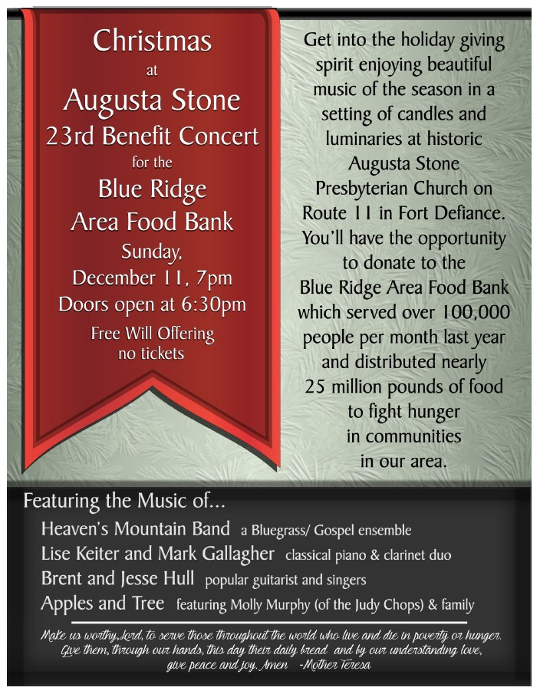



**Mailing Address**

P. O. Box 877

Waynesboro, VA 22980

**Phone**

540.949.8366

**Fax**

540.949.5750

**E-mail**

church@firstpresway.com

**Website**

www.firstpresway.org

**Church Office Hours**

Monday-Wednesday

8 a.m. – 2:30 p.m.

Thursday

8 a.m. – 4:30 p.m.

**Interim Pastor**

Rev. Patrick S. Pettit

pspettit@gmail.com

**Administrative Assistant**

Mrs. Colleen Cash

ccash@firstpresway.com

**Preschool Director**

Mr. Nate Rudin

preschool@firstpresway.com

**Director of Music**

Mr. Roger Daggy

[firstpreswaymusic@gmail.com](mailto:firstpreswaymusic@gmail.com)

**Music Associate**

Mrs. Kimberlea Daggy

[firstpreswaymusic@gmail.com](mailto:firstpreswaymusic@gmail.com)

**Audio/Visual Technician**

Mr. Craig Cavanaugh

**Maintenance Technician**

Mr. Michael Griffith

**Thursday, December 1**

6-8 PM Food Bank

7-9 PM Symphony – Sanctuary

**Friday, December 2**

12:15 PM First Friday Organ Concert with Lite Lunch

**Saturday, December**

12-3 PM Sarah Braverman Recital Practice

**Sunday, December 4**

11 AM Worship Service

**Thursday, December 8**

2-4 PM Food Bank

**Saturday, December 10**

3 PM Braverman Students Concert

**Sunday, December 11**

11 AM Worship Service

**Tuesday, December 13**

Disciples’ Kitchen

2:30 PM Session Room 212

**Thursday, December 15**

6-8 PM Food Bank

6:30 PM Preschool Christmas Program

**Sunday, December 18**

11AM Worship Service

**Thursday, December 22**

2-4 PM Food Bank

**Saturday, December 24**

7 PM Candlelight Service

**Sunday, December 25**

Virtual Worship

**CHRISTMAS EVE CANDLELIGHT SERVICE**

**Lessons and Carols**

**Saturday night, 7:00 p.m. in-person**

**CHRISTMAS DAY SERVICE**

**Sunday 11:00 online only**