First Presbyterian Church, Waynesboro, VA
First Presbyterian Church of Waynesboro is a community-minded
congregation living out the love of Christ as we serve one another with
humility, gentleness, and patience through God’s grace.

THE COLUMNS

February 2023, Volume 61, Issue 2

From the Interim
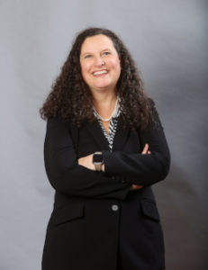
As January gives way to February, our discussions with Fishburne have picked up steam once again. The session has retained Franchesca Fede Gomez as counsel, and she is now working with her counterpart from Fishburne to draft a contract based on our Memorandum of Understanding. A graduate of the University of Virginia, Ms. Gomez earned her law degree from the George Mason University School of Law. She has been a shareholder (Partner) at Allen & Carwile since 2007, with her practice concentrating on residential and commercial real estate transactions. Ms. Gomez also serves as Commissioner of Accounts for the City of Waynesboro, a position she has held since 2019.

Our to do list includes:

Title Search. This has been conducted, and indicates there are no clauses or other impediments connected to the deed for the church property.

Property Inspection. We are scheduling an inspection of the church building. This will provide both parties with an accurate view of its condition, and will serve as the basis for any pre transfer repairs. Three particular areas which we know need attention are: the air conditioning system; a small, intermittent roof leak in the sanctuary; and repairs to the sanctuary ceiling and subsequent repainting.

Contract. Once the inspection is completed, we will enter into a contract with Fishburne. This contract will be presented to the Presbytery of Shenandoah for their concurrence - since all church property is held in trust by the congregation for the Presbyterian Church (U.S.A.), it is the responsibility of presbytery to act as the agent for the denomination and approve any transfer of church property.

Once all this is done, we can turn our attention to WHAT COMES NEXT. Like Double Jeopardy, this will be a time when things can really change, and I for one can't wait to start the conversations. After all, that what transition is all about.

Music Notes for February

February may be the shortest month of the year, but in it, one season ends and another begins. Epiphany is celebrated for most of the month until 22 February, Ash Wednesday. As always, the music for each Sunday is based on the Scripture readings for the day.

For the first Sunday of February, the choir will sing a fairly recent setting of The Beatitudes (Matthew 5: 3-12). This musical arrangement of Jesus’ statement of blessings was first heard in the Russian Orthodox church back in the 10th century, part of the Orthodox Divine Liturgy. In 1983, Richard Proulx (1937-2010) created the setting that will be heard on 5 February. It is one of more than 300 pieces composed or arranged by Proulx. Although most of his compositions are sacred, particularly choral music, he wrote quite a few secular pieces, including two operas and a theme song for Union Pacific Railroad in 1971.

One of the Scripture readings for the final Sunday of Epiphany is Psalm 119: 33-40, which begins with “Teach me, o Lord, the way of Thy statutes, and I shall keep it to the end.” These words have been set to music by countless composers over the centuries, and on 19 February, the choir will sing a setting by David Hurd (b. 1950). Dr. Hurd served as Professor of Sacred Music and Director of Chapel Music at General Theological Seminary in New York City for 39 years. He is currently Director of Music/Organist at the Church of St. Mary the Virgin in Times Square. Hurd is also an active concert organist. Teach Me, O Lord is one of over 100 choral and organ compositions published by Hurd.

Ash Wednesday falls on 22 February, and with it, the beginning of Lent. We will walk with Jesus during his Lenten journey, and the music throughout the season will reflect the trials and tribulations of our Lord.

February marks the return of the First Friday Organ Programs and Light Luncheons. Please come and listen to Roger play a program at 12:15 on Friday 3 February, followed by a delightful repast kindly provided by Susan Johnson. 2023 is a banner year for FPC’s 1893 Woodberry and Harris pipe organ. We will celebrate the organ’s 130th anniversary throughout the year with various programs. Stay tuned!

With gratitude,

Roger and Kimberlea Daggy

SESSION HIGHLIGHTS

Session held a Stated Meeting on January 10, 2023.
Work with Fishburne Military School continues. FPC has hired Fran Gomez of Allen & Carwile as its lawyer who will be conducting a title search. We need to have chats with our congregation on “What is important in our future?”
Lenten Luncheons were discussed. Instead of resuming the pre-pandemic schedule of lunches with five other churches, we will have simple lunches on our own in the Barksdale Room. Bible Study will be led by Rev. Pettit on Wednesdays March 1 - 29. Members of other churches would be welcome.
The Mission/Outreach reported is printed below.
Rev. Rachel Hamburger led worship on January 4.
Session approved a “Better Together” Pulpit Swap for January 29. Rev. Pettit will preach at Hermitage PC and Rev. Dr. Tommy Carrico from Finley Memorial PC will preach at First Pres.
The next Stated Meeting will be held on February 14, 2023.

FPC MISSION/OUTREACH REPORT

- Ordered and received food from Blue Ridge Area Food Bank 12/6 and 12/20. Volunteers assembled 20 pantry boxes for each order.
- Maintained temperature logs for refrigerators and freezers.
- Food Bank held 12/8 and 12/20.
- Updated weekly shopping list for extra options.
- Served 56 meals at Disciples’ Kitchen 12/13.
- Nativity books were given to our preschoolers. Extra books were sent to Westminster PC where they were distributed on Christmas Eve.
- Completed pantry inventory and report: Served 51 individuals in December. Numbers are down reflecting poor turn-out for evening hours and ice storms.
- Number of individuals served during 2022 was 1390.
- Collecting donations of individually wrapped bath size bars of soap during January for the “Disaster Room”. --Cynthia Hoover, Chair

Birthdays

2 Terry Crickenberger
5 Anne Johnson
7 Cathy Cunningham Nancy Snider
16 Sandi Henderson’
18 Phyllis Poluito Valerie Purcell
27 Arnett Tomey

Liturgists

5 Cynthia Hoover

12 Joan Berry

19 Bill Pannill

26 Betsy Ruehl

FIRST FRIDAY CONCERT
February 3, 12:15 in the Sanctuary
Followed by light repast in Barksdale Room

ASH WEDNESDAY SERVICE
February 22, 12 noon in the Sanctuary

REQUESTED
FEBRUARY DONATIONS FOR ‘DISASTER ROOM’
Band-aids, emery boards and nail clippers
FEBRUARY DONATIONS FOR FPC FOOD BANK
Chicken Noodle Soup

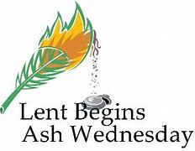

ASH WEDNESDAY
Ash Wednesday begins the season of Lent with a public act of confession and contrition. Acknowledging that all have sinned and fallen short of the glory of God, we stand in solidarity as fellow creatures before our Creator, acutely aware of our mortality. In the face of our transgressors, we pledge ourselves anew to live unto God’s Word in Jesus Christ, the eternal Word that remains forever.
Historically, Ash Wednesday was a time when penitents were presented for church discipline during Lent,
culminating in reconciliation on Maundy Thursday. Ash Wednesday is also the occasion when would-be disciples of Christ, known as catechumens, were enrolled in the catechumenate, a special time of learning the basics of the faith in preparation for baptism on Easter Sunday or during the Easter Vigil.

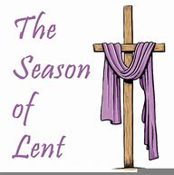

A TIME TO TURN
The Lenten journey from the ashes of death to resurrected life begins on the first day of Lent, Ash Wednesday, which signifies a time to turn around, to change directions, to repent.
This first day of Lent reminds us that unless we are willing to die to our old selves, we cannot be raised to new life with Christ. The first step of this journey calls us to acknowledge and confront our mortality, individually and corporately. In many traditions this is symbolized through the imposition of ashes, a cross on one’s forehead. On Ash Wednesday we begin our Lenten trek through the desert toward Easter.
Trusting in the “accomplished fact” of Christ’s resurrection, we listen for the Word of God in the time-honored stories of the church’s Lenten journey. We follow Jesus into the wilderness, resist temptation, fast, and proceed “on the way” to Jerusalem and the cross. Our Lenten journey is one of mentanoia (“turning around”), of changing directions from self-serving toward the self-giving way of the cross.

(Both articles from Presbyterian Church (U.S.A.) Presbyterian Mission website)

IT’S STILL A NEW YEAR

“I am about to do a new thing; now it springs forth, do you not perceive it? I will make a way in the wilderness and rivers in the desert.” Isaiah 43:19, NRVSVue

Each January we begin a new year and with it comes a new calendar. What a sight to see, all those empty blocks just waiting to be filled with appointments and reminders. In no time at all, each month becomes a messy page as we enter information and then cross it off as it changes or erase appointments as they are cancelled.
Our lives are like that new calendar. We are fresh and new each day, just waiting for God to start writing on our lives. Unfortunately, we make mistakes, called sin. This is when things get messy.
The good news is that God gives us a way to clean up those messy places. It is called repentance. Jesus, the son of God, brought salvation to the world for those who repent from their sin. Jesus teaches us that when we confess our sin with humble and contrite hearts, in repentance, we receive the gift of forgiveness. All those mistakes on our calendar pages are cleaned up.
Those acts of repentance and confession are not just for the beginning of a new year. Jesus says that we should be mindful of those things we do which separate us from God and confess whenever it is needed.
As we listen to the culture around us say that 2023 is a new year with all sorts of amazing possibilities, please know this; every day is a new day with astonishing possibilities through Jesus Christ our Lord. Every day is an opportunity to look for God in our lives and listen for the Holy Spirit to give us direction. Each day brings with it the chance to experience God’s salvation through Jesus Christ.
--Pastor Susi, First Presbyterian Church, Covington, VA

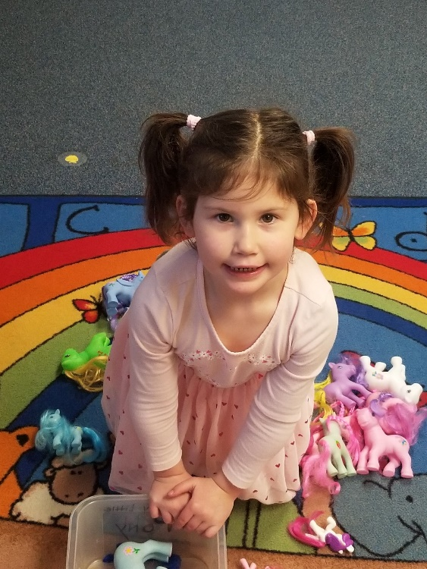

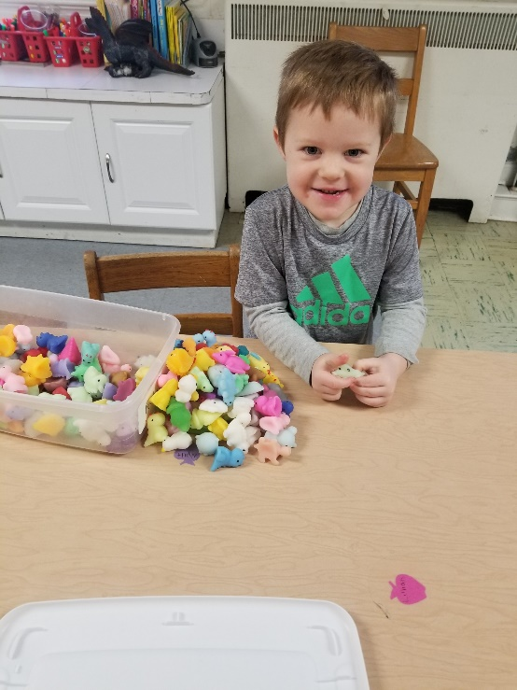

Mailing Address
P. O. Box 877
Waynesboro, VA 22980
Phone
540.949.8366
Fax
540.949.5750
E-mail
church@firstpresway.com
Website
www.firstpresway.org

Church Office Hours
Monday-Wednesday
8 a.m. – 2:30 p.m.
Thursday
8 a.m. – 4:30 p.m.

Interim Pastor
Rev. Patrick S. Pettit
pspettit@gmail.com

Administrative Assistant
Mrs. Colleen Cash
ccash@firstpresway.com

Preschool Director
Mr. Nate Rudin
preschool@firstpresway.com

Director of Music
Mr. Roger Daggy
firstpreswaymusic@gmail.com

Music Associate
Mrs. Kimberlea Daggy
firstpreswaymusic@gmail.com

Audio/Visual Technician
Mr. Craig Cavanaugh

Maintenance Technician
Mr. Michael Griffith

Thursday, February 2
6-8 PM Food Bank
Friday, February 3
12:15 PM First Friday Concert/ Lite Lunch
Sunday, February 5
11 AM Worship Service
Tuesday, February 7
7-9 PM Symphony Practice- Fellowship Hall
Thursday, February 9
2-4 PM Food Bank
Sunday, February 12
11 AM Worship Service
Tuesday, February 14
2:30 PM Session Meeting Room, Room 212
7-9 PM Symphony Practice Fellowship Hall
Thursday, February 16
6-8 PM Food Bank
Sunday, February 19
11 AM Worship Service
Tuesday, February 21
7-9 PM Symphony Practice- Fellowship Hall
Wednesday, February 22
12 PM Ash Wednesday Service
Thursday, February 23
2-4 PM Food Bank
Sunday, February 26
11 AM Worship Service
3 PM Symphony Concert

