FIRST SUNDAY OF CHRISTMAS January 1, 2023

PRELUDE Noël IX, Sur les Flûtes d’Aquin (1694-1772)

WELCOME & ANNOUNCEMENTS

INTROIT Angels, We Have Heard on High Gloria

CALL TO WORSHIP
Leader: The voice of the Lord calls to gather this day.
People: This is the voice of power; a voice that breaks cedars and shakes
the wilderness.
Leader: This is a voice that flashes forth with flames of fire; a voice
that causes the oaks to whirl.
People: This voice is the voice of our Lord who calls us to worship
in splendor and glory.
Leader: Let us worship God!

*OPENING HYMN 152 What Star is This, with Beams so Bright Puer nobis nascitur

CALL TO CONFESSION

PRAYER OF CONFESSION
Gracious God, at Creation, you separated light from darkness and called
it good. We are afraid to look closely at our lives, and so we prefer the dark.
And yet, even now, we crave the light only You can provide. Forgive us,
Lord, this and all our sin. Dispel the darkness in which we hide, and bring
us into the light as your beloved children, with whom you are well pleased.

SILENT PRAYER

ASSURANCE OF PARDON

*GLORIA PATRI #581 Greatorex

FIRST SCRIPTURE LESSON Isaiah 60:1-3,19-22 p. 602

ANTHEM Break Forth, O Beauteous Heavenly Light Schop (1590-1644)
Bach (1685-1750)
(text can be found in hymn 130)

SECOND SCRIPTURE LESSON John 8:12 p. 870

SERMON Light for the New Year Rev. Rachel Hamburger

*AFFIRMATION OF FAITH The Apostles’ Creed Hymnal p. 35

THE LORD’S SUPPER
Invitation
Great Thanksgiving
Communion of the People

PASTORAL PRAYER

*CLOSING HYMN 119 Hark, the Herald Angels Sing Mendelssohn

*CHARGE & BENEDICTION

POSTLUDE From Heaven Above to Earth I Come, BWV 606 Bach

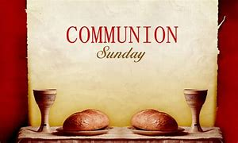

*PLEASE STAND IF ABLE.

Link for this week’s service is: https://youtube.com/watch?v=yXfWwS97ZZs&feature=shares

Audio aids are available for your convenience.
Please be aware that they do not function until after the service begins.

Legacy at North Augusta: Mary June Cook

UVA: Beth Crickenberger

The Colonnades’: Bird Heuchert

Regency at Augusta: Edie Lawrence

Shenandoah Nursing Home: Rubye Schwab, Nancy Garber

Home: Dick Huff, Mary Ultee, Mary Ann Maupin,
Walt Flora, Warner & Linda Sandquist, Ruth and Lewis Kelley.

Friends and Family: Erwin Berry (Joan), Bill Bromley, Ron Buckalew,
Jean Custen, Jerry Hughes, Sally McNeel, Bill Metzel (Joyce Tipton),
Col. Stuart Roberts (Mark Henderson), Paul Watts (Colleen Cash).

Military: Carson Craig

We welcome back to our Pulpit Rev. Rachel Hamburger, and thank her for
supplying today’s message.

Offerings must be received by Jan 8, 2023, to be applied to the 2022 year.
Please make a note as to which year you would like.

FIRST PRESBYTERIAN CHURCH
WAYNESBORO, VIRGINIA

A community-minded congregation living out the love of Christ as we serve one another with humility, gentleness, and patience through God’s grace.

January 1, 2023 11:00 AM

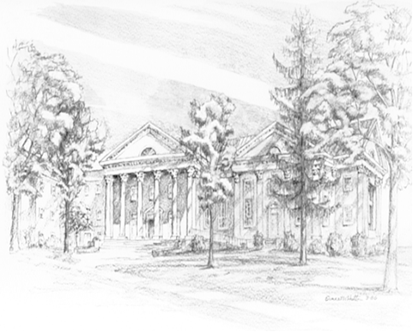

P.O. Box 877
249 South Wayne Avenue
Waynesboro, Virginia
(540) 949-8366
Church Website: www.firstpresway.org
Preschool Website: www.firstprespre.org
Email: church@firstpresway.com

