Second Sunday after Epiphany January 15, 2023

PRELUDE Come, Holy Spirit BuxWV 199 Buxtehude (1637-1707)

WELCOME & ANNOUNCEMENTS

INTROIT Spirit of God, Descend Upon My Heart Cook Atkinson (1841-1896)

CALL TO WORSHIP
Leader: Here is the servant of God, a light to all the nations.
People: Come and see the Messiah, the Lord.
Leader: Here is the Lamb of God, who takes away the sin of the world.
People: Come and see the Messiah, the Lord.
Leader: Let us worship God.

MORNING PRAYER

OPENING HYMN 282 Come Down, O Love Divine Down Ampney

CALL TO CONFESSION

PRAYER OF CONFESSION
God of glory, we confess that we do not seek your face. We labor for worldly things and lack in spiritual gifts. We sacrifice much for false idols and forsake the way of your Son. Forgive us, Lord, this and all our sin. Teach us, as disciples, to show the wonder of your love in Jesus Christ our Lord.

SILENT PRAYER

ASSURANCE OF PARDON

*GLORIA PATRI 581 Greatorex

FIRST SCRIPTURE READING Isaiah 49:1-7 p. 592

SPECIAL MUSIC Divine Spirits Boëly (1785-1858)

SECOND SCRIPTURE READING John 1:29-42 p. 862

SERMON Come and see… Patrick Pettit, Interim Pastor

*AFFIRMATION OF FAITH The Apostles' Creed Hymnal p. 35

PRAYERS OF THE PEOPLE & THE LORD’S PRAYER

*CLOSING HYMN 292 Come Holy Spirit, Heavenly Dove St Agnes

*CHARGE and BENEDICTION

POSTLUDE Come, Holy Spirit BWV 651 Bach (1685-1750)

*Please stand if able

Today’s link is: https://youtube.com/watch?v=KFh5qS2nNlo&feature=shares

Hearing devices are available for your convenience.
Please be aware that they do not function until after the service begins.

The Legacy: Mary June Cook

UVA: Beth Crickenberger

Regency at Augusta: Edie Lawrence

Brightview Baldwin Park: Walt Flora

Shenandoah Nursing Home: Rubye Schwab, Nancy Garber

Home: Dick Huff, Mary Ultee, Mary Ann Maupin, Bird Heuchert
Warner & Linda Sandquist, Ruth and Lewis Kelley.

Friends and Family: Erwin Berry (Joan), Bill Bromley, Ron Buckalew, Jean Custen,
Jerry Hughes, Sally McNeel, Bill Metzel (Joyce Tipton),
Col. Stuart Roberts (Mark Henderson), Paul Watts (Colleen Cash).

Military: Carson Craig

Next Sunday, January 22, we will have a simple meal after Worship. Please join us in the Barksdale Room.

Disaster Supplies: Single wrapped bars of soap for January

FIRST PRESBYTERIAN CHURCH
WAYNESBORO, VIRGINIA

A community-minded congregation living out the love of Christ as we serve one another with humility, gentleness, and patience through God’s grace.

January 15, 2023 11:00 AM

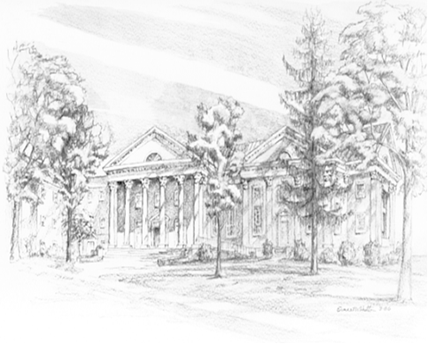

P.O. Box 877
249 South Wayne Avenue
Waynesboro, Virginia
(540) 949-8366
Church Website: www.firstpresway.org
Preschool Website: www.firstprespre.org
Email: church@firstpresway.com

