Third Sunday after Epiphany January 22, 2023

PRELUDE Melodia Op. 129, no. 4 Reger (1873-1916)

WELCOME & ANNOUNCEMENTS

INTROIT Alleluia Milburn (b. 1963)

CALL TO WORSHIP
Leader: Jesus said: Repent, for the realm of heaven has come near.
People: The Lord is my light and salvation; whom shall I fear?
Leader: Jesus said: Follow me, and I will make you fish for people.
People: My heart says: Go, and seek his face.
Leader: Let us worship God.

MORNING PRAYER

OPENING HYMN 12 Immortal, Invisible, God Only Wise St. Denio

CALL TO CONFESSION

PRAYER OF CONFESSION
God of glory, we confess we have not sought your face. You call us to follow Jesus, but we are afraid to walk in faith. You call us to be one in Christ, but we continue to quarrel and fight. Forgive us, Lord, this and all our sin. As you have sent a Savior to us, send us out as witnesses: to show the wonder of your love in Jesus Christ our Lord.

SILENT PRAYER

ASSURANCE OF PARDON

*GLORIA PATRI 581 Greatorex

FIRST SCRIPTURE READING Psalm 27:1, 4-9 p. 437

ANTHEM Steal Away to Jesus Willis (1820-1880)
(text can be found in hymn 358)

SECOND SCRIPTURE READING Matthew 4:12-23 p. 785

SERMON Called… Patrick Pettit, Interim Pastor

*AFFIRMATION OF FAITH The Apostles' Creed Hymnal p. 35

PRAYERS OF THE PEOPLE & THE LORD’S PRAYER

*CLOSING HYMN 738 O Master, Let Me Walk with Thee Maryton

*CHARGE and BENEDICTION

POSTLUDE Intermezzo Op. 59, no. 3 Reger

*Please stand if able

Today’s link is: https://youtube.com/watch?v=_Fqwp0J0XW4&feature=shares

Hearing devices are available for your convenience.
Please be aware that they do not function until after the service begins.

The Legacy: Mary June Cook

UVA: Beth Crickenberger

Regency at Augusta: Edie Lawrence

Brightview Baldwin Park: Walt Flora

Shenandoah Nursing Home: Rubye Schwab, Nancy Garber

Home: Dick Huff, Mary Ultee, Mary Ann Maupin, Bird Heuchert
Warner & Linda Sandquist, Ruth and Lewis Kelley.

Friends and Family: Erwin Berry (Joan), Bill Bromley, Ron Buckalew, Jean Custen,
Jerry Hughes, Sally McNeel, Bill Metzel (Joyce Tipton),
Col. Stuart Roberts (Mark Henderson), Paul Watts (Colleen Cash).

Military: Carson Craig

Please join us in the Barksdale Room after Worship for lunch.

Disaster Supplies: Single wrapped bars of soap for January

On January 29, 2023, the following churches will participate in a pulpit swap during their Sunday morning worship services.
First PC welcomes Rev. Dr. Tommy Carrico from Finley Memorial PC
Hermitage Presbyterian Church welcomes Rev. Patrick Pettit from First PC
Second Presbyterian Church welcomes Rev. Jaci Smith Patman from Hermitage PC
Westminster Presbyterian Church welcomes Rev. Cait Hoy from Second PC
Finley Memorial Presbyterian Church welcomes Rev. April H. Cranford from Westminster PC

FIRST PRESBYTERIAN CHURCH
WAYNESBORO, VIRGINIA

A community-minded congregation living out the love of Christ as we serve one another with humility, gentleness, and patience through God’s grace.

January 22, 2023 11:00 AM

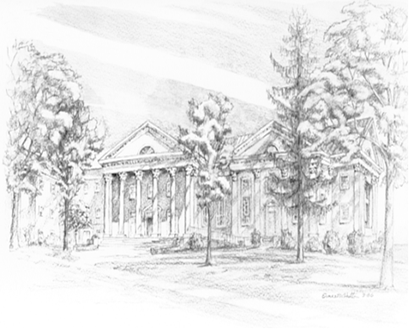

P.O. Box 877
249 South Wayne Avenue
Waynesboro, Virginia
(540) 949-8366
Church Website: www.firstpresway.org
Preschool Website: www.firstprespre.org
Email: church@firstpresway.com

