Fourth Sunday after Epiphany January 29, 2023

PRELUDE Sonata in B-flat, Op. 65, no 4: Andante religioso
Mendelssohn (1809-1847)

WELCOME & ANNOUNCEMENTS

INTROIT Now Enter In Hebble (1934-2020)

CALL TO WORSHIP
Leader: With what shall we come before the Lord, to bow before the Most High?
People: Blessed are the poor in spirit, for theirs is the kingdom of heaven.
Leader: Who can abide in the temple of the Lord, or stand in God's presence?
People: Blessed are the pure in heart, for they will see God.
Leader: Let us worship God.

MORNING PRAYER

OPENING HYMN 396 Brethren, We Have Met to Worship Holy Manna

CALL TO CONFESSION

PRAYER OF CONFESSION
God of glory, we confess we have not sought your face. We demand signs and desire wisdom; yet the cross of Christ is all we need. We boast of our strengths; yet the weakness of Christ has saved us. Forgive us, Lord, this and all our sin. Teach us what is truly wise and good and blessed: empower us to show the wonder of your love in Jesus Christ our Lord.

SILENT PRAYER

ASSURANCE OF PARDON

*GLORIA PATRI 581 Greatorex

PRAYER FOR ILLUMINATION

ANTHEM For All the Faithful Women
Finnish folk tune, arr. Evans (1874-1948)
(text can be found in hymn 324)

FIRST SCRIPTURE READING Matthew 1:1-17 p. 783

SECOND SCRIPTURE READING Ruth 1:1-18 p. 210

SERMON Your People Are My People
Your God Is My God Rev. Dr. Tommy Carrico

*AFFIRMATION OF FAITH The Apostles' Creed Hymnal p. 35

PRAYERS OF THE PEOPLE & THE LORD’S PRAYER

*CLOSING HYMN 610 O For A Thousand Tongues to Sing Azmon

*CHARGE and BENEDICTION

POSTLUDE Sonata in B-flat, Op. 65, no 4: Allegro con brio Mendelsohn

*Please stand if able

Today’s link is: https://youtube.com/watch?v=0qQrKMq4ty4&feature=shares

Hearing devices are available for your convenience.
Please be aware that they do not function until after the service begins.

The Legacy: Mary June Cook

Encompass at Fontaine : Beth Crickenberger

Regency at Augusta: Edie Lawrence

Brightview Baldwin Park: Walt Flora

Shenandoah Nursing Home: Rubye Schwab, Nancy Garber

Home: Dick Huff, Mary Ultee, Mary Ann Maupin, Bird Heuchert,
Warner & Linda Sandquist, Ruth and Lewis Kelley.

Friends and Family: Erwin Berry (Joan), Bill Bromley, Ron Buckalew, Jean Custen,
Jerry Hughes, Sally McNeel, Bill Metzel (Joyce Tipton),
Col. Stuart Roberts (Mark Henderson), Paul Watts (Colleen Cash).

Military: Carson Craig

We welcome Rev. Dr. Tommy Carrico, pastor from Finley Presbyterian in Stuarts Draft,
And thank him for sharing worship with us today.

February Disaster Supplies : nail clippers, emery boards, band aids

Food Bank : chicken noodle soup

FIRST PRESBYTERIAN CHURCH
WAYNESBORO, VIRGINIA

A community-minded congregation living out the love of Christ as we serve one another with humility, gentleness, and patience through God’s grace.

January 29, 2023 11:00 AM

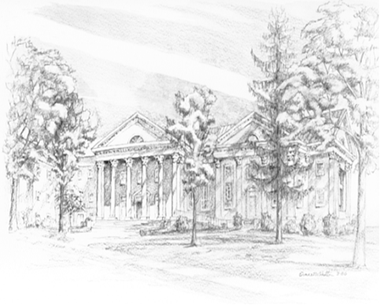

P.O. Box 877
249 South Wayne Avenue
Waynesboro, Virginia
(540) 949-8366
Church Website: www.firstpresway.org
Preschool Website: www.firstprespre.org
Email: church@firstpresway.com

