First Presbyterian Church, Waynesboro, VA
First Presbyterian Church of Waynesboro is a community-minded
congregation living out the love of Christ as we serve one another with
humility, gentleness, and patience through God’s grace.

THE COLUMNS

March 2023, Volume 61, Issue 3

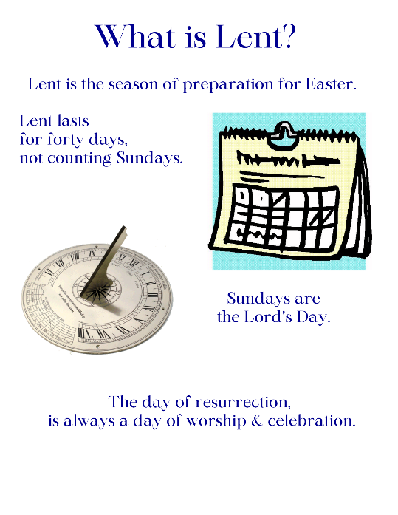
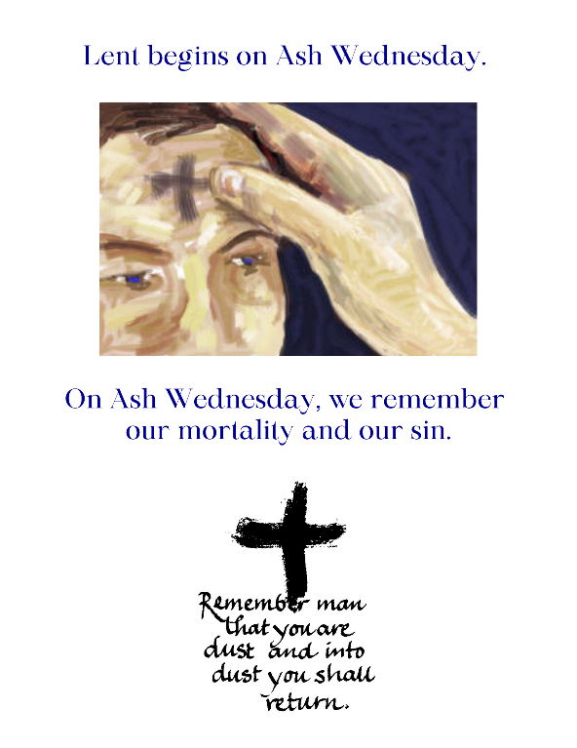

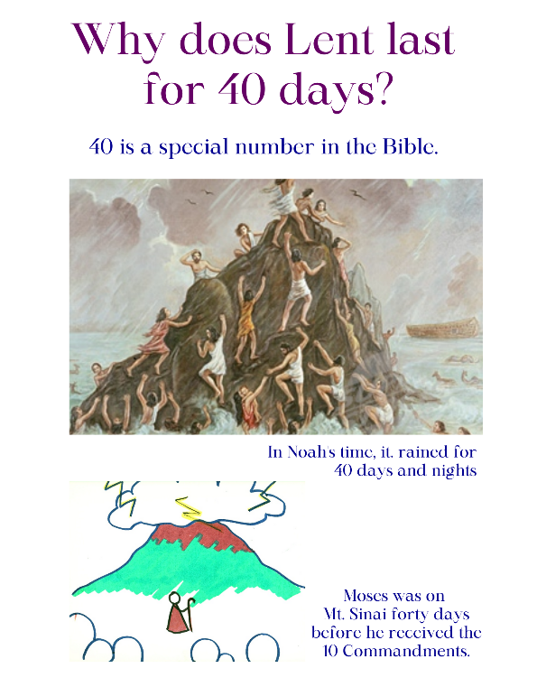

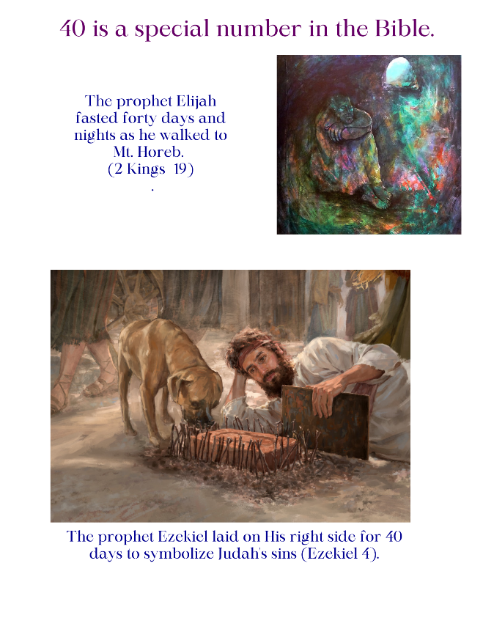
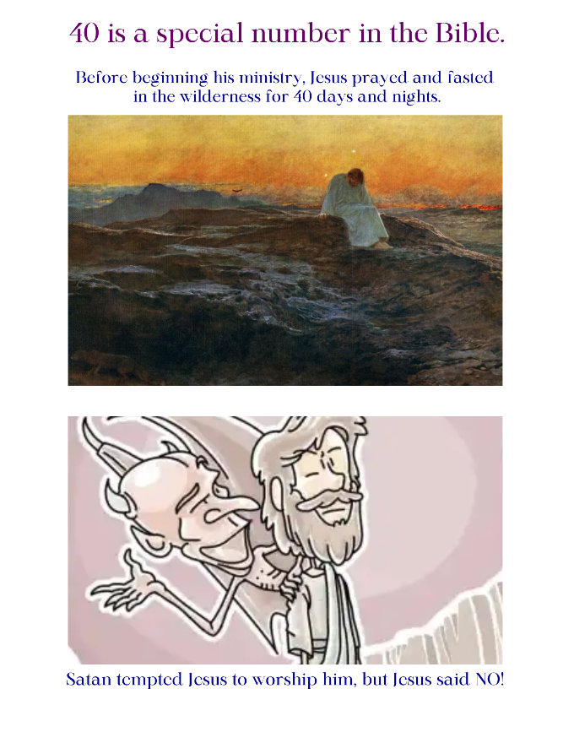

MUSIC NOTES

We have entered the time of penitence, when we reflect on our lives and aspire to live in the way Jesus has called us to do so, by loving God and loving others. The music for this time of Lent reflects our collective journey. During this season, the congregation will sing the introit, Lord Have Mercy, composed by Swee Hong Lim (b. 1963). We have sung this setting of the Kyrie many times during the last few years. Each Sunday service in Lent will open with this call for mercy, sung twice by the entire congregation.

The season of Lent also brings some of the most famous passages in all of Scripture. The lessons for first Sunday of March will be Psalm 121 and John 3: 1-17, including the 16th chapter, which reads, “For God so loved the world that He gave His only begotten Son, that who so believeth in Him should have everlasting life.” The hymns for 5 March will reflect the Scripture readings: I to the Hills Will Lift My Eyes and At the Name of Jesus.

Psalm 23 will be read on the third Sunday of March, and we will sing two hymns based on the text, both of which are based on folk tunes. The King of Love My Shepherd Is is set to the tune St. Columba, named for the Irish saint who brought Irish Christianity to Scotland. The melody was one of many Irish tunes collected by George Petrie (1789-1866) and included in various publications, such as Hymns Ancient and Modern in 1868 and The English Hymnal of 1906. My Shepherd Will Supply My Need comes from an anonymous Appalachian melody. The tune, initially known as Hopewell, first appeared in 1828 in The Beauties of Harmony. A few years later, the tune was renamed Resignation for the 1832 publication Genuine Church Music.

For the final Sunday of March, we welcome flutist Carolyn Gill, who also plays Irish flute, tin whistle and bagpipes! She is an Air Force veteran and currently plays with the Band of the South, one of five Air National Guard Bands. Gill also plays with the Albemarle Pipes and Drums and teaches flute and piano at Valley Music Academy. We look forward to hearing Carolyn play on Sunday 26 March.

In other news, another First Friday is fast approaching! Please plan to hear Roger play a recital on FPC’s 130-year-old Woodberry and Harris pipe organ on Friday 3 March at 12:15, followed by a light luncheon generously provided by Susan Johnson. All are welcome!

Later this month, Roger will join other musicians for the annual Bach Around the Clock celebration at Christ Lutheran Church in Staunton. On Saturday 18 March, concerts will be played all day, from 9a to 9p, by musicians from the Heifetz Institute (ensembles from which play every summer at FPC) as well as several organists, including members of the Charlottesville-Albemarle chapter of the American Guild of Organists, of which Roger is a member. The chapter’s recital is currently scheduled for 3p.

Thank you for your continued support of the music program at First Presbyterian Church!

Blessings,
Roger and Kimberlea Daggy

SESSION HIGHLIGHTS

Session held a Stated Meeting on February 14, 2023.
The Clerk submitted the Church Information Form and 2022 Statistical Report online to Presbytery.
Elder Mike Cunningham was elected Commissioner to the online Shenandoah Presbytery Meeting on February 28.
A Job Description (Administrative Assistant, Treasurer and Physical Plant Supervisor) needs to be created for a Church Administrator. This job description would reflect the way those jobs at the church have been handled the past several years.
Session elected Colleen Cash Treasurer.
Preschool – Our current 2-year-old room must be brought up to the latest building code. Session toured the ground floor and discussion ensued.
Session approved an Ash Wednesday Service for noon February 22 and a Maundy Thursday service for noon on April 6.
Session approved the request of Grace Episcopal Church to use church facilities for the Installation of a new Bishop on October 21.
Session approved the One Great Hour of Sharing Offering for Easter Sunday.
The Annual Congregational Meeting will be held sometime in June.
The Mission/Outreach report is printed elsewhere in The Columns.
The next Session meeting will be held (change) on Monday, March 13.
All Session meetings are opened and closed with prayer.
--Betsy Ruehl

LENTEN BIBLE STUDY
On the Parables
March 1, 8, 15, 22, 29
Barksdale Room – noon
Brown bag lunch
Invite your friends!

ONE GREAT HOUR OF SHARING OFFERING
Easter Sunday, April l6, 2023

Around the world, millions of people lack access to sustainable food sources, clean water, sanitation, education and opportunity. The three programs supported by One Great Hour of Sharing – Presbyterian Disaster Assistance, the Presbyterian Hunger Program, and Self-Development of People – all work in different ways to serve individuals and communities in need. From initial disaster response to ongoing community development, their work fits together to provide people with safety, sustenance and hope.
Received on Easter Sunday each gift helps to improve the lives of people in these challenging situations. The Offering provides us a way to share God’s love with our neighbors in need. In fact, One Great Hour of Sharing is the single, largest way that Presbyterians come together every year for a better world.
Offerings, so designated, may be sent to the Church Office at any time.

MISSION/OUTREACH REPORT

- Ordered and received food from Blue Ridge Area Food Bank 1/10and 1/24. Volunteers assembled 20 pantry boxes for each order.
- Maintained temperature logs for refrigerators ad freezers. Defrosted new refrigerator. Cleaned all refrigerators.
- Food Bank held January 12, 19 and 26.
- Purchased eggs, bread, margarine for Food Bank weekly.
- Updated weekly shopping list for extra options.
- Attended webinar: Partner and Innovation Grants
- Completed pantry inventory and report: Served 82 individuals in January.
- Exploring moving the panty to 501c3 designation which would open up more grant possibilities to sustain the pantry. Grant funds available to cover legal expenses.
- Collecting band-aids, emery boards, clippers in February. Collecting chicken noodle soup for Food Bank during February.
- Discussing expanding Food Bank to students in need at WHS.
- Will serve at Disciples’ Kitchen March 28.
- MEALS FOR WARM SHELTER –
March 14 – evening snacks, water, goldfish. March 15 – Breakfast (boxed), Lunch (boxed), Dinner served at Expo.
Breakfast – dry cereal, milk, breakfast bar, gogurt (no, not a typo), coffee
Lunch – ham/cheese/lettuce, turkey/cheese/lettuce, peanut butter/jelly sandwiches; fruit cup, bagged chips, packaged cookies, juice/water
Dinner – Baked ziti, dinner roll, fruit cup, brownie, tea/lemonade
--Cynthia Hoover

UNDERGRADUATE COLLEGE SCHOLARSHIPS FOR 2023-24
First Presbyterian Church will offer financial support for the continuing education of worthy students in our community. Scholarships from the Church’s Memorial Educational Fund are available for undergraduate, vocational training and nursing students. Some funds are available specifically for students pursing teaching or religious careers. Applications will be available in the Church Office and on the Church website on Monday, February 27, 2023.
A Scholarship Selection Committee selects recipients each year for varying awards depending on funding availability and the number of applications received. Scholarships are awarded as grants, not loans.
APPLICATION DEADLINE: The Selection Committee must receive completed applications and all support information from applicants no later than Thursday, April 27, 2023. Applicants must also submit copies of their most recent high school or college transcripts with their applications. Late or incomplete applications will not be considered.
If you have questions, please email Holly Bennett at hollybbennett@outlook.com

BETTER TOGETHER
Presbyterians in Action

Representatives from some of the smaller area Presbyterian churches have been meeting every couple of months to improve communication and plan some activities they can do together. The name “Better Together – Presbyterians in Action” was chosen. The first effort was last summer when they served hot dogs, chips and water at the “Back to School Bash” at Kate Collins.
On January 29 there was a pastor exchange – April Cranford at Finley Memorial, Patrick Pettit at Hermitage, Jaci Smith Patman at Westminster, and Tommy Carrico at First.
Most recently five different Ash Wednesday services were publicized enabling parishioners to choose a service at noon, 1:30, 4:00, 6:00 or 7:00. Since I have a Wednesday commitment weekly, I was delighted to join folks at the 6:00 service in the Chapel at Westminster led by Revs. Cranford and Carrico. It was informal and moving. And my very first Ash Wednesday service.
During the week of March 13-19 six churches are supplying meals and snacks for 45 at the WARM shelter housed at Expo. Participating are Finley Memorial, Westminster, Smyrna, Hermitage, Second and First. Our Mission chair, Cynthia Hoover, is organizing our efforts for March 14-15. With no cooking facilities available at Expo, a lot of preparation is needed in advance. Sign-up sheets are in the narthex or call Cynthia (540 255-9616) if you are willing to help.
I believe wholeheartedly the importance of Presbyterian churches cooperating and working together, as well as sharing resources. The more we get to know and appreciate each other, the better off we’ll be. Stay tuned! --Betsy Ruehl

8- Holly Bennett
14- Olive Prettyman
19-Art Johnson
20-Pam Hammock
21-Dick Huff
22-Buck Hartley
25-Linda Sandquist

LITURGISTS

March 5 Jean Hashagen

March 12 Betsy Ruehl

March 19 Bill Pannill

March 26 Cynthia Hoover

IN MEMORIAM

Nancy T. Geer
October 10, 1930 – January 28, 2023

Arnett Tomey
February 27, 1931 – February 4, 2023

FIRST FRIDAY CONCERT
March 3, 2023, 12:15 p.m.
Followed by a light repast in the Barksdale Room

REQUESTED
MARCH DONATIONS FOR ‘DISASTER’ ROOM
Wide tooth combs – no tails, no handles

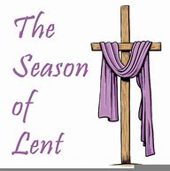
THE SEASON OF LENT

The season of Lent is a time of prayer, fasting and self-examination in preparation for the celebration of the resurrection of the Lord at Easter. It is a period of 40 days – like the flood of Genesis, Moses’ sojourn at Mount Sinai, Elijah’s journey to Mount Horeb, Jacob’s call to Nineveh to repent and Jesus’ time of testing in the wilderness. (The Sundays in Lent are not counted in tis reckoning of the time between Ash Wednesday and Easter, as every Lord’s Day is a celebration of the resurrection of Jesus Christ.)
In the early church, Lent was a time of preparation for the celebration of baptism at the Easter Vigil. In many communities of faith it remains a time to equip and nurture candidates for baptism and confirmation and to reflect deeply on the theme of baptismal discipleship.

The Paschal Mystery
An excerpt from the Companion to the Book of Common Worship

What we hear during Lent is the power and possibility of the paschal mystery, and that the way of the cross, the way to Easter, is through death. To approximate the new life that is beyond the power of death means we must die with Christ who was raised for us. To live for Christ, we must die with him. New life requires a daily surrendering of the old life, letting go of the present order, so that we may embrace the new humanity. “I die every day!” asserts Paul (Corinthians 15:33). Resurrection necessitates death as a preceding act. The church’s peculiar Lenten claim is that in dying we live, that all who are baptized into Christ are baptized into his death. To be raised with Christ means one must also die with Christ. In order to embrace the resurrection, we must experience the passion of Jesus. The way of the cross, the way to Easter, is through death of the “old self.” In dying, we live.
Therefore, at the beginning of Lent, we are reminded that our possessions, our rulers, our empires, our projects, our families and even our lives do not last forever. ”You are dust, and to dust you shall return” (Genesis 3:19). The liturgies throughout Lent try to pry loose our fingers, one by one, from presumed securities and plunge us into unknown baptismal waters, waters that turn out to be not only our death tomb but surprisingly our womb of life. Rather than falling back into nothingness, we fall back on everlasting arms. Death? How can we fear what we have already undergone in baptism?
It is the power of the resurrection on the horizon ahead that draws us into repentance toward the cross and tomb. Through the intervention of God’s gracious resurrection, lifelong changes in our values and behavior become possible. By turning from the end of the “old self” in us, Lenten repentance makes it possible for us to affirm joyfully, “Death is no more” and to aim toward the landscape of the new age. Faithfully adhering to the Lenten journey of “prayer, fasting and almsgiving” leads to the destination of Easter.
During the final week, Holy Week, we hear the fullness of Christ’s passion, his death, and resurrection. From Jesus’ triumphal entry into Jerusalem and on to the Triduum (Maundy Thursday, Good Friday and Holy Saturday), all of Holy Week focuses on the passion. As his followers, we travel Christ’s path of servanthood through the Lord’s Supper and the suffering of the cross toward the glory of Easter, all of which underscores the inseparable link between the death and resurrection of Jesus.

Dear Congregation,
A warmer-than-normal February was a nice change of pace from the cold days previously. The children were able to go outside and enjoy the sunny days. Inside, the children celebrated Valentine’s Day by handing out their Valentines to their friends. We even handmade special Valentines for their loved ones that arrived in the mail in time to open on the 14th.
Going into March we hope to continue the good luck of warm weather as we search for the Infamous Lucky the Leprechaun. He has once again made a home out of the Preschool, and he is not willing to share any of his fine pieces of gold.
God Bless,
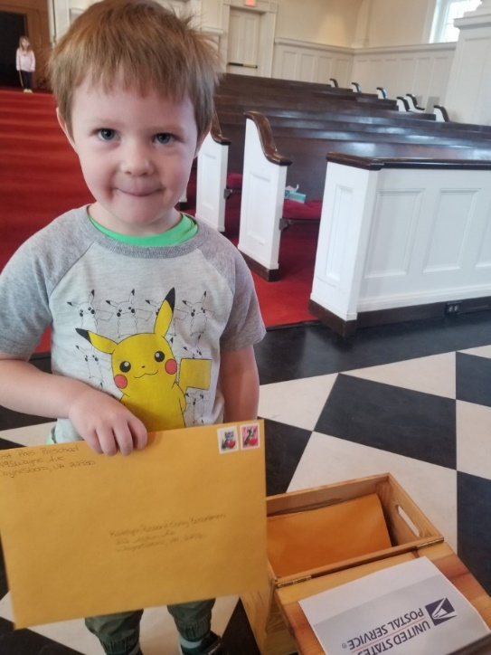
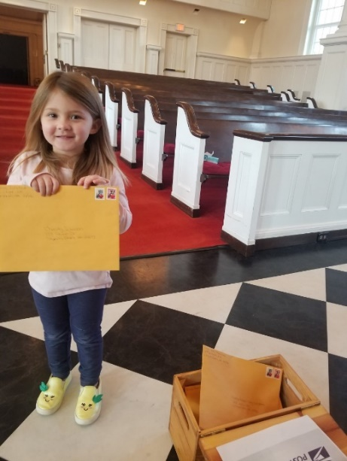
Nate Rudin, Director

Mailing Address
P. O. Box 877
Waynesboro, VA 22980
Phone
540.949.8366
Fax
540.949.5750
E-mail
church@firstpresway.com
Website
www.firstpresway.org

Church Office Hours
Monday-Wednesday
8 a.m. – 2:30 p.m.
Thursday
8 a.m. – 4:30 p.m.

Interim Pastor
Rev. Patrick S. Pettit
pspettit@gmail.com

Administrative Assistant
Mrs. Colleen Cash
ccash@firstpresway.com

Preschool Director
Mr. Nate Rudin
preschool@firstpresway.com

Director of Music
Mr. Roger Daggy
firstpreswaymusic@gmail.com

Music Associate
Mrs. Kimberlea Daggy
firstpreswaymusic@gmail.com

Audio/Visual Technician
Mr. Craig Cavanaugh

Maintenance Technician
Mr. Michael Griffith

Wednesday, March 1
Noon Lenten Bible Study
Thursday, March 2
6-8 PM Food Bank
Friday, March 3
12:15 PM First Friday Concert/ Lite Lunch
Sunday, March 5
11 AM Worship Service
Tuesday, March 7
7-9 PM Symphony Practice- Sanctuary
Wednesday, March 8
Noon Lenten Bible Study
Thursday, March 9
2-4 PM Food Bank
7-9 PM Symphony Sanctuary & Fellowship Practice
Sunday, March12
11 AM Worship Service
Monday, March 13
2:30 PM Session Meeting Room, Room 212
7-9 PM Symphony Practice Sanctuary
Tuesday, March 14
7-9 PM Symphony Practice Sanctuary
Wednesday, March 15
Noon Lenten Bible Study
Thursday, March 16
6-8 PM Food Bank
Sunday, March 19
11 AM Worship Service
2:15 PM Symphony Sound Check
Tuesday, March 21
7-9 PM Symphony Practice- Fellowship Hall
Wednesday, March 22
Noon Lenten Bible Study
Thursday, March23
2-4 PM Food Bank
Sunday, March 26
11 AM Worship Service
Tuesday, March 28
7-9 PM Symphony Practice Fellowship
Wednesday, March 29
Noon Lenten Bible Study
Thursday, March 30
No Food Bank

