Third Sunday in Lent March 12, 2023

PRELUDE Pastorella I, BWV 590 Bach (1685-1750)

WELCOME & ANNOUNCEMENTS

INTROIT 576 Lord, Have Mercy Singapura (sung twice)

CALL TO WORSHIP Betsy Ruehl
Leader: O come, let us worship and bow down; let us kneel before the Lord our Maker!
People: For we are your people, the flock that you shepherd. We will know of your power as we listen for your voice!
Leader: Let us worship God.

MORNING PRAYER

OPENING HYMN 438 Rock of Ages Toplady

CALL TO CONFESSION

PRAYER OF CONFESSION
God of mercy, you call us to hearken to the sound of your voice, but we harden our hearts to your word. You have given us Jesus, the Word of Life, but we confess our reluctance to obey the direction he brings. We ignore your Holy Spirit, choosing our own counsel. Forgive us, Lord, this and all our sin. Help us through Christ to follow where you lead.

SILENT PRAYER

ASSURANCE OF PARDON

*GLORIA PATRI 581 Greatorex

FIRST SCRIPTURE READING Psalm 95 p.479

SPECIAL MUSIC Pastorella III, BWV 590 Bach
SECOND SCRIPTURE READING Romans 5:1-11 p.917

SERMON The faith of Christ Patrick Pettit, Interim Pastor

*AFFIRMATION OF FAITH The Apostles' Creed Hymnal p. 35

PRAYERS OF THE PEOPLE & THE LORD’S PRAYER

*CLOSING HYMN 224 When I Survey the Wondrous Cross Rockingham

*CHARGE and BENEDICTION

POSTLUDE Sonata in c, R. 19 Soler (1729-1783)

*Please stand if able

Today’s link is: https://www.youtube.com/watch?v=b31aljdt3bc

Hearing devices are available for your convenience.
Please be aware that they do not function until after the service begins.

The Legacy: Mary June Cook

Regency at Augusta: Edie Lawrence

Brightview Baldwin Park: Walt Flora

Shenandoah Nursing Home: Rubye Schwab, Nancy Garber

Home: Dick Huff, Mary Ultee, Mary Ann Maupin, Bird Heuchert
Warner & Linda Sandquist, Ruth and Lewis Kelley.

Friends and Family: Erwin Berry (Joan), Bill Bromley, Ron Buckalew, Jean Custen,
Jerry Hughes, Sally McNeel, Bill Metzel (Joyce Tipton), Col. Stuart Roberts (Mark Henderson), Paul Watts, Bob Cash (Colleen Cash). Greg Wood (Anne Wood)

Military: Carson Craig

Lenten lunch Parables studies continue Wednesdays at noon.

REMEMBER to sign up for WARM shelter meals; sign-up sheets are in the Narthex

FIRST PRESBYTERIAN CHURCH
WAYNESBORO, VIRGINIA

A community-minded congregation living out the love of Christ as we serve one another with humility, gentleness, and patience through God’s grace.

March 12, 2023 11:00 AM

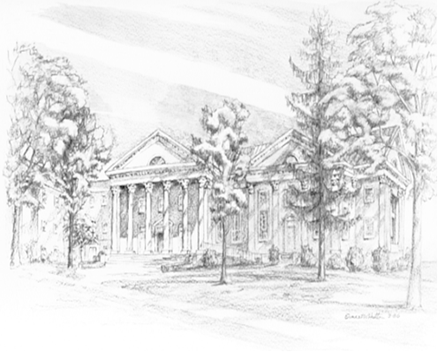

P.O. Box 877
249 South Wayne Avenue
Waynesboro, Virginia
(540) 949-8366
Church Website: www.firstpresway.org
Preschool Website: www.firstprespre.org
Email: church@firstpresway.com

