Fourth Sunday in Lent March 19, 2023

PRELUDE Variations Sweelinck (1562-1621)

WELCOME & ANNOUNCEMENTS

INTROIT 576 Lord, Have Mercy Singapura (sung twice)

CALL TO WORSHIP
Leader: The Lord is my shepherd; I shall not want.
People: Surely your goodness and mercy shall follow us all the days of our lives.
Leader: Let us worship God.

MORNING PRAYER

OPENING HYMN 802 The King of Love My Shepherd Is Traditional Irish

CALL TO CONFESSION

PRAYER OF CONFESSION
God our Solid Rock, our wavering spirits keep us from following you. Our grudges weigh us down until we cannot walk straight in your way. Our anger becomes a fire which scorches our friends and loved ones. Our fears blind us to the goodness in those we believe to be different. Forgive us, Lord, this and all our sin. Set us free from our wrongdoings and failures, that we may we offer your love to the world, in the name of Christ.

SILENT PRAYER

ASSURANCE OF PARDON

*GLORIA PATRI 581 Greatorex

FIRST SCRIPTURE READING Psalm 23 p. 435

ANTHEM My Shepherd Will Supply My Need Traditional American
(text can be found in hymn 803)

SECOND SCRIPTURE READING John 9:1-41 p. 871

SERMON There’s Seeing and then there’s SEEING. Patrick Pettit, Interim Pastor

*AFFIRMATION OF FAITH The Apostles' Creed Hymnal p. 35

PRAYERS OF THE PEOPLE & THE LORD’S PRAYER

*CLOSING HYMN 187 Savior, Like a Shepherd Lead Us Bradbury

*CHARGE and BENEDICTION

POSTLUDE Concerto in a: I Vivaldi (1678-1741)
arranged for organ by Bach (1685-1750)

*Please stand if able

Today’s link is: https://www.youtube.com/watch?v=rmlhJlBn1mA

Hearing devices are available for your convenience.
Please be aware that they do not function until after the service begins.

The Legacy: Mary June Cook

Regency at Augusta: Edie Lawrence

Brightview Baldwin Park: Walt Flora

Shenandoah Nursing Home: Rubye Schwab, Nancy Garber

Home: Dick Huff, Mary Ultee, Mary Ann Maupin, Bird Heuchert
Warner & Linda Sandquist, Ruth and Lewis Kelley. Cathy Cunningham.

Friends and Family: Erwin Berry (Joan), Bill Bromley, Ron Buckalew, Jean Custen,
Jerry Hughes, Sally McNeel, Bill Metzel (Joyce Tipton), Col. Stuart Roberts (Mark Henderson), Paul Watts, Bob Cash (Colleen Cash). Greg Wood (Anne Wood). Josh Slonaker, Beth Crickenberger, Barb Ostrander (Holly Bennett), Marty Rogers (Sister of Cathy Cunningham)

Military: Carson Craig

Lenten lunch Parables studies continue Wednesdays at noon.

FIRST PRESBYTERIAN CHURCH
WAYNESBORO, VIRGINIA

A community-minded congregation living out the love of Christ as we serve one another with humility, gentleness, and patience through God’s grace.

March 19, 2023 11:00 AM

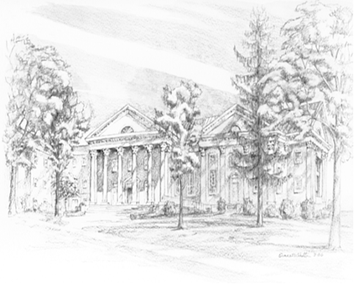

P.O. Box 877
249 South Wayne Avenue
Waynesboro, Virginia
(540) 949-8366
Church Website: www.firstpresway.org
Preschool Website: www.firstprespre.org
Email: church@firstpresway.com

