Fifth Sunday in Lent March 26, 2023

PRELUDE Suite in a: Overture Telemann (1681-1767)

WELCOME & ANNOUNCEMENTS

INTROIT 576 Lord, Have Mercy Singapura (sung twice)

CALL TO WORSHIP
Leader: If you, O Lord, should mark iniquities, Lord, who could stand?
People: But there is forgiveness in God, that we might sing the praises of the Lord.
revered.
Leader: Let us worship God!

MORNING PRAYER

OPENING HYMN 286 Breathe on Me, Breath of God Trentham

CALL TO CONFESSION

PRAYER OF CONFESSION
You called us to life in the Spirit, yet we seek to satisfy the flesh. We call you gracious, yet we practice greed. We praise you with our lips, O God, yet we do not honor you in our lives. Forgive us, Lord, this and all our sin. Redeem us from selfish desire that we may be worthy to be called righteous in Christ.

SILENT PRAYER

ASSURANCE OF PARDON

*GLORIA PATRI 581 Greatorex

FIRST SCRIPTURE READING John 11:1-11 p. 873

SPECIAL MUSIC Sonata no. 2. BWV 1031: Siciliano Bach (1685-1750)
Carolyn Gill, flute

SECOND SCRIPTURE READING John 11:12-45 p. 873

SERMON Take away the Stone… Patrick Pettit, Interim Pastor

*AFFIRMATION OF FAITH The Apostles' Creed Hymnal p. 35

PRAYERS OF THE PEOPLE & THE LORD’S PRAYER

*CLOSING HYMN 250 In the Bulb There is a Flower Promise

*CHARGE and BENEDICTION

POSTLUDE Prelude in e, BWV 555 attr. Bach

*Please stand if able

Today’s link is: https://www.youtube.com/watch?v=4RFVKv5weYA

Hearing devices are available for your convenience.
Please be aware that they do not function until after the service begins.

The Legacy: Mary June Cook

Regency at Augusta: Edie Lawrence

Brightview Baldwin Park: Walt Flora

Shenandoah Nursing Home: Rubye Schwab, Nancy Garber

Home: Dick Huff, Mary Ultee, Mary Ann Maupin, Bird Heuchert
Warner & Linda Sandquist, Ruth and Lewis Kelley. Cathy Cunningham.

Friends and Family: Erwin Berry (Joan), Bill Bromley, Ron Buckalew, Jean Custen,
Jerry Hughes, Sally McNeel, Bill Metzel (Joyce Tipton), Col. Stuart Roberts (Mark Henderson), Paul Watts, Bob Cash (Colleen Cash). Greg Wood (Anne Wood). Josh Slonaker, Beth Crickenberger, Barb Ostrander (Holly Bennett), Marty Rogers (Sister of Cathy Cunningham)

Military: Carson Craig

We welcome Carolyn Gill to First Presbyterian Church this morning. She received degrees in music education and flute performance from the University of Florida. She currently plays flute with the Air National Guard Band of the South, based in Knoxville, TN, and freelances with the Waynesboro Symphony Orchestra. Gill also plays bagpipes with the Albemarle Pipes and Drums band and teaches private lessons in Waynesboro.

Lenten lunch Parables studies continue Wednesdays at noon.

FIRST PRESBYTERIAN CHURCH
WAYNESBORO, VIRGINIA

A community-minded congregation living out the love of Christ as we serve one another with humility, gentleness, and patience through God’s grace.

March 26, 2023 11:00 AM

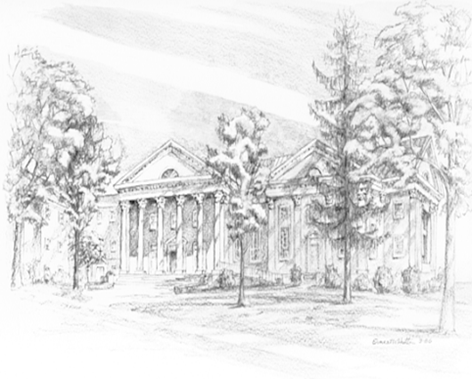

P.O. Box 877
249 South Wayne Avenue
Waynesboro, Virginia
(540) 949-8366
Church Website: www.firstpresway.org
Preschool Website: www.firstprespre.org
Email: church@firstpresway.com

