Second Sunday in Easter April 16, 2023

PRELUDE Prelude in F, BuxWV 145 Buxtehude (1637-1707)

WELCOME & ANNOUNCEMENTS

INTROIT Now Enter In Hebble (1934-2020)

CALL TO WORSHIP
Leader: On the evening of Jesus’ resurrection, the disciples were gathered in fear.
People: The risen Christ appeared in their midst and said, Peace be with you.
Leader: And also with you. The Lord is risen!
People: He is risen indeed!
Leader: Let us worship God.

MORNING PRAYER

OPENING HYMN 234 Come, You Faithful, Raise the Strain St. Kevin

CALL TO CONFESSION

PRAYER OF CONFESSION
Wondrous God, you have broken the power of sin and death, and by Your great mercy, given us new birth and life. But seeds of doubt grow quickly in our hearts. Fear chokes off confidence and prevents us from receiving your Spirit. Forgive us, Lord, this and all our sin. Grant us the peace that passes understanding, that we may find joy in the fullness of Your presence. Amen.

SILENT PRAYER

ASSURANCE OF PARDON

*GLORIA PATRI 581 Greatorex

FIRST SCRIPTURE READING Psalm 16 p.430

ANTHEM Glory to God in the Highest Mathias (1934-1992)
Maximilian Daggy, baritone

SECOND SCRIPTURE READING 1 Peter 1:3-9 p. 983

SERMON Joy Indescribable. Patrick Pettit, Interim Pastor

*AFFIRMATION OF FAITH The Apostles' Creed Hymnal p. 35

PRAYER OF THE PEOPLE AND THE LORD’S PRAYER

*CLOSING HYMN 238 Thine is the Glory Judas Maccabeus

*CHARGE and BENEDICTION

POSTLUDE Fugue in F, BuxWV 145 Buxtehude

*Please stand if able

Hearing devices are available for your convenience.
Please be aware that they do not function until after the service begins.

Today’s link is: https://www.youtube.com/watch?v=pq-3yg__RcE

The Legacy: Mary June Cook

Regency at Augusta: Edie Lawrence

Brightview Baldwin Park: Walt Flora

Shenandoah Nursing Home: Rubye Schwab, Nancy Garber

Home: Dick Huff, Mary Ultee, Mary Ann Maupin, Bird Heuchert,
Warner & Linda Sandquist, Ruth and Lewis Kelley, Cathy Cunningham

Friends and Family: Erwin Berry (Joan), Bill Bromley, Ron Buckalew, Jean Custen,
Jerry Hughes, Sally McNeel, Bill Metzel (Joyce Tipton), Col. Stuart Roberts (Mark Henderson), Paul Watts, Bob Cash (Colleen Cash). Greg Wood (Anne Wood), Josh Slonaker, Beth Crickenberger, Barb Ostrander (Holly Bennett), Marty Rogers (sister of Cathy Cunningham)

Military: Carson Craig

Session approved calling a Congregational Meeting at the conclusion of worship today. The purpose of the meeting is to present for the congregation's concurrence the Memorandum of
Understanding for the sale of the First Presbyterian Church property to the Fishburne Military
School.

One Great Hour of Sharing offerings are still be accepted through April.

FOOD BANK NEEDS
Chicken Noodle Soup

FIRST PRESBYTERIAN CHURCH
WAYNESBORO, VIRGINIA

A community-minded congregation living out the love of Christ as we serve one another with humility, gentleness, and patience through God’s grace.

April 16, 2023 11:00 AM
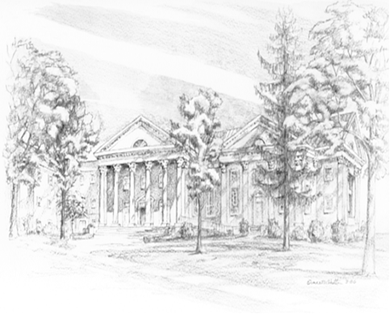

P.O. Box 877
249 South Wayne Avenue
Waynesboro, Virginia
(540) 949-8366
Church Website: www.firstpresway.org
Preschool Website: www.firstprespre.org
Email: church@firstpresway.com

