First Presbyterian Church, Waynesboro, VA

*First Presbyterian Church of Waynesboro is a community-minded*

*congregation living out the love of Christ as we serve one another with*

*humility, gentleness, and patience through God’s grace.*

THE COLUMNS

**April 2023, Volume 61, Issue 4**

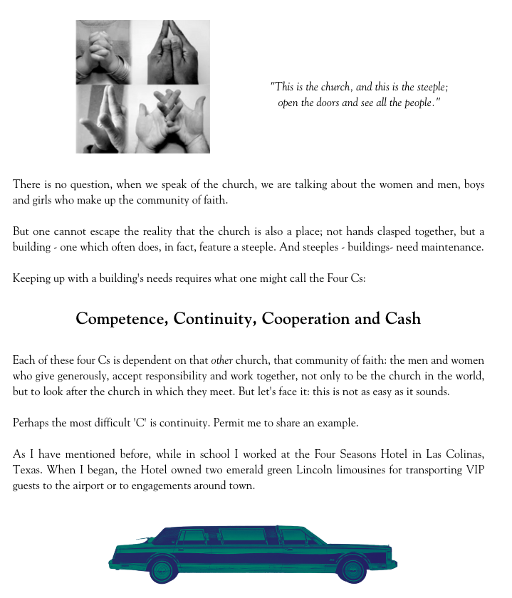

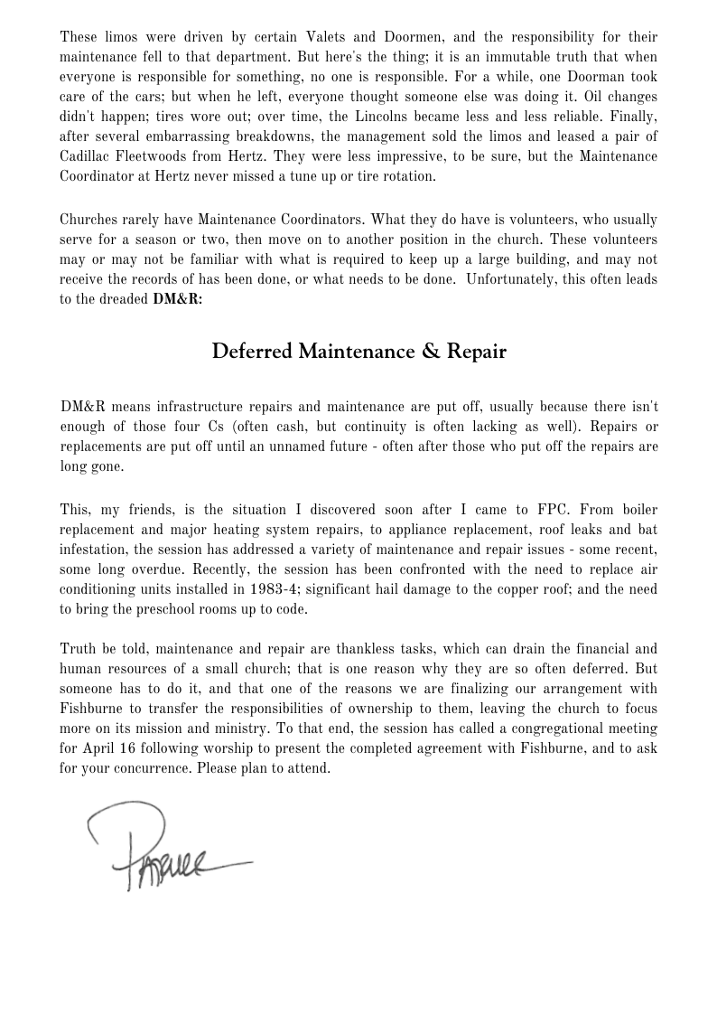



**FIRST FRIDAY CONCERT**

**No Concert on Good Friday**

**ONE GREAT HOUR OF SHARING OFFERING**

**Easter Sunday, April 9, 2023**

Around the world, millions of people lack access to sustainable food sources, clean water, sanitation, education and opportunity. The three programs supported by One Great Hour of Sharing are Presbyterian Disaster Assistance, the Presbyterian Hunger Program, and Self-Development of People.

Let me tell you about Smitha, a widow in India.

From the moment she was born, Smitha faced devastating discrimination and economic injustice based on her social status. The word “Dalit”, the name of Smitha’s caste, means “oppressed” or “broken”. In her culture, access to resources and full participation in the community is limited by custom and law. Dalits are not even allowed to enter temples to worship. She supported her five children by working as a tailor. Then a tsunami hit. It wiped out her thatched and mud home and everything in it, including her sewing machine.

However, you were there with her - through One Great Hour of Sharing.

Your gift supported a grant that provided Smitha with a safe place to live and a new sewing machine so she could work. “*It was lifesaving,”,* she says, “*(It) has not only restored my livelihood but has also restored my hope and dignity.”*

Received on Easter Sunday each gift helps to improve the lives of people in these challenging situations. The Offering provides us a way to share God’s love with our neighbors in need. **In fact, One Great Hour of Sharing is the single, largest way that Presbyterians come together every year for a better world.**

Offerings, so designated, may be sent to the Church Office during April.

**HIGHLIGHTS**

from the Highlights of the 196th Stated Meeting of

Shenandoah Presbytery – February 28, 2023, by Zoom

Worship included the Campus Ministry of RISE/Ukirk at JMU. Following worship, the necrology report was read followed by prayer.

The Rev. April Cranford, pastor of Westminster Presbyterian Church in Waynesboro, was installed at Moderator for 2023.

The Committee on Mission and Outreach shared information about our ongoing relationship with Ethiopia and the opportunity to give to a scholarship fund for women seeking seminary education in Ethiopia.

Two new minister members of the presbytery were introduced.

A new worshiping community in Martinsburg, the Community Cup, has opened. There is an ongoing search for a pastor.

The committee on Church Vitality and Transformation shared the work being done around the presbytery including the ongoing “Better Together” conversations happening with our Waynesboro congregations.

The amendments to the constitution (Book of Order) were presented as an omnibus motion for vote. The body asked that numbers 22A, 22B, 22E, 22I and 22P be pulled from the omnibus motion. They will be docketed for discussion, debate and vote at the May meeting of presbytery. There will be time for further education concerning these specific amendments before the May meeting.

With sadness the presbytery voted to concur with the recommendation from the Administrative Commission working with the Bethel congregation in Staunton to dismiss them to the Covenant Order of Evangelical Presbyterians (ECO). The moderator shared some personal history with that congregation and prayed for their continued ministry in Christ.

--Rev. Browen Boswell, General Presbyter

**SESSION HIGHLIGHTS**

Session held a Stated Meeting on March 13, 2023.

Commissioner Mike Cunningham reported on the online Shenandoah Presbytery Meeting held on

February 28.

Session approved calling a Congregational Meeting at the conclusion of worship on April 16. The purpose

of the meeting is to present for the congregation’s concurrence the Memorandum of Understanding for the sale of the First Presbyterian Church property to the Fishburne Military School.

Preschool – Our current 2-year-old room must be brought up to the latest building code.

Session approved a contract with Riddleberger Bros., Inc. to replace HVAC Equipment. Present units were installed in 1983.

A new Yard Man has been hired.

The Mission/Outreach report is printed elsewhere in *The Columns.*

All Session meetings are opened and closed with prayer.

--Betsy Ruehl



**MISSION/OUTREACH REPORT**

* Ordered and received food from Blue Ridge Area Food Bank 2/7 and 2/21. Volunteers assembled 20 pantry boxes for each order.
* Maintained temperature logs for refrigerators and freezers.
* Food Bank held February 2, 9, 16 and 23.
* Purchased eggs, bread, and margarine for Food Bank weekly.
* Updated weekly shopping list for extra options.
* Completed pantry inventory and report: Served 85 individuals in February.
* Collected emery boards and clippers in February. Collecting wide tooth combs for hygiene kits and shampoo for Food Bank during March.
* Many difficulties in requested expanding of Food Bank to students in need at WHS.
* Will serve at Disciples’ Kitchen March 28.
* MEALS FOR WARM SHELTER –

March 14 – evening snacks, water, goldfish. March 15 – Breakfast (boxed), Lunch (boxed), Dinner served at Expo. Plan to assemble meals in Fellowship Hall Kitchen.

All food items purchased. Total cost to date: $307.98.

--Cynthia Hoover

**REQUESTED DONATIONS IN APRIL**

**FOR HYGIENE KITS - individually wrapped toothbrushes**

**FOR FOOD BANK - shampoo**

**UNDERGRADUATE COLLEGE SCHOLARSHIPS FOR 2023-24**

First Presbyterian Church is offering financial support for the continuing education of worthy students in our community. Scholarships from the Church’s Memorial Educational Fund are available for undergraduate, vocational training and nursing students. Some funds are available specifically for students pursuing teaching or religious careers. Applications are available in the Church Office and on the Church website.

A Scholarship Selection Committee selects recipients each year for varying awards depending on funding availability and the number of applications received. Scholarships are awarded as grants, not loans.

APPLICATION DEADLINE: The Selection Committee must receive completed applications and all support information from applicants no later than Thursday, April 27, 2023. Applicants must also submit copies of their most recent high school or college transcripts with their applications. Late or incomplete applications will not be considered.

If you have questions, please email Holly Bennett at hollybbennett@outlook.com

**BIRTHDAYS**

2 Ann Bryant 23 Cary Bennett

3 Susan Johnson 28 Mary Scott Miller

8 Ann Nelson

10 Cynthia Hoover

**CONGRATULATIONS AND BEST WISHES**

**to Elizabeth “Liz” Ferguson Hoover,**

**daughter of Cynthia and John Hoover,**

**and Jordan Dotson**

**upon their marriage on February 28, 2023**

**in Chatham, MA**

**APRIL** **LITURGISTS**



2- Betsy Ruehl

9-

16-

23-

30-

Dear Congregation,

March brought more warm days and plenty of fun. The month’s highlight was our hunt and capture of Lucky the Leprechaun. The children worked hard following his tracks. And the hard work paid off since they made out with Lucky’s personal chocolate coins. A week of celebrating Dr. Seuss always is a hit, crazy hair, mix match clothes and breakfast of green eggs and ham.

Hopefully, April will not bring too many showers as the children enjoy playtime outside. We will be learning about the true meaning of Easter. All the classes will enjoy an egg hunt and party to celebrate the day.

God Bless,

Nate Rudin

Director

**CONGREGATIONAL MEETING**

**Sunday, April 16, at conclusion of Worship**

**Purpose of the meeting is to present for congregation’s concurrence**

**the Memorandum of Understanding for the sale of the First Presbyterian**

**Church property to the Fishburne Military School**

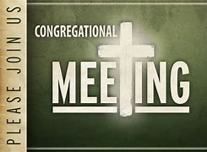

**PRAYER FOR EASTER**

*Lord, the resurrection of Your Son has given us new life and renewed hope.*

*Help us to live as new people in pursuit of the Christian ideal.*

*Grant us wisdom to know what we must do, the will to want to do it, the courage to undertake it,*

*the perseverance to continue to do it, and the strength to complete it.*

--New Saint Joseph People’s Prayer Book



**Transform our Cross Draped in Black on Good Friday -**

**Bring flowers on Easter Sunday!**



**Mailing Address**

P. O. Box 877

Waynesboro, VA 22980

**Phone**

540.949.8366

**Fax**

540.949.5750

**E-mail**

church@firstpresway.com

**Website**

www.firstpresway.org

**Church Office Hours**

Monday-Wednesday

8 a.m. – 2:30 p.m.

Thursday

8 a.m. – 4:30 p.m.

**Interim Pastor**

Rev. Patrick S. Pettit

pspettit@gmail.com

**Administrative Assistant**

Mrs. Colleen Cash

ccash@firstpresway.com

**Preschool Director**

Mr. Nate Rudin

preschool@firstpresway.com

**Director of Music**

Mr. Roger Daggy

[firstpreswaymusic@gmail.com](mailto:firstpreswaymusic@gmail.com)

**Music Associate**

Mrs. Kimberlea Daggy

[firstpreswaymusic@gmail.com](mailto:firstpreswaymusic@gmail.com)

**Audio/Visual Technician**

Mr. Craig Cavanaugh

**Maintenance Technician**

Mr. Michael Griffith

**Sunday, April 2 Palm Sunday**

11 AM Worship Service

Monday April 3

6-8 PM Waynesboro Players /Choir Room

**Tuesday, April 4**

7-9 PM Symphony Practice- Fellowship Hall

**Thursday, April 6**

12 PMMaundy Thursday/worship and meal

6-8 PM Food Bank

7-9 PM Symphony Sanctuary & Fellowship Hall Practice

**Sunday, April 9 Easter**

11 AM Worship Service

**Tuesday, April 11**

2:30 PM Session Meeting Room, Room 212

7-9 PM Symphony Practice Fellowship Hall

**Thursday, April 13**

2-4 PM Food Bank

**Saturday, April 15** Symphony Practice Fellowship/Sanctuary

**Sunday, April 16**

11 AM Worship Service

Congregational Meeting

**Tuesday, April 18**

7-9 PM Symphony Practice- Fellowship Hall

**Thursday, April 20**

**6-8** PM Food Bank

**Sunday, April 23**

11 AMWorship Service

**Tuesday, April 25**

5-10 PM Symphony Practice Sanctuary

**Thursday, April 27**

**2-4 PM** Food Bank

**MAUNDY THURSDAY WORSHIP SERVICE APRIL 6**

**Barksdale Room – noon**

**Simple Soup Lunch**

**Invite your friends!**



**TAX PREPARATIION AS A SPIRITUAL PRACTICE**

**A blogger scratches both his head and his heart**

With the April 15 deadline looming, my wife and I are once again taking on Form 1040 with its schedules and worksheets. We are tackling taxes.

Early on in our marriage, we discovered two shared activities that really stressed our relationship: hanging wallpaper and doing our taxes.

We dealt with the first by agreeing not to do it again. Ever. But the taxes – they still had to be done, and we are still doing them together. I think we are getting better at the together part.

Going through the process this year, I’m wondering if tax preparation would serve as a spiritual practice. What do I see when I look through our tax forms and schedules? What does God see?

As itemizers, we have to add up all our giving: church pledge, special offerings, food bank, and all the other charitable gifts. Is the total as generous as I like to think it is? I look at our account balance and our income from various sources. We are richer than I thought. Do I need to re-hear the gospel from this place of relative wealth?

Paying taxes, I contribute to the common good. I also end up supporting the common bad. Can my faith still live with the dissonance?

As you can see, I’ve been scratching my head, and my heart.

A few nights ago, in an almost awake but not quite asleep moment, I bumped into a Bible story, or maybe the story bumped into me. The full version resides at Matthew 17:24-27. It’s a story about Jesus dealing with a tax obligation.

The tax in question was a yearly assessment for the support of the Temple. As established in Exodus 30, this religious requirement fell on all Jewish men age 20 and older. Each was to pay half a shekel, roughly two days’ wages.

“Doesn’t your teacher pay the temple tax?” The story begins with a question from those who were gathering the tax. Peter answers, “He does.”

Later, when Peter catches up with Jesus, Jesus anticipates the tax question. He asks Peter about taxes levied by an earthly ruler. “Are those taxes paid by the ruler’s children or by others?” Peter asks. ”By others,” Jesus says. “So the children are exempt.”

The implication seems to be that Jesus, as the son of God, shouldn’t have to pay a tax levied in the Torah by his Father, who is the heavenly ruler.

But Jesus, concerned about possibly leading others astray, arranges to pay the tax anyway. He tells Peter to go fishing, take the first fish he catches, and look in its mouth. There he would find a coin worth two half shekels, enough to pay the temple tax for the both of them.

End of story.

Now I’m aware that the temple tax was not the same as taxes paid to Rome, and neither was a direct parallel to our income tax. I also know that a full accounting of Jesus and taxes, or Christians and taxes, would require a book instead of a blog.

But I draw comfort from this story, hearing that Jesus paid taxes, too. That’s a companionable thought when the night gets late and the forms get blurry. Even in this, he shared our life.

I’m also noticing that it took a minor miracle for Jesus to get his taxes turned in.

I know for me, it’s always felt that way.

(By Ken Rummer, for *Presbyterians Today*)