Third Sunday in Easter April 23, 2023

PRELUDE Prelude in A, BWV 536 Bach (1685-1750)

WELCOME & ANNOUNCEMENTS

INTROIT Let All the World Routley (1917-1982)

CALL TO WORSHIP
Leader: What shall we return to God for all God’s bounty to us?
People: We will lift up the cup of salvation and call on the name of the Holy One, our God.
Leader: The Lord is risen!
People: He is risen indeed!
Leader: Let us worship God.

MORNING PRAYER

OPENING HYMN 246 Christ Is Alive! Truro

CALL TO CONFESSION

PRAYER OF CONFESSION
Risen Lord, how often you come to us, and we do not recognize you. You come in friends and strangers, who seek and offer kindness; in words that make sense of our lives and the world around us; in living, enduring promises that we have all but forgotten, Forgive us, Lord, this and all our sin. Stay with us, engage us, and awaken us to your presence. Kindle within us deep and genuine love for you, and for the brothers and sisters you give to us. Amen.

SILENT PRAYER

ASSURANCE OF PARDON

*GLORIA PATRI 581 Greatorex

FIRST SCRIPTURE READING Psalm 116: 12-19 p. 491

ANTHEM Alleluia! Alleluia, Give Thanks to the Risen Lord Fishel (b.1950)
(text can be found in hymn 240)

SECOND SCRIPTURE READING 1 Peter1: 17-23 p. 983

SERMON Imperishable. Patrick Pettit, Interim Pastor

*AFFIRMATION OF FAITH The Apostles' Creed Hymnal p. 35

PRAYER OF THE PEOPLE AND THE LORD’S PRAYER

*CLOSING HYMN 254 That Easter Day with Joy was Bright Puer nobis nascitur

*CHARGE and BENEDICTION

POSTLUDE Fugue in F, BuxWV 145 Buxtehude (1637-1707)

*Please stand if able

Hearing devices are available for your convenience.
Please be aware that they do not function until after the service begins.

Today’s link is: https://www.youtube.com/watch?v=9o15V83RWkA

The Legacy: Mary June Cook

Regency at Augusta: Edie Lawrence

Brightview Baldwin Park: Walt Flora

Shenandoah Nursing Home: Rubye Schwab, Nancy Garber

Home: Dick Huff, Mary Ultee, Mary Ann Maupin, Bird Heuchert,
Warner & Linda Sandquist, Cathy Cunningham

Friends and Family: Erwin Berry (Joan), Bill Bromley, Jean Custen,
Jerry Hughes, Sally McNeel, Bill Metzel (Joyce Tipton), Col. Stuart Roberts (Mark Henderson), Paul Watts, Bob Cash (Colleen Cash). Greg Wood (Anne Wood), Josh Slonaker, Beth Crickenberger, Barb Ostrander (Holly Bennett), Marty Rogers (sister of Cathy Cunningham)

Military: Carson Craig

One Great Hour of Sharing offerings are still being accepted through April.

FOOD BANK NEEDS
Chicken Noodle Soup

FIRST PRESBYTERIAN CHURCH
WAYNESBORO, VIRGINIA

A community-minded congregation living out the love of Christ as we serve one another with humility, gentleness, and patience through God’s grace.

April 23, 2023 11:00 AM

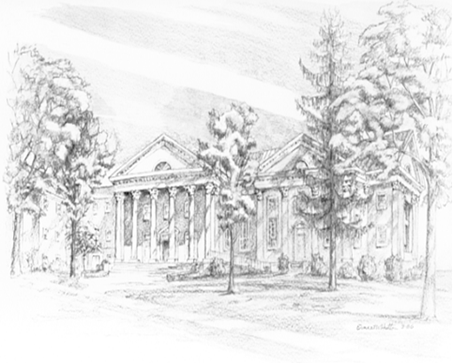

P.O. Box 877
249 South Wayne Avenue
Waynesboro, Virginia
(540) 949-8366
Church Website: www.firstpresway.org
Preschool Website: www.firstprespre.org
Email: church@firstpresway.com

