Fourth Sunday in Easter April 30, 2023

PRELUDE Soul, Adorn Yourself with Gladness, Op. 122, no. 5 Brahms (1833-1897)

WELCOME & ANNOUNCEMENTS

INTROIT Alleluia Milburn (b. 1963)

CALL TO WORSHIP
Leader: From you, O God, comes my praise in the great congregation.
People: We will honor our vows before those who fear the Lord.
Leader: The Lord is risen!
People: He is risen indeed!
Leader: Let us worship God.

MORNING PRAYER

OPENING HYMN 618 O Love, How Deep, How Broad, How High Deo Gracias

CALL TO CONFESSION

PRAYER OF CONFESSION
Merciful God, reconciled to us in Christ, you call us to be your reconciling force in the world. But we confess we have little discipline; when enemies taunt us, when tensions arise, when misunderstanding, and suspicion hit, we find ourselves lost and paralyzed. Forgive us, Lord, this and all our sin. Give us the faith to make Christ supreme in our lives. Help us translate our words of confession into acts of compassion, that we might be a faithful people, serving You in the world. Amen.

SILENT PRAYER

ASSURANCE OF PARDON

*GLORIA PATRI 581 Greatorex

FIRST SCRIPTURE READING Psalm 107:23-32 p. 487

ANTHEM The Gift of Love Hopson (b. 1933)
(Text can be found in hymn 693)

SECOND SCRIPTURE READING Mark 4:35-41 p. 815

SERMON Love Lessons from the Master Teacher Rev. April Cranford
Westminster Presbyterian

*AFFIRMATION OF FAITH The Apostles' Creed Hymnal p. 35

PRAYER OF THE PEOPLE AND THE LORD’S PRAYER

*CLOSING HYMN 463 How Firm a Foundation Foundation

*CHARGE and BENEDICTION

POSTLUDE Concerto in G: Presto BWV 592 Ernst (1696-1715) Bach (1685-1750)

*Please stand if able

Hearing devices are available for your convenience.
Please be aware that they do not function until after the service begins.

Today’s link is: https://www.youtube.com/watch?v=iWf1Wek4-o4

The Legacy: Mary June Cook

Regency at Augusta: Edie Lawrence

Brightview Baldwin Park: Walt Flora

Shenandoah Nursing Home: Rubye Schwab, Nancy Garber

Home: Dick Huff, Mary Ultee, Mary Ann Maupin, Bird Heuchert,
Warner & Linda Sandquist, Cathy Cunningham

Friends and Family: Erwin Berry (Joan), Bill Bromley, Jean Custen,
Jerry Hughes, Sally McNeel, Bill Metzel (Joyce Tipton), Col. Stuart Roberts (Mark Henderson), Paul Watts, Bob Cash (Colleen Cash). Greg Wood (Anne Wood), Josh Slonaker, Beth Crickenberger, Barb Ostrander (Holly Bennett), Marty Rogers (sister of Cathy Cunningham)

Military: Carson Craig

We welcome to the pulpit today Rev. April Cranford, pastor of Westminster Presbyterian Church since 2015. This is the second pulpit exchange to seek fellowship and cooperation between local Presbyterian congregations.

One Great Hour of Sharing offerings are still being accepted through April.

FOOD BANK NEEDS
Chicken Noodle Soup

FIRST PRESBYTERIAN CHURCH
WAYNESBORO, VIRGINIA

A community-minded congregation living out the love of Christ as we serve one another with humility, gentleness, and patience through God’s grace.

April 30, 2023 11:00 AM

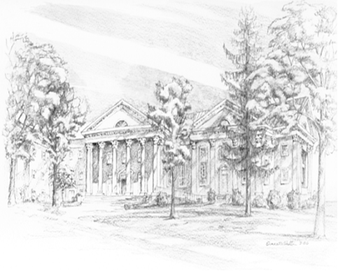

P.O. Box 877
249 South Wayne Avenue
Waynesboro, Virginia
(540) 949-8366
Church Website: www.firstpresway.org
Preschool Website: www.firstprespre.org
Email: church@firstpresway.com

