PENTECOST SUNDAY May 28, 2023

PRELUDE Come, Holy Spirit BuxWV 199 Buxtehude (1637-1707)

WELCOME & ANNOUNCEMENTS

INTROIT Spirit of the Living God Iverson (1890-1977)

PROCLAMATION OF THE PENTECOST
Acts 2:1-13

MORNING PRAYER

OPENING HYMN 289 On Pentecost They Gathered Munich

PRAYER OF THE DAY
We thank you Lord, for Your gift of the Holy Spirit, for we know how desperate is our need. Come, Holy Spirit; for our vision is dim, and our dreams too small. Come, Holy Spirit; for our hearts are cold, and our faith is feeble. Come, Holy Spirit; our bodies are broken, our unity breached. Come, Holy Spirit: Heal and preserve us Kindle fire within us; fill our lives with songs of praise. Fuel our ministry with power and grace. Renew this world, we pray, that it
might glow with the light of your love and show forth your salvation. Amen.

*GLORIA PATRI 581 Greatorex

FIRST SCRIPTURE READING Psalm 104:24-34 p.483

ANTHEM We Are One in the Spirit Scholtes (1938-2009)
(Text can be found in hymn 300)

SECOND SCRIPTURE READING 1 Corinthians 12:3-13 p.927

SERMON What a body can do. Patrick Pettit, Interim Pastor

*AFFIRMATION OF FAITH The Apostles' Creed Hymnal p. 35

PRAYERS OF THE PEOPLE & THE LORD’S PRAYER

*CLOSING HYMN 298 Lord, You Give the Great Commission Abbot’s Leigh
(Stanzas 1, 2, 5)

*CHARGE and BENEDICTION

POSTLUDE Come, Holy Spirit BWV 651 Bach (1685-1750)

*Please stand if able

Hearing devices are available for your convenience.
Please be aware that they do not function until after the service begins.

Today’s link is: https://www.youtube.com/watch?v=_ktj_SOMddo

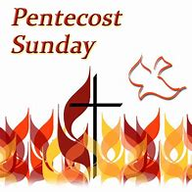

The Legacy: Mary June Cook

Regency at Augusta: Edie Lawrence

Shenandoah Nursing Home: Rubye Schwab, Nancy Garber

Home: Dick Huff, Mary Ultee, Mary Ann Maupin, Warner & Linda Sandquist,
Cathy Cunningham

Friends and Family: Erwin Berry (Joan), Bill Bromley, Jean Custen, Jerry Hughes, Sally McNeel, Bill Metzel (Joyce Tipton), Col. Stuart Roberts (Mark Henderson), Paul Watts, Kathleen Clements, (Colleen Cash), Josh Slonaker, Beth Crickenberger, Barb Ostrander (Holly Bennett), Marty Rogers (sister of Cathy Cunningham)

Military: Carson Craig

Disciples’ Kitchen dates are May 30 and June 27.

Church office will be closed on Monday, Memorial Day.

FIRST PRESBYTERIAN CHURCH
WAYNESBORO, VIRGINIA

A community-minded congregation living out the love of Christ as we serve one another with humility, gentleness, and patience through God’s grace.

May 28, 2023 11:00 AM

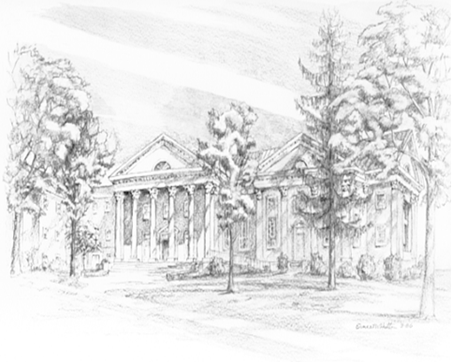

P.O. Box 877
249 South Wayne Avenue
Waynesboro, Virginia
(540) 949-8366
Church Website: www.firstpresway.org
Preschool Website: www.firstprespre.org
Email: church@firstpresway.com

