FIFTH SUNDAY OF EASTER May 7, 2023

PRELUDE Prelude, Op. 31, no. 5 Vierne (1870-1937)

WELCOME & ANNOUNCEMENTS

INTROIT Alleluia Milburn (b. 1963)

CALL TO WORSHIP
Leader: God is our rock and fortress.
People: In God alone we take refuge.
Leader: The Lord is risen!
People: He is risen indeed!
Leader: Let us worship God.

MORNING PRAYER

OPENING HYMN 394 Christ is Made the Sure Foundation Westminster Abbey

CALL TO CONFESSION

PRAYER OF CONFESSION
God of grace and mercy, we confess we refuse too many of your gifts. You show us yourself, that we might believe; we close our ears and eyes to You. You offer us refuge and salvation; we resort to violence as we seek our own security. Forgive us, Lord, this and all our sin. Let Your face shine upon us again, that we may grow into salvation, and serve you in faithfulness. Amen.

SILENT PRAYER

ASSURANCE OF PARDON

*GLORIA PATRI 581 Greatorex

FIRST SCRIPTURE READING Psalm 31:1-5 p.439

ANTHEM The Disciples Knew the Lord Jesus Milburn

(Refrain) The disciples knew the Lord Jesus in the breaking of the bread.
(I) The bread which we break, alleluia, is the communion of the body of Christ.
(II) One body are we, alleluia, though we are many we share one cup.

SECOND SCRIPTURE READING 1 Peter 2:1-10 p.984

SERMON God’s own people. Patrick Pettit, Interim Pastor

*AFFIRMATION OF FAITH The Apostles' Creed Hymnal p. 35

THE LORD’S SUPPER
Invitation
Great Thanksgiving
Communion of the People

PASTORAL PRAYER

THE LORD’S PRAYER

*CLOSING HYMN 353 My Hope is Built on Nothing Less Solid Rock

*CHARGE and BENEDICTION

POSTLUDE Fugue in E, BWV 566 Bach (1685-1750)

*Please stand if able

Hearing devices are available for your convenience.
Please be aware that they do not function until after the service begins.

The Legacy: Mary June Cook

Regency at Augusta: Edie Lawrence

Brightview Baldwin Park: Walt Flora

Shenandoah Nursing Home: Rubye Schwab, Nancy Garber

Home: Dick Huff, Mary Ultee, Mary Ann Maupin, Bird Heuchert,
Warner & Linda Sandquist, Cathy Cunningham

Friends and Family: Erwin Berry (Joan), Bill Bromley, Jerry Hughes, Sally McNeel, Bill Metzel (Joyce Tipton), Col. Stuart Roberts (Mark Henderson), Paul Watts, Bob Cash (Colleen Cash). Greg Wood (Anne Wood). Josh Slonaker, Beth Crickenberger, Barb Ostrander (Holly Bennett), Marty Rogers (sister of Cathy Cunningham)

Military: Carson Craig

FOOD BANK Chicken Noodle Soup

FIRST PRESBYTERIAN CHURCH
WAYNESBORO, VIRGINIA

A community-minded congregation living out the love of Christ as we serve one another with humility, gentleness, and patience through God’s grace.

May 7, 2023 11:00 AM

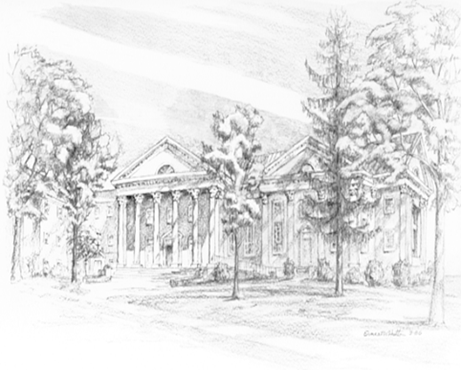
P.O. Box 877
249 South Wayne Avenue
Waynesboro, Virginia
(540) 949-8366
Church Website: www.firstpresway.org
Preschool Website: www.firstprespre.org
Email: church@firstpresway.com

