Second Sunday after Pentecost June 11, 2023

PRELUDE Préambule, Op. 31, no. 1 Vierne (1870-1937)

WELCOME & ANNOUNCEMENTS

INTROIT Alleluia Milburn (b. 1963)

CALL TO WORSHIP (based on Psalm 33:1-12)
Rejoice in the Lord, O you God’s beloved;
Sing to God a new song! For the word of the Lord is upright,
and all God’s work is done in faithfulness.
Our God loves righteousness and justice;
The earth is full of the steadfast love of the Lord.
The counsel of the Lord stands forever,
The thoughts of his heart to all generations.
Let us worship God.

MORNING PRAYER

OPENING HYMN 415 Come, Ye Sinners, Poor and Needy Restoration

CALL TO CONFESSION

PRAYER OF CONFESSION
Merciful God, you are always drawing the circle of your love wider, but often we resist. You tell us that all people are your beloved, and we ask, “Why?” “Why them?” “Even them?!” We are quick to judge others rather than being grateful that we, too, are included in the fold. We prioritize the privileged, the powerful and the people who look and act right, but you extend grace first to the sinner, the outcast and the marginalized. Forgive us, O God. Transform us, that we may show mercy as you show mercy. Amen.

SILENT PRAYER

ASSURANCE OF PARDON

*GLORIA PATRI 581 Greatorex

FIRST SCRIPTURE READING Genesis 12:1-9 p. 8

SPECIAL MUSIC Le Soir (Evening), Op. 5, no. 1 Vierne
Celia Daggy, viola

SECOND SCRIPTURE READING Matthew 9:9-13, 18-26 p. 790

SERMON The Art of Following Terry Crickenberger

*AFFIRMATION OF FAITH (adapted from the confession of 1967)
We believe in Jesus Christ, the realization of true humanity. Jesus, a Palestinian Jew, lived among his own people, sharing their needs, temptations, joys, and sorrows. Expressing God’s love in word and deed, he became a friend to sinners, and a refuge for those cast aside. Many rejected him and demanded his death, but he gave himself freely, with mercy and love. God raised this Jesus from the dead, vindicating him as Messiah and Lord. The victim of sin became the victor, conquering death for all people. In Christ Jesus, love gets the final word.

PRAYERS OF THE PEOPLE & THE LORD’S PRAYER

*CLOSING HYMN 796 We Come to You for Healing, Lord Land of Rest
*CHARGE and BENEDICTION

POSTLUDE Légende, Op. 5, no. 2 Vierne

*Please stand if able

Hearing devices are available for your convenience.
Please be aware that they do not function until after the service begins.

Today’s link is: https://www.youtube.com/watch?v=quFZFxt2nW4

The Legacy: Mary June Cook

Regency at Augusta: Edie Lawrence

Shenandoah Nursing Home: Rubye Schwab, Nancy Garber

Home: Dick Huff, Mary Ultee, Mary Ann Maupin, Warner & Linda Sandquist,
Cathy Cunningham

Friends and Family: Erwin Berry (Joan), Bill Bromley, Jean Custen, Jerry Hughes, Sally McNeel, Bill Metzel (Joyce Tipton), Col. Stuart Roberts (Mark Henderson), Paul Watts, Kathleen Clements, (Colleen Cash), Josh Slonaker, Barb Ostrander (Holly Bennett), Marty Rogers (sister of Cathy Cunningham)

Military: Carson Craig

Disciples’ Kitchen date is June 27.

We welcome to the pulpit today our own Elder Terry Crickenberger who is studying at Union Seminary in Richmond.

Guest musician is Celia Daggy, daughter of Roger and Kimberlea, Principal Viola of the Virginia Symphony Orchestra.

FIRST PRESBYTERIAN CHURCH
WAYNESBORO, VIRGINIA

A community-minded congregation living out the love of Christ as we serve one another with humility, gentleness, and patience through God’s grace.

June 11, 2023 11:00 AM

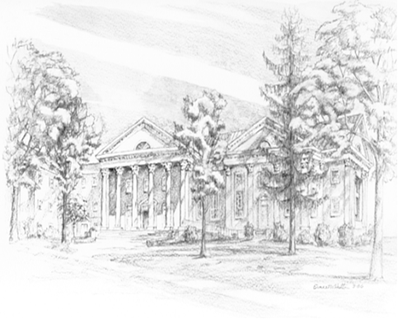

P.O. Box 877
249 South Wayne Avenue
Waynesboro, Virginia
(540) 949-8366
Church Website: www.firstpresway.org
Preschool Website: www.firstprespre.org
Email: church@firstpresway.com

