Third Sunday after Pentecost June 18, 2023

PRELUDE Our Father in Heaven BWV 683 Bach, JSB (1685-1750)

WELCOME & ANNOUNCEMENTS

INTROIT Faith of our Fathers Henry (1818-1888)

CALL TO WORSHIP
Rejoice in the Lord, O you righteous!
Sing to the Lord a new song!
Your word is upright, O God;
The earth is full of your steadfast love.
Let us worship God.

MORNING PRAYER

OPENING HYMN 370 This is My Father’s World Terra Beata

CALL TO CONFESSION

PRAYER OF CONFESSION
O God, you open your door to us and invite us in; we judge some as unworthy to darken your threshold. You call us to faith in the Lord Jesus Christ; we turn away those we deem unfit to come in. You desire mercy, not sacrifice, as a response to your grace; we expect others to be thankful that we accept them at all. Forgive us Lord, this and all our sin. Make us mindful of those whom you also hold dear, that we may serve and be served in love.

SILENT PRAYER

ASSURANCE OF PARDON

*GLORIA PATRI 581 Greatorex

FIRST SCRIPTURE READING Psalm 33:1-12 p. 440

SPECIAL MUSIC Sonata in A-flat, H. 31: I Bach, CPE (1714-1788)

SECOND SCRIPTURE READING Genesis 12:1-9 p. 8

SERMON Where are we going? Patrick Pettit, Interim Pastor

*AFFIRMATION OF FAITH

PRAYERS OF THE PEOPLE & THE LORD’S PRAYER

*CLOSING HYMN 169 Dear Lord and Father of Mankind Rest

*CHARGE and BENEDICTION

POSTLUDE Fugue in g, BWV 535 Bach, JSB

*Please stand if able

Hearing devices are available for your convenience.
Please be aware that they do not function until after the service begins.

Today’s link is: https://www.youtube.com/watch?v=xrNbSjx2JAU

The Legacy: Mary June Cook

Regency at Augusta: Edie Lawrence

Shenandoah Nursing Home: Rubye Schwab, Nancy Garber

Home: Dick Huff, Mary Ultee, Mary Ann Maupin, Warner & Linda Sandquist,
Cathy Cunningham

Friends and Family: Erwin Berry (Joan), Bill Bromley, Jean Custen, Jerry Hughes, Sally McNeel, Bill Metzel (Joyce Tipton), Col. Stuart Roberts (Mark Henderson), Paul Watts, Kathleen Clements, (Colleen Cash), Josh Slonaker, Barb Ostrander (Holly Bennett), Marty Rogers (sister of Cathy Cunningham)

Military: Carson Craig

Nancy Meehan Yao’s surgery for breast cancer was scheduled for June 15. Her mailing address is: 107 Winchester Ave., Moorefield, WV 26836.
Please keep Nancy, and her husband, Jim, in your prayers through the surgery and recovery.

Disciples’ Kitchen date is June 27.

Volunteers are needed for the Food Bank
Items Needed
Peanut Butter
Wrapped Toothbrushes

FIRST PRESBYTERIAN CHURCH
WAYNESBORO, VIRGINIA

A community-minded congregation living out the love of Christ as we serve one another with humility, gentleness, and patience through God’s grace.

June 18, 2023 11:00 AM
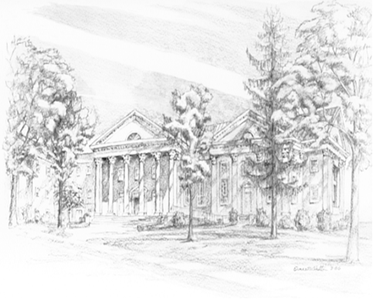

P.O. Box 877
249 South Wayne Avenue
Waynesboro, Virginia
(540) 949-8366
Church Website: www.firstpresway.org
Preschool Website: www.firstprespre.org
Email: church@firstpresway.com

