TRINITY SUNDAY June 4, 2023

PRELUDE Trio Rheinberger (1839-1901)

WELCOME & ANNOUNCEMENTS

INTROIT What Does the Lord Require Routley (1917-1982)

CALL TO WORSHIP

God said, "Let There be Light," and there was light!

O Lord our God, how majestic is your name!

You have set your glory above the heavens.

O Lord our God, how majestic is your name!
Let us worship God.

MORNING PRAYER

OPENING HYMN 1 Holy, Holy, Holy Nicaea

CALL TO CONFESSION

PRAYER OF CONFESSION
O Lord our God, called as your people, we fail to reflect your glory. We neglect our responsibilities and abuse creation. We profess our faith but reject your authority with our actions. Forgive us, Lord, this and all our sin. Restore us by your grace in Jesus Christ. Reorder our lives by the power of the Spirit, that we may serve you faithfully and live in peace with one all.

SILENT PRAYER

ASSURANCE OF PARDON

*GLORIA PATRI 581 Greatorex

FIRST SCRIPTURE READING Psalm 8 p. 427

ANTHEM Bread of Heaven, on Thee We Feed arr. Davies (1844-1907)
(Text can be found in hymn 496)

SECOND SCRIPTURE READING Genesis 1-1,2: -4 p. 1

SERMON And so it begins. Patrick Pettit, Interim Pastor

*AFFIRMATION OF FAITH The Apostles' Creed Hymnal p. 35

THE LORD’S SUPPER
Invitation
Great Thanksgiving
Communion of the People

PASTORAL PRAYER

THE LORD’S PRAYER

*CLOSING HYMN 2 Come Thou, Almighty King Italian Hymn

*CHARGE and BENEDICTION

POSTLUDE The King Sitteth at His Throne Dupré (1886-1971)

*Please stand if able

TODAYS LINK https://www.youtube.com/watch?v=BIo3J5OSx78

Hearing devices are available for your convenience.
Please be aware that they do not function until after the service begins.

The Legacy: Mary June Cook

Regency at Augusta: Edie Lawrence

Shenandoah Nursing Home: Rubye Schwab, Nancy Garber

Home: Dick Huff, Mary Ultee, Mary Ann Maupin, Bird Heuchert,
Warner & Linda Sandquist, Cathy Cunningham

Friends and Family: Erwin Berry (Joan), Bill Bromley, Jerry Hughes, Sally McNeel, Bill Metzel (Joyce Tipton), Col. Stuart Roberts (Mark Henderson), Paul Watts, Kathleen Clements (Colleen Cash). Josh Slonaker, Beth Crickenberger, Barb Ostrander (Holly Bennett), Marty Rogers (sister of Cathy Cunningham)

Military: Carson Craig

FOOD BANK Peanut Butter

FIRST PRESBYTERIAN CHURCH
WAYNESBORO, VIRGINIA

A community-minded congregation living out the love of Christ as we serve one another with humility, gentleness, and patience through God’s grace.

June 4, 2023 11:00 AM

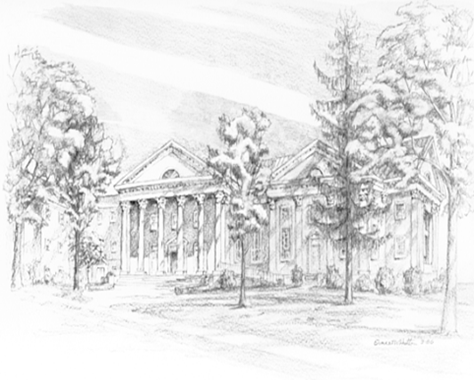
P.O. Box 877
249 South Wayne Avenue
Waynesboro, Virginia
(540) 949-8366
Church Website: www.firstpresway.org
Preschool Website: www.firstprespre.org
Email: church@firstpresway.com

