First Presbyterian Church, Waynesboro, VA
First Presbyterian Church of Waynesboro is a community-minded
congregation living out the love of Christ as we serve one another with
humility, gentleness, and patience through God’s grace.

THE COLUMNS

May 2023, Volume 61, Issue 5

A Message from our General Presbyter

If someone were to ask you what your church is doing to further the kingdom of God – how would you answer?

It is a question we all need to be pondering as we move into the future. What are we doing as followers of Christ to love our neighbors as ourselves? What are we doing to make a better life for those around us that we may not know? Are we making sure that everyone who needs it is housed, clothed, and fed? What are we doing to let people know that all – and I mean all – people are made in the image of God? What are we doing to accept those who are different from ourselves, who think differently than we do, who do not know how they fit into today’s society – how are we, the church, a place for all people?

In this season of Eastertide, let us work towards being the kingdom of God on earth – doing what Christ calls us to do, out in the world, so that we can answer the question – how is your church furthering the kingdom of God?

If you would like some help in exploring the question, give me a call. Let us be the people Christ calls us to be, in all that we do and all that we say.

Blessings,

Bronwen

MAY MUSIC NOTES

The month of May showers us in its beauty, with flowers and trees bursting forth in a glorious kaleidoscope of color. The music that we will sing this month also erupts with aural color, reflecting the message of each Sunday.

May opens with one of the most famous passages from I Peter: “The stone the builders rejected has become the cornerstone,” and both of the hymns for the Easter V service amplify this passage. The opening hymn will be Christ is Made the Sure Foundation and the closing hymn will be My Hope is Built on Nothing Less, known by its tune name, SOLID ROCK.

The second Sunday of May is Mother’s Day, and the hymns for the Easter VI service will be For the Beauty of the Earth and All Things Bright and Beautiful. These hymns celebrate the joy, beauty and wonder of creation, as we celebrate those who bring life into the world!

Scripture passages for the third Sunday of May amplify the Ascencion of Jesus. The hymns, Come, Christians, Join to Sing and All Hail the Power of Jesus’ Name, celebrate His glory as He rises to meet the Father. The postlude will be from Olivier Messiaen’s (1908-1992) four movement organ work, L’Ascension. The title of the third movement is “Transports de joie d'une âme devant la gloire du Christ qui est la sienna” (Outbursts of Joy From a Soul Before the Self-Fulfiling Glory of Christ), and, oh, does this toccata burst forth with elation!

We celebrate Pentecost on the final Sunday of May. All of the music celebrates the descent of the Holy Spirit. The hymns will be On Pentecost They Gathered and We Are One in the Spirit, also known as They’ll Know We Are Christians By Our Love, one of the most familiar hymns from the 1960s. The text and music for this iconic hymn was written in a day by Peter Scholtes for his youth choir. The service opens and closes with renditions of the tune, Komm, heiliger Geist (Come, Holy Ghost). The prelude was composed by Dieterich Buxtehude (1637-1707), the influential composer, organist and kapellmeister (music director) who worked in Lübeck, Germany. The postlude was composed by a man who spent months soaking in all Buxtehude could offer, Johann Sebastian Bach. His chorale fantasia on Komm, heiliger Geist, is a musical depiction of the swirling Holy Spirit as the chorale melody thunders in the pedals.

Finally, after a respite for Good Friday, Roger will present a First Friday organ recital on 5 May at 12:15. Please consider attending the program, which has become quite popular with the noon-day crowd! The recital will be followed by a light repast, generously provided by Susan Johnson.

Finally, we express our heartfelt thanks to Jean Hashagen, Betsy Ruehl, Susan Elder, Bill Pannill and Patrick Pettit for singing each Sunday. The choir may be small in numbers, but mighty in singing praises to our Lord and Savior!

Many thanks for your continued support of the music program at First Presbyterian Church!

Blessings –

Roger and Kimberlea Daggy

March 2023

- Ordered and received food from BRAFB 3/9 and 3/16. Volunteers assembled 20 pantry boxes for each order.
- Maintained temperature logs for refrigerators and freezers.
- Food Bank held March 2, 9, 16 and 23.
- Purchased eggs, bread, and margarine for Food Bank weekly.
- Updated weekly shopping list for extra options.
- Completed pantry inventory and report: Served 132 individuals and 46 households in March.
- Collecting wide tooth combs for hygiene kits. Collecting shampoo for Food Bank.
- Discussing expanding the Food Bank to students in need at WHS identified by Mrs. Phelps. Mrs. Phelps estimates that the WHS pantry would initially serve 40 students and their families. The situation is complicated with lack of parental signatures, USDA foods, delivery. Will start delivering food to WHS on April 11. Made possible through a grant from BRAFB. 10 boxes of packed food delivered to WHS by Danny Woodworth. Have established a separate account (7611-1)
- Served 45 meals at Disciples’ Kitchen March 28. Next Disciples’ Kitchen is May 23.
- For April: Collecting individually wrapped toothbrushes for hygiene kits and chicken noodle soup for Food Bank.
--Cynthia Hoover, Chair

SUGGESTED ITEMS NEEDED IN MAY
Hygiene Kits – Individually wrapped toothbrushes.
Food Bank – More Chicken Noodle Soup

Birthdays
May 2 Bird Heuchert
May 12 Roger Bryant
May 13 Walt Flora
May 14 Don Hashagen
May 15 Betty Dixon
May 16 Carrol Smith
May 26 Ron Smith
May 31 Molly Martin

May 19 Burnie and Carol Powers
May 24 Cary and Holly Bennett
May 25 John and Cynthia Hoover
May 31 Danny and Pam Leech

MAY LITURGISTS

7- Betsy Ruehl
14- Jean Hashagen
21- Cynthia Hoover
28- Joan Berry

SESSION HIGHLIGHTS

Session held a Stated Meeting on April 11, 2023.
- Session continues to seek options for bringing the Preschool area up to code.
- There is concern about church security with doors being propped open or unlocked.
- Lenten Study and Maundy Thursday service went well. There will be a Congregational Meal after worship on Sunday, May 21. Details will be forthcoming.
- The Mission/Outreach report is printed elsewhere in The Columns.
- A proposal for a new copper roof has been received. We need a quote on a steel roof. Some insurance monies, amount to be determined, should be forthcoming.
- The meeting was opened and closed with prayer. Next scheduled meeting is May 9.
--Betsy Ruehl, Clerk of Session

CONGREGATIONAL MEETING

A Congregational Meeting was held April 16, 2003, after worship for the purpose of presenting for the congregation’s concurrence the Memorandum of Understanding for the sale of First Presbyterian Church to the Fishburne Military School. A quorum was present.
Highlights of the Memorandum of Understanding were distributed to the congregation. Rev. Pettit led discussion of each highlight. The first two of nine highlights are:
“First Presbyterian Church shall deed its property to Fishburne, except for the pulpit, communion table, communion set, paraments, Bible, hymnals, and other worship ‘stuff’.”
“In return, the Church will continue to have free use of the property for worship, fellowship, outreach, or any other activity related to its mission and ministry, for as long as the church remains an active congregation of the Presbyterian Church (U.S.A.).”
The remaining highlights involve financial and more specific matters.
After a question-and-answer period, the following motion was approved unanimously. MOTION: First Presbyterian Church shall proceed with the Sale of First Presbyterian Church to the Fishburne Military School.
The meeting was opened and closed with prayer.
--Betsy Ruehl, Secretary

FIRST FRIDAY CONCERT
May 5, 2003; 12:15 p.m.
followed by a light repast in the Barksdale Room

CONGREGATIONAL MEAL
following worship on Sunday, May 21, 2023
in the Barksdale Room

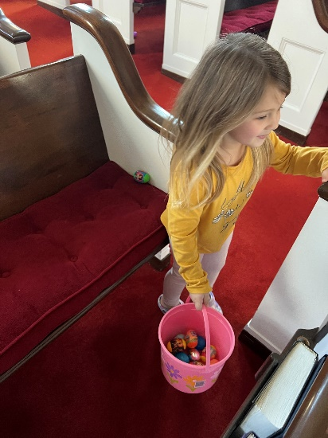
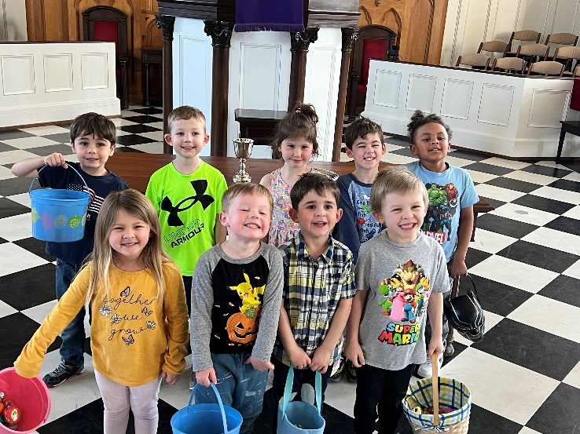
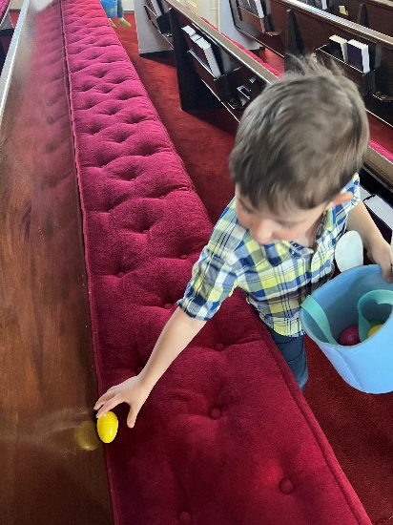
Preschool

WHAT MAKES US UNIQUE

“In gratitude to God, empowered by the Spirit we strive to serve Christ in our daily tasks
and to live holy and joyful lives even as we watch for God’s new heaven and new earth
praying, ‘Come Lord Jesus.’” From “A Brief Statement of Faith”

At the core of Presbyterian identity is a secure hope in the grace of God in Jesus Christ, a hope that, by the power of the Holy Spirit, empowers us to live lives of gratitude: “In affirming with the earliest Christians that Jesus is Lord, the Church confesses that he is its hope, and that the Church, as Christ’s body, is bound to his authority and thus free to live in the lively, joyous reality of the grace of God.” (Book of Order F-1.0204)
The strong emphasis on the grace of God in Jesus Christ is our heritage from the founder of the Reformed tradition, John Calvin.
The name Presbyterian comes from the Greek term in the New Testament for elder, presbuteros, a term used 72 times in the New Testament. The Presbyterian movement began among Protestants in the 16th and 17th centuries and centered on what form of church government would be appropriate. Some thought the church should be governed by bishops and became the Episcopalian party, some by elders and became the Presbyterian party, and some directly by the congregation which became the Congregationalist party.
Presbyterian church government emphasizes that the leadership of the church is shared by those called to be ministers and church members called to be elders within the congregation – we use the term Teaching Elder to refer to ministers and Ruling Elder to church members called to be elders. The strong emphasis on Presbyterian government is our heritage from Scottish Presbyterians.
The Presbyterian Church (U.S.A.) is Reformed in its theology and Presbyterian in its church government.
In North America the first presbytery was organized in 1706, the first synod in 1717; the first General Assembly was held in 1789. Today’s Presbyterian Church (U.S.A.) was created by the 1983 reunion of the two main branches of Presbyterians in America separated since the Civil War – the Presbyterian Church in the U.S. and the United Presbyterian Church in the U.S.A. The latter had been created by the union of the Presbyterian church in the U.S.A. and the United Presbyterian Church of North America in 1958.
The Presbyterian Church (U.S.A.) is distinctly a confessional and a connectional church, distinguished by the representation of elders in the government.

(What Makes Us Unique to be continued)

On Memorial Day, usually the last Monday in May in the United States,
we remember those who died in active service of our country.
We honor them with thankfulness for their service
and prayer for our military families, our troops and our nation.
The day has been set aside by presidential proclamation since 1969
as a day of prayer for peace.

A MEMORIAL DAY PRAYER

On this day of remembrance for those who have made the ultimate sacrifice for the freedom we enjoy every day, we consider how they have followed in the footsteps of your Son, our Savior, Jesus Christ.
Please hold our servicemen and women in your strong arms. Cover them with your sheltering grace and your presence as they stand in the gap for our protection.
We also remember the families of our troop. We ask for your unique blessing to fill their homes, and we pray for your peace, provision, hope, and strength to fill their lives.
May the members of our armed forces be supplied with the courage to face each day and may they trust in the Lord’s mighty power to accomplish each task. Let our military brothers and sisters feel our love and support.
Sovereign God and Lord of all nations, may we take time to reflect on the great blessing we share as nation and as a people. Our blessings have come at a high cost to others. May we always remember those sacrifices with deep gratitude.
We ask that you grant wisdom to the leaders of our armed forces. Guide and direct them in their decisions. May they be led by your will and your heart as they pursue our nation’s freedoms. We continue to pray for peace in our world. Lord, let your kingdom on earth be as it is in heaven.
In the name of Jesus Christ, we pray. Amen.

May Calendar

Mailing Address
P. O. Box 877
Waynesboro, VA 22980
Phone
540.949.8366
Fax
540.949.5750
E-mail
church@firstpresway.com
Website
www.firstpresway.org

Church Office Hours
Monday-Wednesday
8 a.m. – 2:30 p.m.
Thursday
8 a.m. – 4:30 p.m.

Interim Pastor
Rev. Patrick S. Pettit
pspettit@gmail.com

Administrative Assistant
Mrs. Colleen Cash
ccash@firstpresway.com

Preschool Director
Mr. Nate Rudin
preschool@firstpresway.com

Director of Music
Mr. Roger Daggy
firstpreswaymusic@gmail.com

Music Associate
Mrs. Kimberlea Daggy
firstpreswaymusic@gmail.com

Audio/Visual Technician
Mr. Craig Cavanaugh

Maintenance Technician
Mr. Michael Griffith

Thursday, May 4
6-8 PM Food Bank
Friday, May 5
12:15 PM First Friday Concert, lite lunch
Sunday, May 7
11 AM Worship Service
Tuesday, May 9
2:30 PM Session Meeting Room, Room 212
Thursday, May 11
10 AM Fishburne Graduation Practice
2-4 PM Food Bank
Saturday, May 13
10:00 AM Fishburne Graduation
1:15 PM Sarah Braverman Rehearsal
Sunday, May 14
11 AM Worship Service
Thursday, May 18
6-8 PM Food Bank
Saturday, May 20
Noon Sarah Braverman Recital
Sunday, May 21
11 AM Worship Service
Congregational Lunch
Thursday, May 25
2-4 PM Food Bank
Sunday, May 28
11 AM Worship Service

