SIXTH SUNDAY AFTER PENTECOST July 9, 2023

PRELUDE Variations Sweelinck (1562-1621)

WELCOME & ANNOUNCEMENTS

INTROIT America the Beautiful Materna, arr. Samuel Garcia, violin

CALL TO WORSHIP
Come from your labors, from journeys that take you far from home.
Here is rest and renewal.
Open your hearts to receive God’s life-giving Word.
Here is grace and welcome.
Let us worship God.

MORNING PRAYER

OPENING HYMN 475 Come, Thou Fount of Every Blessing Nettleton

CALL TO CONFESSION

PRAYER OF CONFESSION
Gracious God, you send us to proclaim your coming reign, as witnesses embodying your justice, kindness, and mercy. Yet we shrink from your call. We are silent when we should speak boldly; we cling to comfort and safety, even at the expense of discipleship. Forgive us, Lord. this and all our sin. Embolden us and send us again as heralds of your good news.

SILENT PRAYER

ASSURANCE OF PARDON

*GLORIA PATRI 581 Greatorex

FIRST SCRIPTURE READING Psalm 13 p. 429

SPECIAL MUSIC String Quartet no. 1 in g, Op. 27: I Grieg (1843-1907)
The Merrimak Quartet

SECOND SCRIPTURE READING Genesis 22: 1-15 p. 15

SERMON An only son. Patrick Pettit, Interim Pastor

*AFFIRMATION OF FAITH Apostles’ Creed p.35

PRAYERS OF THE PEOPLE & THE LORD’S PRAYER

*CLOSING HYMN 39 Great is Thy Faithfulness Faithfulness

*CHARGE and BENEDICTION

POSTLUDE Fugue in C BuxWV 174 Buxtehude (1637-1707)

This week marks our annual visit from musicians with the Heifetz International Music Institute in Staunton. Every summer, for six weeks, faculty from renowned conservatories and music schools train talented young musicians from around the globe, ages 13-30. This year, FPC welcomes the Merrimak Quartet, with violinists Samuel Garcia (17), of Monroe, LA, and Logan Lee (15) of New York, NY; violist Rebekah Sung (15) of Fremont, CA, and cellist Joie Kuo (15) of Bridgewater, NJ.

*Please stand if able

Hearing devices are available for your convenience.
Please be aware that they do not function until after the service begins.

Today’s link is: https://www.youtube.com/watch?v=WCrTuGBON9c

The Legacy: Mary June Cook

Regency at Augusta: Edie Lawrence

Shenandoah Nursing Home: Rubye Schwab, Nancy Garber

Home: Dick Huff, Mary Ultee, Mary Ann Maupin, Warner & Linda Sandquist,
Cathy Cunningham, Charles Simpkins

Friends and Family: Erwin Berry (Joan), Bill Bromley, Jean Custen, Jerry Hughes, Sally McNeel, Bill Metzel (Joyce Tipton), Col. Stuart Roberts (Mark Henderson), Paul Watts, Kathleen Clements, (Colleen Cash), Josh Slonaker, Barb Ostrander (Holly Bennett), Marty Rogers (sister of Cathy Cunningham)

Military: Carson Craig

A luncheon, prepared by dedicated volunteers,
will be held in the Barksdale Room after worship on July 16.
If you can help set up or clean up, please contact Joan Berry or the Church Office.

FIRST PRESBYTERIAN CHURCH
WAYNESBORO, VIRGINIA

A community-minded congregation living out the love of Christ as we serve one another with humility, gentleness, and patience through God’s grace.

July 9, 2023 11:00 AM

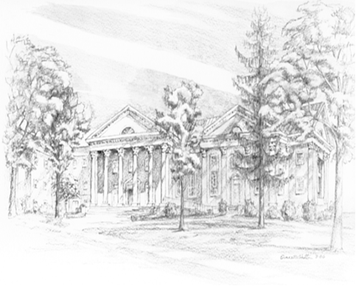

P.O. Box 877
249 South Wayne Avenue
Waynesboro, Virginia
(540) 949-8366
Church Website: www.firstpresway.org
Preschool Website: www.firstprespre.org
Email: church@firstpresway.com

