SEVENTH SUNDAY AFTER PENTECOST July 16, 2023

PRELUDE Canzona Andrea Gabrieli (1533-1585)

WELCOME & ANNOUNCEMENTS

CALL TO WORSHIP Cynthia Hoover
Leader: God calls the weary,
People: saying "Come to me."
Leader: God offers the burdened a gentle yoke,
People: saying, "You will find rest for your souls."
Leader: Draw near to the Lord,
People: whose yoke is easy and whose burden is light.
Let us worship God.

MORNING PRAYER

OPENING HYMN 30 O God, In A Mysterious Way Dundee

CALL TO CONFESSION

PRAYER OF CONFESSION
Merciful God, even as you beckon us toward new life, we focus on comfort and convenience, distracting ourselves with dreams of wealth and power as if they could satisfy the hunger in our souls. Forgive us, Lord, this and all our sin. Free us from the snares that bind us and draw us near to you, until we finally walk with Christ.

SILENT PRAYER

ASSURANCE OF PARDON

*GLORIA PATRI 581 Greatorex

FIRST SCRIPTURE READING Genesis 24:34-38 p.17

SPECIAL MUSIC Voluntary on Blessed Assurance Bert Carlson (b. 1937)

SECOND SCRIPTURE READING Genesis 24:42-49, 58-67 p.17
.
SERMON A Wedding Story.. Patrick Pettit, Interim Pastor

*AFFIRMATION OF FAITH Apostles’ Creed p.35

PRAYERS OF THE PEOPLE & THE LORD’S PRAYER

*CLOSING HYMN 634 To God Be the Glory To God Be the Glory

*CHARGE and BENEDICTION

POSTLUDE Toccata in G Dennis Eliot

*Please stand if able

Hearing devices are available for your convenience.
Please be aware that they do not function until after the service begins.

Today’s link is: https://www.youtube.com/watch?v=syyvC-1ol-w

We welcome guest organist Diane Kingsbury this morning, as Roger and Kimberlea are away celebrating their 35th wedding anniversary. Diane has helped us on numerous occasions over the years, and we are most grateful to her for providing music for our worship service this morning.

The Legacy: Mary June Cook

Regency at Augusta: Edie Lawrence

Shenandoah Nursing Home: Rubye Schwab, Nancy Garber

Home: Dick Huff, Mary Ultee, Mary Ann Maupin, Warner & Linda Sandquist,
Cathy Cunningham, Charles Simpkins

Friends and Family: Erwin Berry (Joan), Bill Bromley, Jean Custen, Jerry Hughes, Sally McNeel, Bill Metzel (Joyce Tipton), Col. Stuart Roberts (Mark Henderson), Paul Watts, Kathleen Clements, (Colleen Cash), Josh Slonaker, Barb Ostrander (Holly Bennett), Marty Rogers (sister of Cathy Cunningham)

Military: Carson Craig

A luncheon, prepared by dedicated volunteers,
will be held in the Barksdale Room after worship today.

FIRST PRESBYTERIAN CHURCH
WAYNESBORO, VIRGINIA

A community-minded congregation living out the love of Christ as we serve one another with humility, gentleness, and patience through God’s grace.

July 16, 2023 11:00 AM

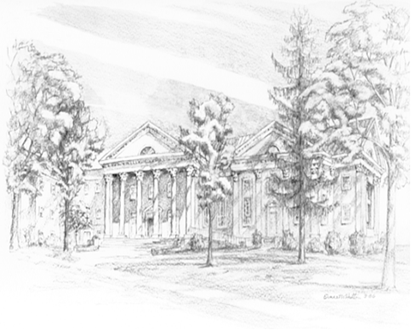

P.O. Box 877
249 South Wayne Avenue
Waynesboro, Virginia
(540) 949-8366
Church Website: www.firstpresway.org
Preschool Website: www.firstprespre.org
Email: church@firstpresway.com

