EIGHTH SUNDAY AFTER PENTECOST July 23, 2023

PRELUDE Ogive No. 1 Satie (1866-1925)

WELCOME & ANNOUNCEMENTS

CALL TO WORSHIP Bill Pannill
Leader: God’s word is a lamp to our feet
People: and a light to our path.
Leader: At table, font, and pulpit,
People: we are rooted in sacred story and grow in faith.
Leader: God’s teachings are our heritage.
People: they bring joy to searching hearts.
Let us worship God.

MORNING PRAYER

OPENING HYMN 282 Come Down, O Love Divine Down Ampney

CALL TO CONFESSION

PRAYER OF CONFESSION
God the Sower, we do not always live as people who seek your will. Like rocky ground, we welcome you when life is simple, but when challenges arise, we forget your teachings and our faith withers. Like a thicket full of thorns, we clamor for more and push out the needy. Forgive us, Lord, this and all our sin. Let your Spirit work within and among us, making of us fertile soil, that your word might grow within us.

SILENT PRAYER

ASSURANCE OF PARDON

*GLORIA PATRI 581 Greatorex

FIRST SCRIPTURE READING Genesis 25:19-26 p.19

SPECIAL MUSIC Gymnopedie No. 1 Satie

SECOND SCRIPTURE READING Genesis 25:27-34 p.19
.
SERMON A story of grace Patrick Pettit, Interim Pastor

*AFFIRMATION OF FAITH Apostles’ Creed p.35

PRAYERS OF THE PEOPLE & THE LORD’S PRAYER

*CLOSING HYMN 459 O Word of God Incarnate Munich

*CHARGE and BENEDICTION

POSTLUDE Sarabande Handel (1635-1759)

*Please stand if able

Hearing devices are available for your convenience.
Please be aware that they do not function until after the service begins.

Today’s link is: https://www.youtube.com/watch?v=BER0lH0vWDk

Thank you to Charles Simpkins for sharing his talents today. Roger and Kimberlea are away hearing their daughter, Celia, play concerts with the Boston Symphony Orchestra. Charles has played piano at FPC on numerous occasions, and we are grateful to him for leading the musical elements of this morning's service.

The Legacy: Mary June Cook

Regency at Augusta: Edie Lawrence

Shenandoah Nursing Home: Rubye Schwab, Nancy Garber

Home: Dick Huff, Mary Ultee, Mary Ann Maupin, Warner & Linda Sandquist,
Cathy Cunningham, Charles Simpkins

Friends and Family: Erwin Berry (Joan), Bill Bromley, Jean Custen, Jerry Hughes, Sally McNeel, Bill Metzel (Joyce Tipton), Col. Stuart Roberts (Mark Henderson), Paul Watts, Kathleen Clements, (Colleen Cash), Josh Slonaker, Barb Ostrander (Holly Bennett), Marty Rogers (sister of Cathy Cunningham)

Military: Carson Craig

We are collecting school supplies for the food bank:
Pencils, Pens, Crayons, Spiral notebooks, and erasers.
Thank you. Cynthia

FIRST PRESBYTERIAN CHURCH
WAYNESBORO, VIRGINIA

A community-minded congregation living out the love of Christ as we serve one another with humility, gentleness, and patience through God’s grace.

July 23, 2023 11:00 AM

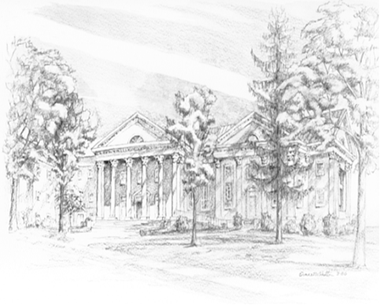

P.O. Box 877
249 South Wayne Avenue
Waynesboro, Virginia
(540) 949-8366
Church Website: www.firstpresway.org
Preschool Website: www.firstprespre.org
Email: church@firstpresway.com

