THIRTEENTH SUNDAY AFTER PENTECOST August 27, 2023

PRELUDE Selected Hymns

WELCOME & ANNOUNCEMENTS

CALL TO WORSHIP
Leader: All who hunger—gather gladly.
People: We come to feast on the life-giving Word.
Leader: Here, love abounds and grace overflows.
People: Here, blessings multiply as gifts are shared.
Leader: Come—let us pour ourselves out in prayer and praise.
People: we are open to renewal and rest.
Leader: Let us worship God.

MORNING PRAYER

OPENING HYMN 396 Brethren, We Have Met to Worship Holy Manna

CALL TO CONFESSION

PRAYER OF CONFESSION
God of power, your mercy descends from heaven to show us a better way. In your hands, the proud are broken, while meager offerings become bread for the world. But we see only scarcity: resources we demand for ourselves; blessings we insist are ours. Forgive us, Lord, this and all our sin. Open our hands to share freely and generously and stretch our hearts to new expressions of love.

SILENT PRAYER

ASSURANCE OF PARDON

*GLORIA PATRI 581 Greatorex

FIRST SCRIPTURE READING Psalm 17:1-7,15 p. 431

CONGREGATIONAL HYMN 471 O Lord, Hear My Prayer Hear My Prayer

SECOND SCRIPTURE READING Genesis 32:22-31 p. 26

SERMON Teachable Moments Patrick Pettit, Interim Pastor

*AFFIRMATION OF FAITH Apostles’ Creed p.35

PRAYERS OF THE PEOPLE & THE LORD’S PRAYER

*CLOSING HYMN 728 Somebody's Knockin' at Your Door Somebody's Knockin'

*CHARGE and BENEDICTION

POSTLUDE Somebody's Knockin' Reprise

*Please stand if able

Hearing devices are available for your convenience.
Please be aware that they do not function until after the service begins.

Today’s link is: https://www.youtube.com/watch?v=xRDLMtwEEFs

The Legacy: Mary June Cook

Shenandoah Nursing Home: Rubye Schwab, Nancy Garber

Home: Dick Huff, Mary Ultee, Mary Ann Maupin, Warner & Linda Sandquist,
Cathy Cunningham, Charles Simpkins

Friends and Family: Erwin Berry (Joan), Bill Bromley, Jean Custen, Jerry Hughes,
Sally McNeel, Bill Metzel (Joyce Tipton), Col. Stuart Roberts (Mark Henderson),
Paul Watts, Kathleen Clements, (Colleen Cash), Josh Slonaker, Barb Ostrander
(Holly Bennett), Marty Rogers (sister of Cathy Cunningham), Brooks Hoover,
Betsy Boswell (Curry)

Military: Carson Craig

Next date to host
August 28

FIRST PRESBYTERIAN CHURCH
WAYNESBORO, VIRGINIA

A community-minded congregation living out the love of Christ as we serve one another with humility, gentleness, and patience through God’s grace.

August 27, 2023 11:00 AM

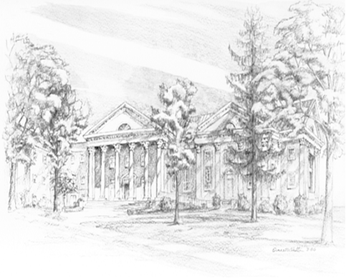

P.O. Box 877
249 South Wayne Avenue
Waynesboro, Virginia
(540) 949-8366
Church Website: www.firstpresway.org
Preschool Website: www.firstprespre.org
Email: church@firstpresway.com

