TENTH SUNDAY AFTER PENTECOST August 6, 2023

PRELUDE Selected Hymns

WELCOME & ANNOUNCEMENTS

CALL TO WORSHIP

Leader: God said, "Let There be Light," and there was light!

People: O Lord our God, how majestic is your name!

Leader: You have set your glory above the heavens.

People: O Lord our God, how majestic is your name!
Leader: Let us worship God.

MORNING PRAYER

OPENING HYMN 634 To God Be the Glory To God Be the Glory

CALL TO CONFESSION

PRAYER OF CONFESSION
O Lord our God, called as your people, we fail to reflect your glory. We neglect our responsibilities and abuse creation. We profess our faith but reject your authority with our actions. Forgive us, Lord, this and all our sin. Restore us by your grace in Jesus Christ. Reorder our lives by the power of the Spirit, that we may serve you faithfully and live in peace with one all.

SILENT PRAYER

ASSURANCE OF PARDON

*GLORIA PATRI 581 Greatorex

FIRST SCRIPTURE READING Psalm 145:1-12 p. 506

CONGREGATION HYMN 499 Bread of the World in Mercy Broken Rendez a Dieu

SECOND SCRIPTURE READING Matthew 14:13-21 p. 796

SERMON So Much Need Ann Pettit, Guest Pastor

*AFFIRMATION OF FAITH The Apostles' Creed Hymnal p. 35

THE LORD’S SUPPER
Invitation
Great Thanksgiving
Communion of the People

*CLOSING HYMN 463 How Firm a Foundation Foundation

*CHARGE and BENEDICTION

POSTLUDE Foundation Reprise

*Please stand if able

Hearing devices are available for your convenience.
Please be aware that they do not function until after the service begins.

Link for this week’s service: https://www.youtube.com/watch?v=BWXiQOiVPK8

The Legacy: Mary June Cook

Shenandoah Nursing Home: Rubye Schwab, Nancy Garber

Home: Dick Huff, Mary Ultee, Mary Ann Maupin, Bird Heuchert,
Warner & Linda Sandquist, Cathy Cunningham, Charles Simpkins

Friends and Family: Erwin Berry (Joan), Bill Bromley, Jerry Hughes, Sally McNeel, Bill Metzel (Joyce Tipton), Col. Stuart Roberts (Mark Henderson), Paul Watts, Kathleen Clements (Colleen Cash). Josh Slonaker, Barb Ostrander (Holly Bennett), Marty Rogers (sister of Cathy Cunningham)

Military: Carson Craig

We welcome Rev Ann Pettit back to our Pulpit today with many “Thanks” for leading us in Worship.

Our Christian sympathies to the family of Edie Lawrence who died July 30, 2023. A graveside service was held on Friday August 4 at Oak Grove Cemetery in Lexington VA. A memorial service is planned for the Fall.

SUGGESTIONS FOR AUGUST MISSION ITEMS:

FOOD BANK – SHAMPOO
HYGIENE KITS – Individually Wrapped TOOTHBRUSHES
School supplies

FIRST PRESBYTERIAN CHURCH
WAYNESBORO, VIRGINIA

A community-minded congregation living out the love of Christ as we serve one another with humility, gentleness, and patience through God’s grace.

August 6, 2023 11:00 AM

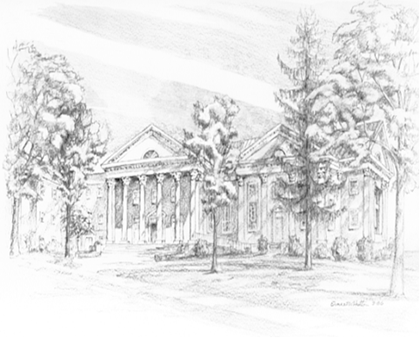
P.O. Box 877
249 South Wayne Avenue
Waynesboro, Virginia
(540) 949-8366
Church Website: www.firstpresway.org
Preschool Website: www.firstprespre.org
Email: church@firstpresway.com

