First Presbyterian Church, Waynesboro, VA
First Presbyterian Church of Waynesboro is a community-minded
congregation living out the love of Christ as we serve one another with
humility, gentleness, and patience through God’s grace.

THE COLUMNS

July 2023, Volume 61, Issue 7

A LITTLE BORDER COLLIE THEOLOGY CAN HELP EXPLAIN THE GOOD SHEPHERD
By Antonio (Tony) Juan Ajo-Torrens, Presbyterians Today)

When someone loses a loved one, we often say things like “God needed another angel.” Really? I don’t think God works that way. There are times when I don’t want theological nuance. All I want is feel-it-in-my-gut-assurance. I want to feel God in my innermost self.
I had the privilege to study under Dr. Wayne Oates, one of the best pastoral care professors around at the time. It was from him I learned how to be a pastoral presence, how to look the mourner in the eye, hold their hand and shut up! Don’t try to explain death, he told his seminary students. At times of suffering, people cannot listen to theological platitudes. They just need a shoulder to cry on.
If you have read books by Isabel Allende or Gabriel Garcia Marque, then you are familiar with “magical realism” – a literary genre that blurs the lines between reality and fantasy, between the here and now, between the heavenly and the earthly. We usually call some of the stories in the Bible metaphor, allegory or simile, but I like magical realism better. I like to think that the ordinary and the extraordinary are held in divine tension. For me, it’s a wonderful way of understanding the unexplainable.
I think Jesus was the first user of magical realism. The imagery of the Good Shepherd makes a lot of sense to me, even though I consider myself to be an urban kid and have never owned sheep. So, if you are anything like me, we may need help understanding the metaphor (or magical realism) of this narrative. I think I can understand it well, though. Why? Because I once had a border collie named Patrick.
It’s been said that when working the dogs will usually be seen in the crouched position, with their eyes fixed on the job at hand. The “hypnotic” eye characteristic is probably more defined in the border collie than any other breed, and it is this quality that makes them so superb at herding sheep, using their eyes to guide a herd without the need to nip or bark.
Here I find an unqualified promise that once we belong to God, we are in God’s hands forever. Listen to the voice of the Good Shepherd. Like a border collie, he rounds us up and protects us and looks at us with eyes of love and understanding and compassion. Let us rejoice in hearing Jesus speak our name. Absorb the grace we have received and experienced in our lives and share that grace with our communities, especially those who suffer not only because of death, but also because of injustice and oppression. Embrace them with your quiet love, look them in the eye and accompany them in their struggle.

(The Rev. Dr. Antonio (Tony) Juan Aja-Torrens is an honorably retired PC(USA) minister. He resides in Florida with his wife, Loyda, and Lucy, a collie mix and beloved companion.)

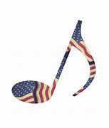
MUSIC NOTES FOR JULY

Happy birthday, America! This month opens with a celebration of our nation’s 247th birthday. Much of the music will reflect our nation’s annual commemoration of our independence.
The prelude was composed by Arthur Foote (1853-1937), a Massachusetts native who studied at the New England Conservatory of Music and what was then Harvard College. Foote also received a Master of Arts degree in music from Harvard, the first such degree conferred in America. He was the first noteworthy American composer to be trained entirely in the United States. Foote was one of the founders of the American Guild of Organists, which he served as president for three years.
The Introit, Lift Every Voice and Sing, was composed by two brothers. James Weldon Johnson wrote the text in 1900. Five years later, his brother, John Rosamond Johnson, composed the music for the anniversary of Abraham Lincoln’s birth. The other hymns celebrating Independence Day will be America (My Country, ‘Tis of Thee) and Materna (O Beautiful for Spacious Skies).
Young musicians from the Heifetz International Music Institute in Staunton will join us for the service on July 9. FPC has been fortunate over these past few years to work with the Institute, which brings talented high school and college musicians to Staunton for the summer to hone their skills.

July 17 marks our (Roger and Kimberlea’s) 35th wedding anniversary. As many of you know, we were married at FPC in 1988. We feel extremely fortunate to make music in the place where our union was blessed! The wonderfully capable and kind Diane Kingsbury will play our historic 1893 Woodberry and Harris organ on Sunday, July 16. We will also be away the following Sunday, July 23, as our daughter, Celia, has been asked to play two concerts with the Boston Symphony Orchestra!

We continue to be grateful to FPC for the support of the music program.

Blessings –
Roger and Kimberlea Daggy

SESSION HIGHLIGHTS

Session held a Stated Meeting on June 13, 2023.
- The minutes of the April 11 Stated Session Meeting and the April 16 Congregational Meeting were approved. The scheduled Session Meeting for May 9 was not held for lack of a quorum.
- The Clerk reported attending a meeting of Clerks at Third PC in Staunton at which the 2022 Session Minutes were stamped by Presbytery with “no exceptions”.
- Commissioner Betsy Ruehl reported on the May 20 meeting of Shenandoah Presbytery. {A summary was provided in the June Columns.}
- Session approved gifts recognizing accomplishments of Nate, Cole and Carolyn Rudin.
- Session approved an after-church Social for Sunday, July 16.
- Cynthia Hoover provided the May Mission/Outreach report. Next Disciples’ Kitchen is June 27. Peanut butter, a primary household staple, currently is unavailable from the Blue Ridge Area Food Bank in Verona.
- Session reaffirmed a motion to accept the proposal from Quality Enterprises to replace the sanctuary roof at a cost of $485,000.
- Rev. April Cranford and Rev. Pettit participated in a Pulpit Exchange on April 30. Elder Terry Crickenberger, seminary student, led worship on June 11.
- Session reaffirmed a motion that Rev. Pettit apply for a grant from the Board of Pensions. He plans to take a week of continuing education July 23-30, 2023, to participate in a Clergy Wellness Retreat.
- Betsy Ruehl reported on the Better Together Presbyterian meeting. A one-day combined Vacation Bible School is scheduled for Saturday, July 8, at Hermitage PC.
- The next scheduled Session Meeting is July 11, 2023.
- All Session meetings are opened and closed with prayer.
--Betsy Ruehl, Clerk of Session

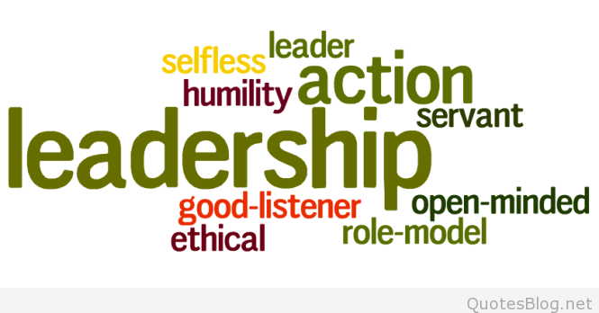

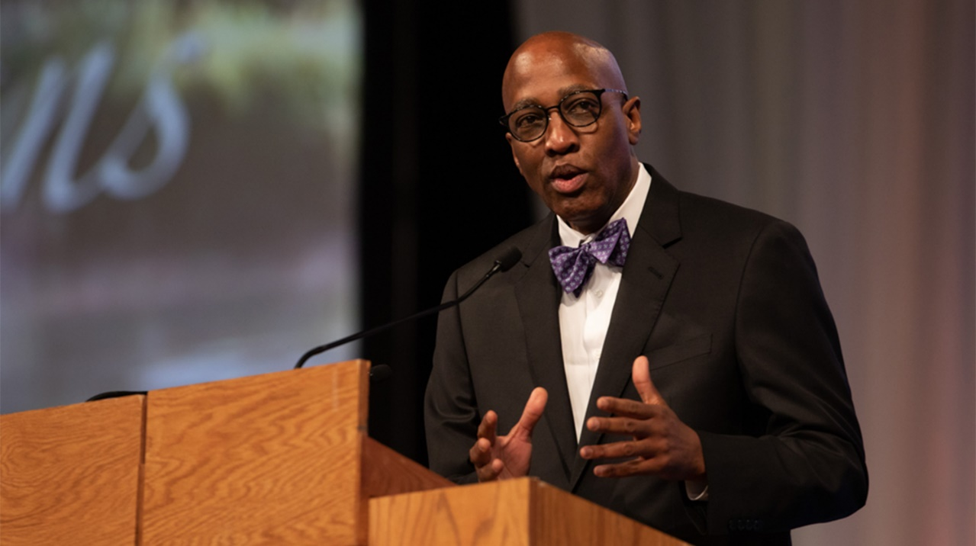

REV. J. HERBERT NELSON, II, STATED CLERK OF THE PC(USA) RETIRES.
SHENANDOAH GENERAL PRESBYTER & STATED CLERK, REV. BRONWEN BOSWELL, APPOINTED ACTING STATED CLERK

At the end of June Rev. J. Herbert Nelson, II, concluded his historic tenure as Stated Clerk of the General Assembly of the PC(USA). Throughout his seven years in this role, his leadership has inspired the Presbyterian Historical Society, reminding us all that history can inform, inspire, and hold accountable the denomination and its future. Not only is he the first African American to serve as Stated Clerk, the top ecclesial officer of the denomination, but he had previously served as Director of the PC(USA) Office of Public Witness in Washington, DC. As pastor of St. James Presbyterian Church in Greensboro, NC, he advocated for workers’ rights and as organizer of Liberation Community Presbyterian Church in Memphis, TN, he gathered an intentional community that reached out to its neighbors.

Filling the unexpired term of the Rev. J. Herbert Nelson, II, our own Shenandoah Presbytery executive assumes the role of Stated Clerk of the PC(USA) for the coming year, effective July 10.
Rev. Boswell says “My task, as I see it, as Acting Stated Clerk, is to be a bridge in this between time of elected Stated Clerk, preparing General Assembly and working with the committees that will need to report to GA next year, specifically the Commission on Unification. My background as a presbytery stated clerk, mid-council leader and interim pastor along with my years as a parliamentarian for GA committees and plenary sessions should stand me in good stead as I seek to lead in this interim time with energy, intelligence, imagination, and love.”

Rev. Boswell joins the staff at a pivotal time in the denomination as the Office of the General Assembly and Presbyterian Mission Agency begin the move toward unification.
A graduate of St. Andrews Presbyterian College with a Master of Divinity from Princeton Theological Seminary, Rev. Boswell is married to the Rev. Howard W. Boswell, Jr., pastor of Buena Vista Presbyterian Church.
Shenandoah Presbytery has granted Rev. Boswell a leave of absence. Plans are being made to help cover many of the facets of her position. The election of a new Stated Clerk will be held at the 226th General Assembly in Salt Lake City, Utah, in the summer of 2024.

(Information from PC(USA) website)
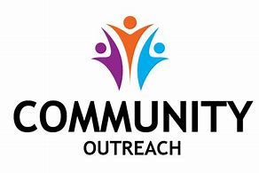

MISSION/OUTREACH MAY 2023

- Ordered and received food from Blue Ridge Area Food Bank May 9 and 23. Volunteers assembled 20 pantry boxes for each order.
- Maintained temperature logs for refrigerators and freezers.
- Food Bank May 4, 11, 18 and 25.
- Purchased eggs, bread, and margarine for Food Bank weekly.
- Updated weekly shopping list for extra options.
- Completed pantry inventory and report: Served 222 individuals for the month of May and 76 households. Included is a Syrian refugee family of seven.
- Served 72 meals at Disciples’ Kitchen May 30.
- May: Collected individually wrapped toothbrushes for hygiene kits. Collected chicken noodle soup for Food Bank.
- June: Still collecting toothbrushes for hygiene kits. Collecting peanut butter for Food Bank.
--Cynthia Hoover, Mission Chair

SUGGESTIONS FOR JULY MISSION ITEMS:

FOOD BANK – SHAMPOO
HYGIENE KITS – Individually Wrapped TOOTHBRUSHES

INDEPENDENCE DAY – JULY 4
Patriotic Quotes from the Famous

Erma Bombeck: “You have to love a nation that celebrates its independence every July 4, not with a parade of guns, tanks and soldiers who file by the White House in a show of strength and muscle, but with family picnics where kids throw Frisbees, the potato salad gets iffy, and the flies die from happiness. You may think you have overeaten, but it is patriotism.”

Dwight D. Eisenhower: “Freedom has its life in the hearts, the actions, the spirit of men and so it must be daily earned and refreshed – else like a flower cut from its life-giving roots, it will wither and die.”

Thomas Paine: “Those who expect to read the blessings of freedom, must, like men, undergo the fatigue of supporting it.”

Lee Greenwood: “And I’m proud to be an American, where at least I know I’m free. And I won’t forget the men who died, who gave that right to me.”

John Quincy Adams: All men profess honesty as long as they can. To believe all men honest would be folly. To believe none so is something worse.”

Woodrow Wilson: “The American Revolution was a beginning, not a consummation.”

John F. Kennedy: “And so, my fellow Americans, ask not what your country can do for you – ask what you can do for your country. My fellow citizens of the world: ask not what America can do for you, but what together we can do for the freedom of man.”

Dear Congregation,

June brought in another year of Summer Camp. We welcomed both new and old faces with open arms.
The children spent time learning and making crafts on Safari Animals, Camping Trips, Aquatic Animals, and The 4th of July. Our annual water day will be celebrated on June 29.

We will be closed July 3 and 4 in celebration of Independence Day.
We have many more fun activities planned for the remainder of Summer Camp.
Our Preschool year will start August 7.

God Bless,
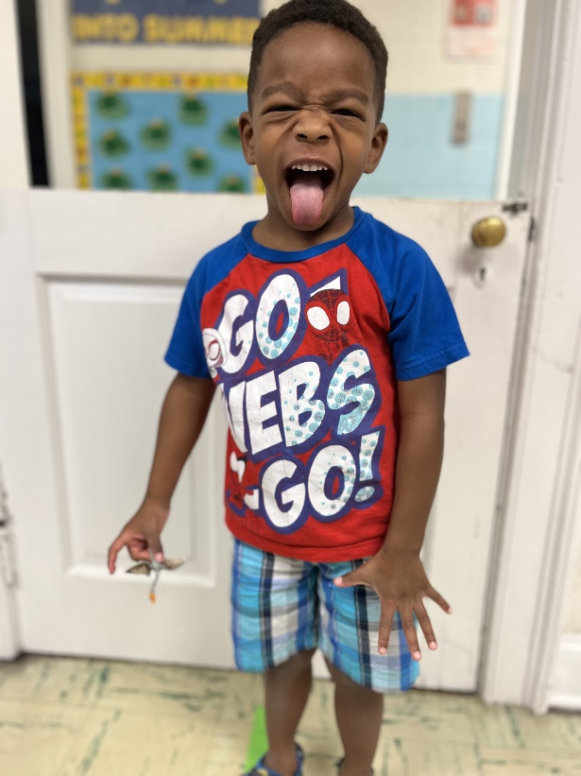
Nate Rudin, Director

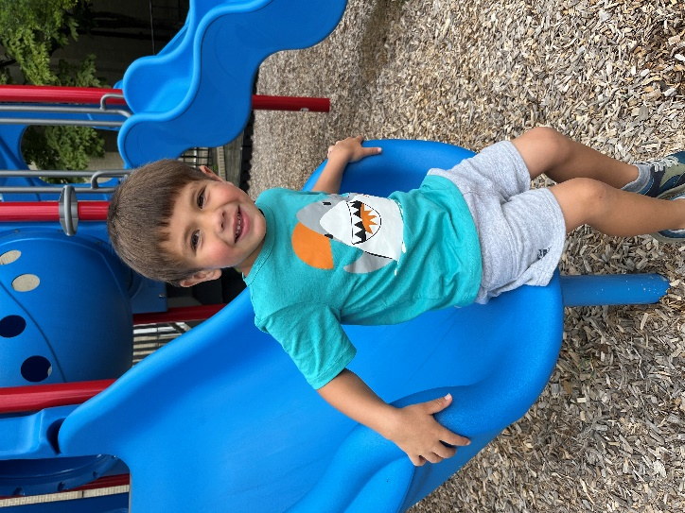
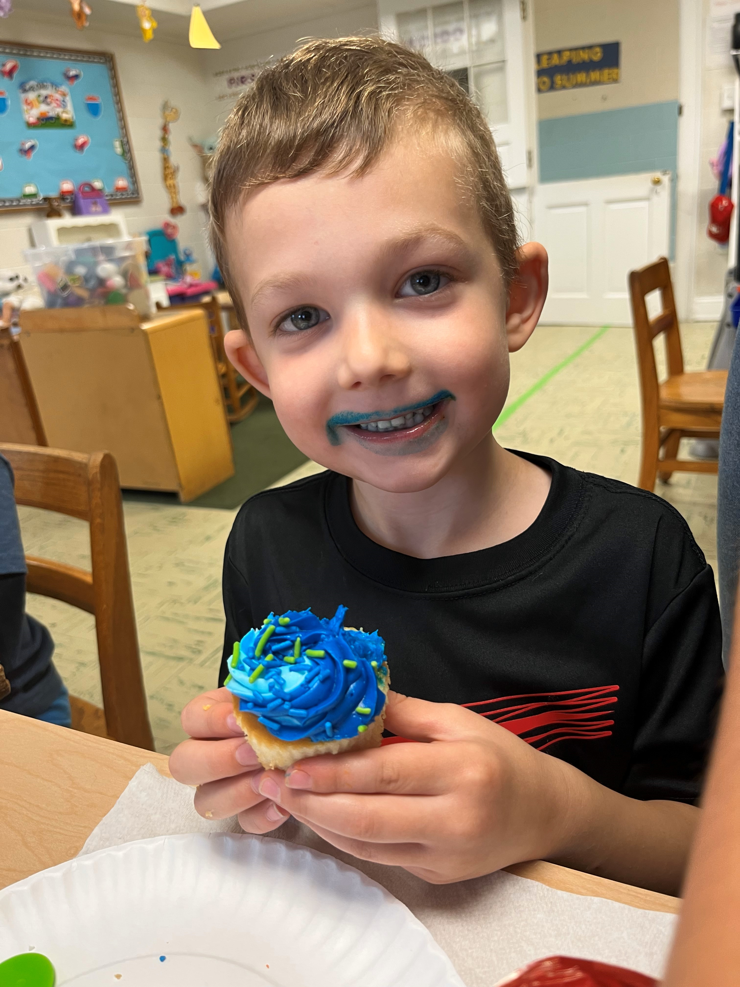

2 Mary June Cook

4 Mike Cunningham

9 Mary Ultee

10 Edie Lawrence

18 Earlene Templeman

21 Ruth Quillen

7 Don & Jeannie Hashagen
7 Randy & Nancy Hypes
17 Roger & Kimberlea Daggy

LITURGISTS

2 Betsy Ruehl

9 Jean Hashagen

16 Cynthia Hoover

23 Bill Pannill

Mailing Address
P. O. Box 877
Waynesboro, VA 22980
Phone
540.949.8366
Fax
540.949.5750
E-mail
church@firstpresway.com
Website
www.firstpresway.org

Church Office Hours
Monday-Wednesday
8 a.m. – 2:30 p.m.
Thursday
8 a.m. – 4:30 p.m.

Interim Pastor
Rev. Patrick S. Pettit
pspettit@gmail.com

Administrative Assistant
Mrs. Colleen Cash
ccash@firstpresway.com

Preschool Director
Mr. Nate Rudin
preschool@firstpresway.com

Director of Music
Mr. Roger Daggy
firstpreswaymusic@gmail.com

Music Associate
Mrs. Kimberlea Daggy
firstpreswaymusic@gmail.com

Audio/Visual Technician
Mr. Craig Cavanaugh

Maintenance Technician
Mr. Michael Griffith

Housekeeping
Jessica Adams

JULY

Saturday, July 1 Girl Scout Graduation-Fellowship Hall
Sunday, July 2
11 AM Worship Service
Thursday, July 6
6-7:30 PM Food Bank
Sunday, July 9
11 AM Worship Service
Tuesday, July 11
2:30 PM Session Meeting, Room 212
Thursday, July 13
2-4 PM Food Bank
Sunday, July 16
11 AM Worship Service / Luncheon
Thursday, July 20
6-7:30 PM Food Bank
Sunday, July 23
11 AM Worship Service
Thursday, July 27
2-4 PM Food Bank
Sunday, July 30
11 AM Worship Service

SAVE THE DATE
AFTER WORSHIP SOCIAL
JULY 16

First Presbyterian Church, Waynesboro, VA
First Presbyterian Church of Waynesboro is a community-minded
congregation living out the love of Christ as we serve one another with
humility, gentleness, and patience through God’s grace.

First Presbyterian Church, Waynesboro, VA
First Presbyterian Church of Waynesboro is a community-minded
congregation living out the love of Christ as we serve one another with
humility, gentleness, and patience through God’s grace.

First Presbyterian Church, Waynesboro, VA
First Presbyterian Church of Waynesboro is a community-minded
congregation living out the love of Christ as we serve one another with
humility, gentleness, and patience through God’s grace.

First Presbyterian Church, Waynesboro, VA
First Presbyterian Church of Waynesboro is a community-minded
congregation living out the love of Christ as we serve one another with
humility, gentleness, and patience through God’s grace.

First Presbyterian Church, Waynesboro, VA
First Presbyterian Church of Waynesboro is a community-minded
congregation living out the love of Christ as we serve one another with
humility, gentleness, and patience through God’s grace.

First Presbyterian Church, Waynesboro, VA
First Presbyterian Church of Waynesboro is a community-minded
congregation living out the love of Christ as we serve one another with
humility, gentleness, and patience through God’s grace.

First Presbyterian Church, Waynesboro, VA
First Presbyterian Church of Waynesboro is a community-minded
congregation living out the love of Christ as we serve one another with
humility, gentleness, and patience through God’s grace.

First Presbyterian Church, Waynesboro, VA
First Presbyterian Church of Waynesboro is a community-minded
congregation living out the love of Christ as we serve one another with
humility, gentleness, and patience through God’s grace.

First Presbyterian Church, Waynesboro, VA
First Presbyterian Church of Waynesboro is a community-minded
congregation living out the love of Christ as we serve one another with
humility, gentleness, and patience through God’s grace.

First Presbyterian Church, Waynesboro, VA
First Presbyterian Church of Waynesboro is a community-minded
congregation living out the love of Christ as we serve one another with
humility, gentleness, and patience through God’s grace.

First Presbyterian Church, Waynesboro, VA
First Presbyterian Church of Waynesboro is a community-minded
congregation living out the love of Christ as we serve one another with
humility, gentleness, and patience through God’s grace.

First Presbyterian Church, Waynesboro, VA
First Presbyterian Church of Waynesboro is a community-minded
congregation living out the love of Christ as we serve one another with
humility, gentleness, and patience through God’s grace.

First Presbyterian Church, Waynesboro, VA
First Presbyterian Church of Waynesboro is a community-minded
congregation living out the love of Christ as we serve one another with
humility, gentleness, and patience through God’s grace.

First Presbyterian Church, Waynesboro, VA
First Presbyterian Church of Waynesboro is a community-minded
congregation living out the love of Christ as we serve one another with
humility, gentleness, and patience through God’s grace.

First Presbyterian Church, Waynesboro, VA
First Presbyterian Church of Waynesboro is a community-minded
congregation living out the love of Christ as we serve one another with
humility, gentleness, and patience through God’s grace.

First Presbyterian Church, Waynesboro, VA
First Presbyterian Church of Waynesboro is a community-minded
congregation living out the love of Christ as we serve one another with
humility, gentleness, and patience through God’s grace.

First Presbyterian Church, Waynesboro, VA
First Presbyterian Church of Waynesboro is a community-minded
congregation living out the love of Christ as we serve one another with
humility, gentleness, and patience through God’s grace.

First Presbyterian Church, Waynesboro, VA
First Presbyterian Church of Waynesboro is a community-minded
congregation living out the love of Christ as we serve one another with
humility, gentleness, and patience through God’s grace.

First Presbyterian Church, Waynesboro, VA
First Presbyterian Church of Waynesboro is a community-minded
congregation living out the love of Christ as we serve one another with
humility, gentleness, and patience through God’s grace.

First Presbyterian Church, Waynesboro, VA
First Presbyterian Church of Waynesboro is a community-minded
congregation living out the love of Christ as we serve one another with
humility, gentleness, and patience through God’s grace.

First Presbyterian Church, Waynesboro, VA
First Presbyterian Church of Waynesboro is a community-minded
congregation living out the love of Christ as we serve one another with
humility, gentleness, and patience through God’s grace.

First Presbyterian Church, Waynesboro, VA
First Presbyterian Church of Waynesboro is a community-minded
congregation living out the love of Christ as we serve one another with
humility, gentleness, and patience through God’s grace.

First Presbyterian Church, Waynesboro, VA
First Presbyterian Church of Waynesboro is a community-minded
congregation living out the love of Christ as we serve one another with
humility, gentleness, and patience through God’s grace.

First Presbyterian Church, Waynesboro, VA
First Presbyterian Church of Waynesboro is a community-minded
congregation living out the love of Christ as we serve one another with
humility, gentleness, and patience through God’s grace.

First Presbyterian Church, Waynesboro, VA
First Presbyterian Church of Waynesboro is a community-minded
congregation living out the love of Christ as we serve one another with
humility, gentleness, and patience through God’s grace.

