FOURTEENTH SUNDAY AFTER PENTECOST September 3, 2023

PRELUDE Selected Hymns

WELCOME & ANNOUNCEMENTS

CALL TO WORSHIP
Children of God, come to the waters.
We gather to be restored and renewed.
Come, with your faith and your doubt.
We respond to the one who claims and calls us.
Come, Christ summons us to draw near.
Let us worship God with joy and thanksgiving!

MORNING PRAYER

OPENING HYMN 449 Show Us, O Lord, Your Steadfast Love Mendon

CALL TO CONFESSION

PRAYER OF CONFESSION
Lord, we long to draw close to you, but we are afraid. Your summons requires us to step out in faith, when we do not know what awaits us. We are wary of taking risks for your sake because the chaos around us seems stronger than your assurances to us. Forgive us Lord, this and all our sin. Reach out your hand and lift us from our fear that we might follow you faithfully.

SILENT PRAYER

ASSURANCE OF PARDON

*GLORIA PATRI 581 Greatorex

FIRST SCRIPTURE READING Psalm 85:8-13 p. 473

ANTHEM Let Us Break Bread Together arr. Althouse (b. 1951)
Jean Hashagen, soprano
(Text can be found in hymn 525)

SECOND SCRIPTURE READING Romans 10:5-15 p.921

SERMON Confess.. Patrick Pettit, Interim Pastor

*AFFIRMATION OF FAITH The Apostles' Creed Hymnal p. 35

THE LORD’S SUPPER
Invitation
Great Thanksgiving
Communion of the People

*CLOSING HYMN 393 O Day of Rest and Gladness Es flog ein kleins Waldvögelein

*CHARGE and BENEDICTION

POSTLUDE Es flog ein kleins Waldvögelein Reprise

*Please stand if able

Hearing devices are available for your convenience.
Please be aware that they do not function until after the service begins.

Link for this week’s service: https://www.youtube.com/watch?v=LWrp-_LWA1s

The Legacy: Mary June Cook

Shenandoah Nursing Home: Rubye Schwab, Nancy Garber

Home: Dick Huff, Mary Ultee, Mary Ann Maupin, Bird Heuchert,
Warner & Linda Sandquist, Cathy Cunningham

Friends and Family: Erwin Berry (Joan), Bill Bromley, Jerry Hughes, Sally McNeel, Bill Metzel (Joyce Tipton), Col. Stuart Roberts (Mark Henderson), Paul Watts, Kathleen Clements (Colleen Cash). Josh Slonaker, Barb Ostrander (Holly Bennett), Marty Rogers (sister of Cathy Cunningham), Robin Crowder, Brooks Hoover, Betsy Boswell (Curry)

Military: Carson Craig
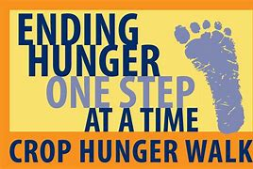

CROP WALK
Sunday, September 24, 2023

Join the Better Together CROP Team to raise funds for Waynesboro/East Augusta CROP Hunger Walk on Sunday, September 24, at 2:00 p.m. This year the participating Better Together Churches, including Westminster PC, Second PC and First PC (and possibly others), will be sponsoring the CROP Walk as a group. They will also provide a joint fellowship potluck lunch at Ridgeview Park’s Woodland Shelter near the Serenity Garden from 12:30-1:30 before the 2:00 send-off.
Anyone wishing to walk should contact Cynthia Hoover at (540) 946-8596. Make out checks to support these walkers to CWS/CROP. Donations of any size may be given to Cynthia or through the Church Office.
Stay tuned, closer to the time, for details about the Potluck. All congregational members are invited!

FIRST PRESBYTERIAN CHURCH
WAYNESBORO, VIRGINIA

A community-minded congregation living out the love of Christ as we serve one another with humility, gentleness, and patience through God’s grace.

September 3, 2023 11:00 AM

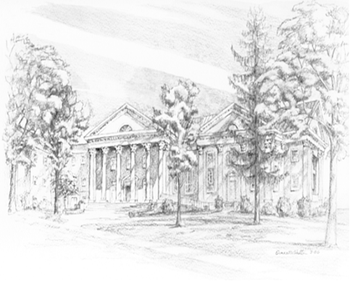
P.O. Box 877
249 South Wayne Avenue
Waynesboro, Virginia
(540) 949-8366
Church Website: www.firstpresway.org
Preschool Website: www.firstprespre.org
Email: church@firstpresway.com

