EIGHTEENTH SUNDAY AFTER PENTECOST October 1, 2023

PRELUDE Prelude in F, BuxWV 145 Buxtehude (1637-1707)

WELCOME & ANNOUNCEMENTS

INTROIT Alleluia Milburn (b. 1963)

CALL TO WORSHIP
Leader: We gather with Christians near and far to sit at table with the Lord.
People: Let us share the bread of life and pass the cup of salvation.
Leader: At God’s table, there is room enough for all.
People: Praise the Lord, who invites us to His joyful feast!
Leader: Let us worship God.

MORNING PRAYER

OPENING HYMN 396 Brethren, We Have Met to Worship Holy Manna

CALL TO CONFESSION

PRAYER OF CONFESSION
Loving Lord, you desire for us we the same mind as Christ, but our minds fix on attitudes and ambitions that draw us away from you. We labor for ourselves before considering how our time and talents could bless the world. We look up to the rich and famous and overlook the lowly, rather than affirming the dignity of all. Transform us, we pray. By your grace, give us the same mind and the same love as our Lord Jesus Christ, and work within us until our actions bear witness to the faith our tongues confess.

SILENT PRAYER

ASSURANCE OF PARDON

*GLORIA PATRI 581 Greatorex

FIRST SCRIPTURE READING Psalm 25:1-10 p.436

ANTHEM In Remembrance Red (1936-2013)
(text can be found in hymn 521)

SECOND SCRIPTURE READING Matthew 21:23-32 p. 802

SERMON Public Opinion Patrick Pettit, Interim Pastor

*AFFIRMATION OF FAITH The Apostles' Creed Hymnal p. 35

THE LORD’S SUPPER
Invitation
Great Thanksgiving
Communion of the People

*CLOSING HYMN 498 Loaves were Broken Beach Spring

*CHARGE and BENEDICTION

POSTLUDE Fugue in F, BuxWV 145 Buxtehude

*Please stand if able

Hearing devices are available for your convenience.
Please be aware that they do not function until after the service begins.

Link for this week’s service: https://www.youtube.com/watch?v=UDQRZDHV6GA

The Legacy: Mary June Cook

Shenandoah Nursing Home: Rubye Schwab, Nancy Garber

Home: Dick Huff, Mary Ultee, Mary Ann Maupin, Warner & Linda Sandquist,
Cathy Cunningham

Friends and Family: Erwin Berry (Joan), Bill Bromley, Jerry Hughes, Sally McNeel, Bill Metzel (Joyce Tipton), Col. Stuart Roberts (Mark Henderson), Paul Watts, Kathleen Clements (Colleen Cash). Josh Slonaker, Barb Ostrander (Holly Bennett), Marty Rogers (sister of Cathy Cunningham), Brooks Hoover, Betsy Boswell (Curry)

Military: Carson Craig

Better Together Bible Study

Will be held Monday Oct 2 at Smyrna Presbyterian Church from 1pm-2pm.
John Tindall, DCE at Westminster PC, will lead the exploration of the great stories and themes of the Bible. Make plans to attend! Class is open to all! Come regularly or when you can!

FIRST PRESBYTERIAN CHURCH
WAYNESBORO, VIRGINIA

A community-minded congregation living out the love of Christ as we serve one another with humility, gentleness, and patience through God’s grace.

October 1, 2023 11:00 AM

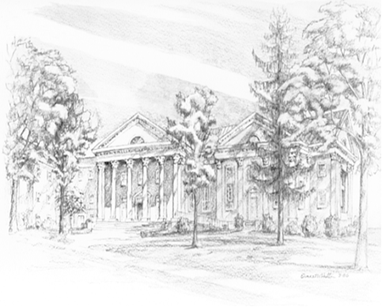
P.O. Box 877
249 South Wayne Avenue
Waynesboro, Virginia
(540) 949-8366
Church Website: www.firstpresway.org
Preschool Website: www.firstprespre.org
Email: church@firstpresway.com

