FIFTEENTH SUNDAY AFTER PENTECOST September 10, 2023

PRELUDE Prelude on Darwall’s 148th

WELCOME & ANNOUNCEMENTS

CALL TO WORSHIP
Leader: Our help is in the name of the Lord
People: who made heaven and earth. (Ps. 124:8)
Leader: “I am the vine,” says our Lord. “You are the branches. Those who live in me and I in them bear much fruit. Without me you can do nothing.” (John 17:17)

MORNING PRAYER

OPENING HYMN 305 Come Sing, O Church, in Joy Darwall’s 148th

CALL TO CONFESSION

PRAYER OF CONFESSION
Almighty God, you poured out your Spirit upon gathered disciples, creating bold tongues, open ears, and a new community of faith. We confess that we hold back the force of your Spirit among us. We do not listen to your word of grace, speak the good news of your love, live as people made one by Christ, or serve others with a strength that comes from you. Have mercy on us, O God. Transform our timid lives by the power of your Spirit and fill us with a flaming desire to be your faithful people, doing your will for the sake of Jesus Christ our Lord.

SILENT PRAYER

ASSURANCE OF PARDON

*GLORIA PATRI 581 Greatorex

FIRST SCRIPTURE READING Acts 2:1-13, 42-47. p.885

CONGREGATIONAL HYMN 321 The Church’s One Foundation Aurelia

SERMON The Four Dimensions of the Church Rev. Malcolm Brownlee
Guest Pastor

*AFFIRMATION OF FAITH Apostles’ Creed p.35

PRAYERS OF THE PEOPLE & THE LORD’S PRAYER

*CLOSING HYMN 307 God of Grace and God of Glory Cwm Rhondda

*CHARGE and BENEDICTION

POSTLUDE Cwm Rhondda Reprise

*Please stand if able

Hearing devices are available for your convenience.
Please be aware that they do not function until after the service begins.

Today’s link is: https://www.youtube.com/watch?v=MOAdrJQ7K-o

The Legacy: Mary June Cook

Shenandoah Nursing Home: Rubye Schwab, Nancy Garber

Home: Dick Huff, Mary Ultee, Mary Ann Maupin, Warner & Linda Sandquist,
Cathy Cunningham

Friends and Family: Erwin Berry (Joan), Bill Bromley, Jean Custen, Jerry Hughes,
Sally McNeel, Bill Metzel (Joyce Tipton), Col. Stuart Roberts (Mark Henderson),
Paul Watts, Kathleen Clements, (Colleen Cash), Josh Slonaker, Barb Ostrander
(Holly Bennett), Marty Rogers (sister of Cathy Cunningham), Brooks Hoover,
Betsy Boswell (Curry), Robin Crowder

Military: Carson Craig

We welcome Rev. Brownlee and thank him for leading us today in Worship.

A Memorial Gathering will be held Saturday, September 23, for Edie Lawrence, at the Orchard Creek Restaurant (Waynesboro Country Club) from 2-4 pm.
Please call Mary Beth Hill with any concerns 207-441-2735 .

MAKE PLANS TO ATTEND THE BETTER TOGETHER BIBLE STUDIES!

The first of an ongoing series of Better Together Bible Studies begins this coming Monday. John Tindall, DCE at Westminster PC, will lead the exploration of the great stories and themes of the Bible. Locations will rotate among the Better Together churches.
Monday, September 11, Second Presbyterian Church will host from 1:00-2:00. Other host churches include Smyrna (first Monday), Hermitage (third Monday), Finley Memorial (fourth Monday) and First (fifth Monday).
Make plans to attend! Class open to all! Come regularly or when you can!

FIRST PRESBYTERIAN CHURCH
WAYNESBORO, VIRGINIA

A community-minded congregation living out the love of Christ as we serve one another with humility, gentleness, and patience through God’s grace.

September 10, 2023 11:00 AM

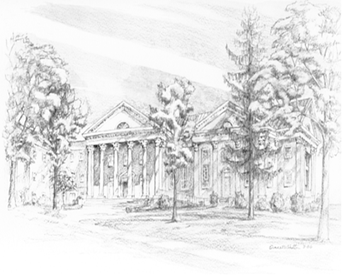

P.O. Box 877
249 South Wayne Avenue
Waynesboro, Virginia
(540) 949-8366
Church Website: www.firstpresway.org
Preschool Website: www.firstprespre.org
Email: church@firstpresway.com

