SIXTEENTH SUNDAY AFTER PENTECOST September 17, 2023

PRELUDE Selected Hymns

WELCOME & ANNOUNCEMENTS

CALL TO WORSHIP
Leader: God is our refuge and strength.
People: The LORD is become our salvation!
Leader: Come, let us sing to the Lord.
People: Come to the font of Salvation.
Leader: Let us worship God.

MORNING PRAYER

OPENING HYMN 435 There’s a Wideness in God’s Mercy In Babilone

CALL TO CONFESSION

PRAYER OF CONFESSION
Loving God, you Call us to loving service, but our lives do not always reflect your transforming power. Where you are gracious, we cling to judgment. Where you are kind, too often we are dismissive, or cruel. You are eternally forgiving, but we hold onto grudges and keep old wounds open. Forgive us, Lord, this and all our sin. Fill us with your Holy Spirit, and make us new through Christ, your Son and our Savior. Amen.

SILENT PRAYER

ASSURANCE OF PARDON

*GLORIA PATRI 581 Greatorex

FIRST SCRIPTURE READING Psalm 114 p.491

CONGREGATIONAL HYMN 442 Just As I Am Woodworth

SECOND SCRIPTURE READING Matthew 18:21-35 p.800

SERMON The Forgiveness Perspective Patrick S Pettit
Interim Pastor

*AFFIRMATION OF FAITH Apostles’ Creed p.35

PRAYERS OF THE PEOPLE & THE LORD’S PRAYER

*CLOSING HYMN 838 Standing on the Promises Promises
(stanzas 1 and 4)

*CHARGE and BENEDICTION

POSTLUDE Reprise Promises

*Please stand if able

Hearing devices are available for your convenience.
Please be aware that they do not function until after the service begins.

Today’s link is: https://www.youtube.com/watch?v=tT_NpYwcfRk

The Legacy: Mary June Cook

Shenandoah Nursing Home: Rubye Schwab, Nancy Garber

Home: Dick Huff, Mary Ultee, Mary Ann Maupin, Warner & Linda Sandquist,
Cathy Cunningham

Friends and Family: Erwin Berry (Joan), Bill Bromley, Jean Custen, Jerry Hughes,
Sally McNeel, Bill Metzel (Joyce Tipton), Col. Stuart Roberts (Mark Henderson),
Paul Watts, Kathleen Clements, (Colleen Cash), Josh Slonaker, Barb Ostrander
(Holly Bennett), Marty Rogers (sister of Cathy Cunningham), Brooks Hoover,
Betsy Boswell (Curry), Robin Crowder

Military: Carson Craig

A Memorial Gathering will be held Saturday, September 23, for Edie Lawrence, at the Orchard Creek Restaurant (Waynesboro Country Club) from 2-4 pm.
Please call Mary Beth Hill with any concerns 207-441-2735.

Better Together Lunch

The Better Together Presbyterian churches will gather for a picnic lunch after worship on Sunday, 9/24 at the Woodland Pavilion at Ridgeview Park prior to the CROP Walk. All are welcome whether or not you’re walking. Each congregation will provide a different component and we're providing hot dogs.
Access to the pavilion is available without having to walk from the parking lot, directions to follow. We'll need a pretty firm number, so please RSVP to the church office by 9/19.
Come and join your Presbyterian friends and neighbors for a couple of hours of fun and fellowship!
MAKE PLANS TO ATTEND THE BETTER TOGETHER BIBLE STUDIES!

The second of an ongoing series of Better Together Bible Studies takes place tomorrow. John Tindall, DCE at Westminster PC, will lead the exploration of the great stories and themes of the Bible. Locations will rotate among the Better Together churches.
Monday, September 18, Hermitage Presbyterian Church will host from 1:00-2:00. Other host churches include Smyrna (first Monday), Second (second Monday), Finley Memorial (fourth Monday) and First (fifth Monday).
Make plans to attend! Class is open to all! Come regularly or when you can!

FIRST PRESBYTERIAN CHURCH
WAYNESBORO, VIRGINIA

A community-minded congregation living out the love of Christ as we serve one another with humility, gentleness, and patience through God’s grace.

September 17, 2023 11:00 AM

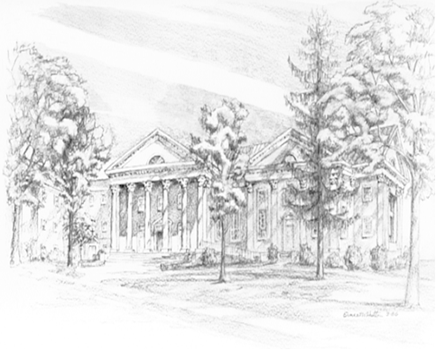

P.O. Box 877
249 South Wayne Avenue
Waynesboro, Virginia
(540) 949-8366
Church Website: www.firstpresway.org
Preschool Website: www.firstprespre.org
Email: church@firstpresway.com

