SEVENTEENTH SUNDAY AFTER PENTECOST September 24, 2023

PRELUDE Melodia, Op. 129, no. 4 Reger (1873-1916)

WELCOME & ANNOUNCEMENTS

INTROIT Now Enter In Hebble (1934-2020)

CALL TO WORSHIP
Leader: Let us declare the abiding love of God in the morning,
People: And display the faithfulness of the Lord all day long.
Leader: Let us worship God.

MORNING PRAYER

OPENING HYMN 41 O Worship the King, All Glorious Above Lyons

CALL TO CONFESSION

PRAYER OF CONFESSION
Almighty God, you call us to enrich people’s lives with the good news of Jesus Chris, but we focus instead on our own well-being, squandering your gifts on schemes that do not satisfy. Called to share your great love, we instead take it for granted. Forgive us, Lord, this and all our sin. Help us to share the spiritual treasure with which you have endowed us, knowing as we do, more, much more, will be given.

SILENT PRAYER

ASSURANCE OF PARDON

*GLORIA PATRI 581 Greatorex

FIRST SCRIPTURE READING Psalm 145:1-9 p. 506

ANTHEM A Hymn of Glory, Let Us Sing The Agincourt Song (c. 1415)

SECOND SCRIPTURE READING Matthew 20: L1-16 p. 801

SERMON Scandal. Patrick S Pettit, Interim Pastor

*AFFIRMATION OF FAITH Apostles’ Creed p.35

PRAYERS OF THE PEOPLE & THE LORD’S PRAYER

*CLOSING HYMN 625 How Great Thou Art How Great Thou Art (stanzas 1 and 4)

*CHARGE and BENEDICTION

POSTLUDE Sonata in B-flat, Op. 65, no. 4: I Mendelssohn (1809-1847)

*Please stand if able

Hearing devices are available for your convenience.
Please be aware that they do not function until after the service begins.

Today’s link is: https://www.youtube.com/watch?v=eFdzyTGQ-TI

The Legacy: Mary June Cook

Shenandoah Nursing Home: Rubye Schwab, Nancy Garber

Home: Dick Huff, Mary Ultee, Mary Ann Maupin, Warner & Linda Sandquist,
Cathy Cunningham

Friends and Family: Erwin Berry (Joan), Bill Bromley, Jean Custen, Jerry Hughes,
Sally McNeel, Bill Metzel (Joyce Tipton), Col. Stuart Roberts (Mark Henderson),
Paul Watts, Kathleen Clements, (Colleen Cash), Josh Slonaker, Barb Ostrander
(Holly Bennett), Marty Rogers (sister of Cathy Cunningham), Brooks Hoover,
Betsy Boswell (Curry)

Military: Carson Craig

Better Together Lunch

The Better Together Presbyterian churches will gather for a picnic lunch after worship today, 9/24, at the Woodland Pavilion at Ridgeview Park prior to the CROP Walk. All are welcome whether or not you’re walking. Each congregation will provide a different component and we're providing hot dogs.
Access to the pavilion is available without having to walk from the parking lot, directions to follow.
Come and join your Presbyterian friends and neighbors for a couple of hours of fun and fellowship!

MAKE PLANS TO ATTEND THE BETTER TOGETHER BIBLE STUDIES!

The second of an ongoing series of Better Together Bible Studies takes place tomorrow. John Tindall, DCE at Westminster PC, will lead the exploration of the great stories and themes of the Bible. Locations will rotate among the Better Together churches.
Monday, September 25, Finley Presbyterian Church, Stuarts Draft will host from 1:00-2:00. Other host churches include Smyrna (first Monday), Second (second Monday),Westminster (third Monday), Finley Memorial (fourth Monday) and First (fifth Monday).
Make plans to attend! Class is open to all! Come regularly or when you can!

FIRST PRESBYTERIAN CHURCH
WAYNESBORO, VIRGINIA

A community-minded congregation living out the love of Christ as we serve one another with humility, gentleness, and patience through God’s grace.

September 24, 2023 11:00 AM

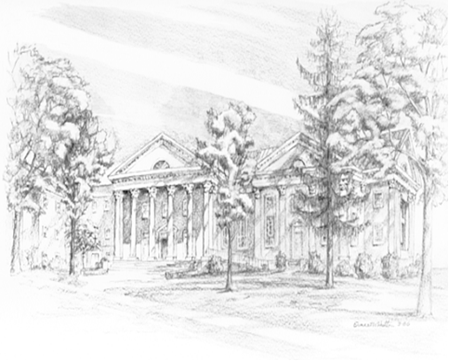

P.O. Box 877
249 South Wayne Avenue
Waynesboro, Virginia
(540) 949-8366
Church Website: www.firstpresway.org
Preschool Website: www.firstprespre.org
Email: church@firstpresway.com

