TWENTY FIRST SUNDAY AFTER PENTECOST October 22, 2023

PRELUDE Passacaglia Dietrich Buxtehude (1637-1707)

WELCOME & ANNOUNCEMENTS

INTROIT

CALL TO WORSHIP
Leader: As Moses was led by God’s goodness, so are we guided by the Lord.
People: We welcome the presence of God as we worship, and as we venture out in faith.
Leader: Let us worship God.

MORNING PRAYER

OPENING HYMN 610 O for a Thousand Tongues to Sing Azmon

CALL TO CONFESSION

PRAYER OF CONFESSION
God of all things, you create us, breathe life into us, and equip us to follow you. But we confess we prefer to live apart from you, and so we stray from your path. We identify as your people when it suits us, but quickly forget to love as you do. We say we look to you for guidance, but too often turn away from your way. Forgive us, Lord, this and all our sin. May your Spirit open us to listen for your word, and be empowered by your wisdom; we ask in the name of Christ. Amen

SILENT PRAYER

ASSURANCE OF PARDON

*GLORIA PATRI 581 Greatorex

FIRST SCRIPTURE READING Psalm 96:1-13 p. 479

SPECIAL MUSIC Intermezzo in E-flat major Johannes Brahms (1833-1897)
arr. Thomas Chesterton

SECOND SCRIPTURE READING Matthew 22:15-22 p. 803

SERMON Obligations. Patrick Pettit, Interim Pastor

*AFFIRMATION OF FAITH Apostles’ Creed p.35

PRAYERS OF THE PEOPLE & THE LORD’S PRAYER

*CLOSING HYMN 708 We Give Thee but Thine Own Schumann

*CHARGE and BENEDICTION

POSTLUDE Postlude on Lancashire Lani Smith (1934-2015)

*Please stand if able

Hearing devices are available for your convenience.
Please be aware that they do not function until after the service begins.

Today’s link is: https://www.youtube.com/watch?v=D73DYSZUdoU

We welcome guest organist Diane Kingsbury this morning, as Roger and Kimberlea are away celebrating Kimberlea’s birthday. Diane has helped us on numerous occasions over the years, and we are most grateful to her for providing music for our worship service this morning.

The Legacy: Mary June Cook

Shenandoah Nursing Home: Nancy Garber

Home: Mary Ultee, Mary Ann Maupin, Warner & Linda Sandquist,
Cathy Cunningham

Friends and Family: Erwin Berry (Joan), Bill Bromley, Jean Custen, Jerry Hughes,
Sally McNeel, Bill Metzel (Joyce Tipton), Col. Stuart Roberts (Mark Henderson),
Paul Watts, Kathleen Clements, (Colleen Cash), Josh Slonaker, Barb Ostrander
(Holly Bennett), Marty Rogers (sister of Cathy Cunningham), Brooks Hoover,
Betsy Boswell (Curry)

Military: Carson Craig

Our Christian sympathies to the families of Rubye Schwab upon her death July 28,2023.

Richard “Dick” Huff who died on October 13, 2023. A memorial was held yesterday in Lewisburg WV.

MAKE PLANS TO ATTEND THE BETTER TOGETHER BIBLE STUDIES!

This week’s Bible Study is Monday, October 23, at 1:00 at Finley Presbyterian Church.
Make plans to attend! Class is open to all! Come regularly or when you can!

Sunday October 29, we will be Worshipping at Second Presbyterian Church, Potluck Lunch to Follow, please let the office know of your attendance and what you will be bringing .

FIRST PRESBYTERIAN CHURCH
WAYNESBORO, VIRGINIA

A community-minded congregation living out the love of Christ as we serve one another with humility, gentleness, and patience through God’s grace.

October 22, 2023 11:00 AM

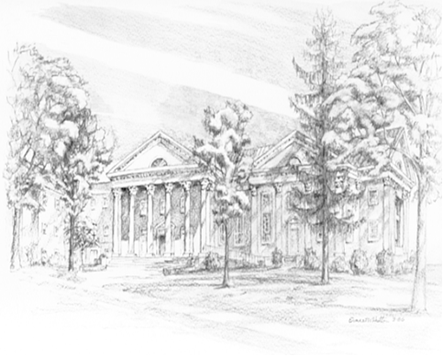

P.O. Box 877
249 South Wayne Avenue
Waynesboro, Virginia
(540) 949-8366
Church Website: www.firstpresway.org
Preschool Website: www.firstprespre.org
Email: church@firstpresway.com

