NINETEENTH SUNDAY AFTER PENTECOST October 8, 2023

PRELUDE Studio D. Scarlatti (1685-1757)

WELCOME & ANNOUNCEMENTS

INTROIT What Does the Lord Require Routley (1917-1982)

CALL TO WORSHIP
Leader: Who can declare all of God’s praise?
People: Happy are those who observe justice and do righteousness at all times.
Leader: Let us worship God.

MORNING PRAYER

OPENING HYMN 667 When Morning Gilds the Skies Laudes Domine

CALL TO CONFESSION

PRAYER OF CONFESSION
Lord, you are our rock and our redeemer; yet we daily deny our need of you. You call us to be stewards of a wonderful world, but we secure parts of it, calling them our own, only to misuse them. You give laws to enhance our life; we see them as burdens designed to keep us down. Forgive us, Lord, this and all our sin. Open our minds to know your truth, our hearts to rejoice in your commands, and our eyes to see the goal you set before us, in the name of Christ. Amen.

SILENT PRAYER

ASSURANCE OF PARDON

*GLORIA PATRI 581 Greatorex

FIRST SCRIPTURE READING Psalm 80:7-19 p.471

SPECIAL MUSIC Intermezzo, Op 116, no. 2 Brahms (1833-1897

SECOND SCRIPTURE READING Matthew 21:33-46 p, 803

SERMON The God who never gives up Patrick Pettit, Interim Pastor

*AFFIRMATION OF FAITH Apostles’ Creed p.35

PRAYERS OF THE PEOPLE & THE LORD’S PRAYER

*CLOSING HYMN 545 Lord, Bid Your Servant Go in Peace Land of Rest

*CHARGE and BENEDICTION

POSTLUDE Prelude in F, BWV 928 Bach (1685-1750)

*Please stand if able

Hearing devices are available for your convenience.
Please be aware that they do not function until after the service begins.

Today’s link is: https://www.youtube.com/watch?v=NxFrrl6q0bE

The Legacy: Mary June Cook

Shenandoah Nursing Home: Rubye Schwab, Nancy Garber

Home: Dick Huff, Mary Ultee, Mary Ann Maupin, Warner & Linda Sandquist,
Cathy Cunningham

Friends and Family: Erwin Berry (Joan), Bill Bromley, Jean Custen, Jerry Hughes,
Sally McNeel, Bill Metzel (Joyce Tipton), Col. Stuart Roberts (Mark Henderson),
Paul Watts, Kathleen Clements, (Colleen Cash), Josh Slonaker, Barb Ostrander
(Holly Bennett), Marty Rogers (sister of Cathy Cunningham), Brooks Hoover,
Betsy Boswell (Curry)

Military: Carson Craig

MAKE PLANS TO ATTEND THE BETTER TOGETHER BIBLE STUDIES!

This week’s Bible Study is Monday, October 9, at 1:00 at Second Presbyterian Church.

Make plans to attend! Class is open to all! Come regularly or when you can!

FIRST PRESBYTERIAN CHURCH
WAYNESBORO, VIRGINIA

A community-minded congregation living out the love of Christ as we serve one another with humility, gentleness, and patience through God’s grace.

October 8, 2023 11:00 AM

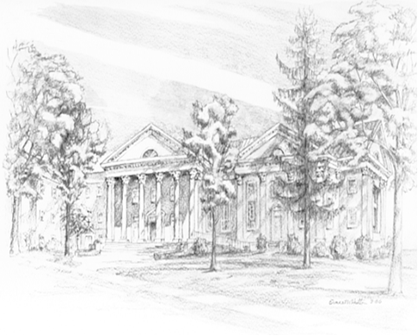

P.O. Box 877
249 South Wayne Avenue
Waynesboro, Virginia
(540) 949-8366
Church Website: www.firstpresway.org
Preschool Website: www.firstprespre.org
Email: church@firstpresway.com

