TWENTY FOURTH SUNDAY after PENTECOST November 12, 2023

PRELUDE Prelude in A, BWV 536 Bach (1685-1750)

WELCOME & ANNOUNCEMENTS

INTROIT Now Enter In Hebble (1934-2020)

CALL TO WORSHIP
Leader: Let us speak of the glorious deeds of the Lord.
People: We will not hide them but will tell them to the coming generations.
Leader: Let us rise up and tell the world, that all might set their hope in God.
People: May we never forget the words of God but keep His commandments.
Leader: Let us worship God.

MORNING PRAYER

OPENING HYMN 8 Eternal Father Strong to Save Melita

CALL TO CONFESSION

PRAYER OF CONFESSION
Almighty God, you love us despite our many betrayals. We confess our failure to appreciate that legacy. We are ignorant of our history; your stories are forgotten. We take your work for granted, discount our dependence upon you, and shirk our responsibility to the covenant we share. Forgive us, O God, this and all our sin. Remind us what You have done, that we might neither grieve nor despair, but find hope in your promises. Amen.

SILENT PRAYER

ASSURANCE OF PARDON

*GLORIA PATRI 581 Greatorex

FIRST SCRIPTURE READING Psalm 70 p. 463

ANTHEM Glory to God in the Highest Rutter (b. 1945)
Maximilian Daggy, baritone

SECOND SCRIPTURE READING Matthew 25:1-13 p.806

SERMON A wedding story Patrick Pettit, Interim Pastor

*AFFIRMATION OF FAITH Apostles’ Creed p.35

PRAYERS OF THE PEOPLE & THE LORD’S PRAYER

*CLOSING HYMN 687 O God, Our Help in Ages Past St. Anne

*CHARGE and BENEDICTION

POSTLUDE Fanfare Soler (1729-1783)

*Please stand if able

Hearing devices are available for your convenience.
Please be aware that they do not function until after the service begins.

Today’s link is: https://www.youtube.com/watch?v=OgtgkbeLP6A

Shenandoah Nursing Home: Nancy Garber

Home: Mary Ultee, Mary Ann Maupin, Warner & Linda Sandquist,
Cathy Cunningham

Friends and Family: Erwin Berry (Joan), Bill Bromley, Jean Custen, Jerry Hughes,
Sally McNeel, Bill Metzel (Joyce Tipton), Col. Stuart Roberts (Mark Henderson),
Paul Watts, Kathleen Clements, (Colleen Cash), Josh Slonaker, Barb Ostrander
(Holly Bennett), Marty Rogers (sister of Cathy Cunningham), Betsy Boswell (Curry)

Military: Carson Craig

MAKE PLANS TO ATTEND THE BETTER TOGETHER BIBLE STUDIES!

This week’s Bible Study is Monday, November 13, at 1:00 at Second Presbyterian Church.

Make plans to attend! Class is open to all! Come regularly or when you can!

FIRST PRESBYTERIAN CHURCH
WAYNESBORO, VIRGINIA

A community-minded congregation living out the love of Christ as we serve one another with humility, gentleness, and patience through God’s grace.

November 12, 11:00 AM

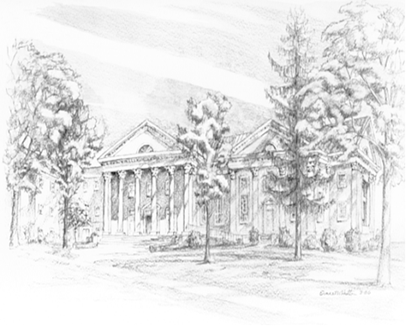

P.O. Box 877
249 South Wayne Avenue
Waynesboro, Virginia
(540) 949-8366
Church Website: www.firstpresway.org
Preschool Website: www.firstprespre.org
Email: church@firstpresway.com

