TWENTY FIFTH SUNDAY after PENTECOST November 19, 2023

PRELUDE Fugue in C, BuxWV 174 Buxtehude (1637-1707)

WELCOME & ANNOUNCEMENTS

INTROIT Let All the World in Every Corner Sing Routley (1917-1982)

CALL TO WORSHIP
Leader: Beloved of God, let us live as children of the light.
People: Let us clothe ourselves with faith and love, and put on the hope of salvation.
Leader: Whether awake or asleep, we may live with Christ.
People: We give thanks for God’s saving work in Jesus Christ.
Leader: Let us worship God.

MORNING PRAYER

OPENING HYMN 367 Come, Ye Thankful People, Come St. George’s, Windsor

CALL TO CONFESSION

PRAYER OF CONFESSION
God of Light, in whom there is no darkness at all, we confess our deep fear of your light. You trust us with the gift of grace but prefer to live as those with something to hide. Called to be the light of the world, we prefer to live in the shadows, afraid of your power to reveal our deepest secrets. Forgive us, Lord, this and all our sin. Enlighten us, that we might shine your love into every corner of our world; through Jesus Christ our Lord. Amen.

SILENT PRAYER

ASSURANCE OF PARDON

*GLORIA PATRI 581 Greatorex

FIRST SCRIPTURE READING Psalm 90:1-12 p.476

ANTHEM For the Fruits of This Creation Jackson (1917-2022)

For the fruits of this creation, thanks be to God;
For good gifts to every nation, thanks be to God;
For the ploughing, sowing, reaping, silent growth while we are sleeping,
Future needs in earth's safe-keeping, thanks be to God.

In the just reward of labor, God's will is done;
In the help we give our neighbor, God's will is done;
In our world-wide task of caring for the hungry and despairing,
In the harvests we are sharing, God's will is done.

For the harvests of the Spirit, thanks be to God;
For the good we all inherit, thanks be to God;
For the wonders that astound us, for the truths that still confound us,
Most of all, that love has found us, thanks be to God!

SECOND SCRIPTURE READING Matthew 25:14-30 p. 807

SERMON Faithful Investing Patrick Pettit, Interim Pastor

*AFFIRMATION OF FAITH Apostles’ Creed p.35

PRAYERS OF THE PEOPLE & THE LORD’S PRAYER

*CLOSING HYMN 643 Now Thank We All Our God Nun danket alle Gott

*CHARGE and BENEDICTION

POSTLUDE Marche triomphale: Nun danket alle Gott Karg-Elert (1877-1933)

*Please stand if able

Hearing devices are available for your convenience.
Please be aware that they do not function until after the service begins.

Today’s link is: https://www.youtube.com/watch?v=QYRMrbLlRr0

Shenandoah Nursing Home: Nancy Garber

Home: Mary Ultee, Mary Ann Maupin, Warner & Linda Sandquist,
Cathy Cunningham

Friends and Family: Erwin Berry (Joan), Bill Bromley, Jean Custen, Jerry Hughes,
Sally McNeel, Bill Metzel (Joyce Tipton), Col. Stuart Roberts (Mark Henderson),
Paul Watts, Kathleen Clements, (Colleen Cash), Josh Slonaker, Barb Ostrander
(Holly Bennett), Betsy Boswell (Curry)

Military: Carson Craig

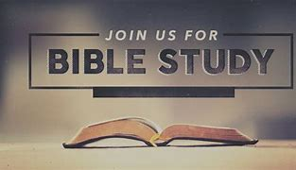

MAKE PLANS TO ATTEND THE BETTER TOGETHER BIBLE STUDIES!

This week’s Bible Study is Monday, November 20, at 1:00 at Hermitage Presbyterian Church.

Make plans to attend! Class is open to all! Come regularly or when you can!

FIRST PRESBYTERIAN CHURCH
WAYNESBORO, VIRGINIA

A community-minded congregation living out the love of Christ as we serve one another with humility, gentleness, and patience through God’s grace.

November 19, 11:00 AM

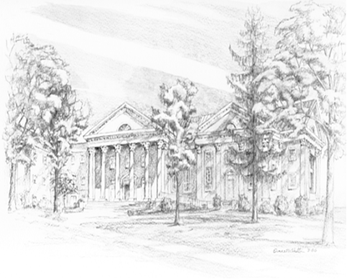

P.O. Box 877
249 South Wayne Avenue
Waynesboro, Virginia
(540) 949-8366
Church Website: www.firstpresway.org
Preschool Website: www.firstprespre.org
Email: church@firstpresway.com

