TWENTY THIRD SUNDAY AFTER PENTECOST November 5, 2023

PRELUDE Prelude, Op. 50, no. 5 Foote (1853-1937)

WELCOME & ANNOUNCEMENTS

INTROIT What Does the Lord Require Routley (1917-1982)

CALL TO WORSHIP
Leader: Blessing and glory and wisdom;
People: Thanksgiving and honor, power and might; be to our God forever!
Leader: I sought the Lord, who answered me, and delivered me from all my fears.
People: Salvation belongs to our God who is seated on the throne, and to the Lamb!
Leader: Let us Worship God.

MORNING PRAYER

OPENING HYMN 351 All Who Love and Serve Your City Charlestown

CALL TO CONFESSION

PRAYER OF CONFESSION
God of power, we pray for your compassion, for we know before you, no one can stand. In our daily living, we lay heavy burdens on others, but are unwilling to share the load. Called to humble service, we seek to enforce our way onto others. While your son was a servant to all, we seek to be to be lifted up as leaders. Forgive us, Lord, this and all our sin. Grant us humble, thankful hearts to love and serve, through Jesus Christ our Lord. Amen.

SILENT PRAYER

ASSURANCE OF PARDON

*GLORIA PATRI 581 Greatorex

FIRST SCRIPTURE READING Psalm 43 p. 448

ANTHEM Draw Us in the Spirit’s Tether Friedell (1905-1958)
(text can be found in hymn 529)

SECOND SCRIPTURE READING Matthew 23:1-12 p.804

SERMON The Negative Example Patrick Pettit, Interim Pastor

*AFFIRMATION OF FAITH The Apostles' Creed Hymnal p. 35

THE LORD’S SUPPER
Invitation
Great Thanksgiving
Communion of the People

*CLOSING HYMN 839 Blessed Assurance Assurance

*CHARGE and BENEDICTION

POSTLUDE Postlude in C Foote

*Please stand if able

Hearing devices are available for your convenience.
Please be aware that they do not function until after the service begins.

Link for this week’s service: https://www.youtube.com/watch?v=roat4N0eXK4

Shenandoah Nursing Home: Nancy Garber

Home: Mary Ultee, Mary Ann Maupin, Warner & Linda Sandquist, Cathy Cunningham

Friends and Family: Erwin Berry (Joan), Bill Bromley, Jerry Hughes, Sally McNeel, Bill Metzel (Joyce Tipton), Col. Stuart Roberts (Mark Henderson), Paul Watts, Kathleen Clements (Colleen Cash). Josh Slonaker, Barb Ostrander (Holly Bennett), Marty Rogers (sister of Cathy Cunningham), Betsy Boswell (Curry)

Military: Carson Craig
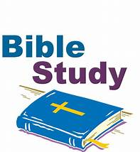

Better Together Bible Study

Will be held Monday, November 6, at Smyrna Presbyterian Church from 1pm-2pm.
John Tindall, DCE at Westminster PC, will lead the exploration of the great stories and themes of the Bible. Make plans to attend! Class is open to all! Come regularly or when you can!

FIRST PRESBYTERIAN CHURCH
WAYNESBORO, VIRGINIA

A community-minded congregation living out the love of Christ as we serve one another with humility, gentleness, and patience through God’s grace.

November 5, 2023 11:00 AM

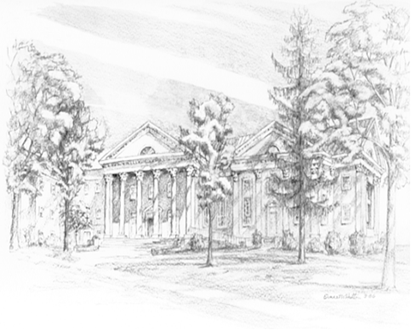
P.O. Box 877
249 South Wayne Avenue
Waynesboro, Virginia
(540) 949-8366
Church Website: www.firstpresway.org
Preschool Website: www.firstprespre.org
Email: church@firstpresway.com

