THE COLUMNS

First Presbyterian Church, Waynesboro, VA

*First Presbyterian Church of Waynesboro is a community-minded*

*congregation living out the love of Christ as we serve one another with*

*humility, gentleness, and patience through God’s grace.*

**January 2024, Volume 62, Issue 1**

With most all of the interim tasks completed, it seemed appropriate to put together some kind of retrospective of the last year. But I have to tell you, over the past few weeks, my social media has been filled with all manner of 'year in review' slide shows, in which friends and strangers alike bombard me with a rapid-fire recap of the year just passed. Some of these reviews featured familiar faces - heck, I even showed up in a few of them - and brought to mind happy experiences of my own 2023. Some of them featured very famous people, and were therefore interesting because, well, celebrities are interesting, I guess. But a lot of them were simply confusing, with people and places I don't know, flashing by with little or no context.

Of course, that's what 2023 was like in a lot of ways: some familiar things, enjoyable experiences; alot of watching, listening and reading about other people's experiences; and more than a little bit of confusion.

So, I changed my mind. I'm much more interested in looking forward to the year to come, and in what tidbits of wisdom I might share with you before I take my leave. For several years, one of my pet projects has been 'Patrick's Rules,' a series of pithy reflections and statements on how we are called to live and work together as brothers and sisters in Christ. I am, of course, not the first person to come up with a signature set of rules (St. Benedict and NCIS Agent Jethro Gibbs come to mind), but I think there's room enough in this wide world for one more set. My first rule is one you might have heard me share before; if you've been in my office, it is featured in a poster on my wall.

In case you were wondering, in John 13:34, Jesus tells the disciples, A new command I give you: Love one another. As I have loved you, so you must love one another.)

Say you're in charge of replacing the carpet in the sanctuary or overseeing a church supper. It's easy to assume the most important element of that task is actually replacing the carpet or getting everyone fed - but that's just not so. No matter what we are called to do - whether it is about maintenance, or worship, or fellowship or finances, or anything else - our top priority is always to build relationships based in the love of God through Jesus Christ. If I manage to get new carpet, but in doing so, I've alienated everyone on my committee, I have failed; if the supper feeds multitudes, but I have hurt the feelings of those cooking and serving, I lose. Nothing is more important than the relationships we build: with God; with our families and friends; with fellow church members; with the community; with the stranger. To paraphrase Paul's First Letter to the Corinthians, If I complete all the tasks set before me, and excel in getting things done, but have not love, I gain nothing.

So that's rule number one. Look for other rules as we continue together into 2024.

**Music Notes for January**

Happy New Year! We begin 2024 – in the Barksdale Room! Since the Sanctuary ceiling is being painted, we will worship in the intimate space of the Barksdale Room until the project is completed. With that in mind, for the first Sunday of January, we will remember Jesus’ baptism with two hymns reflecting the actions of that day: *Sing of God Made Manifest* and *Wild and Lone the Prophet’s Voice.* And, as it is the first Sunday of the month, we will also celebrate the Lord’s Supper.

On the second Sunday of January, the closing hymn will be *I, the Lord of Sea and Sky*, also known as *Here I Am, Lord*.  Dan Schutte (b. 1947) composed the hymn in 1979, one of over 500 compositions to his name. Schutte wrote the piece while studying at the Jesuit School of Theology at Berkeley for the ordination mass of a deacon. In 2004, the international Catholic magazine [The Tablet](https://en.wikipedia.org/wiki/The_Tablet)listed *Here I Am, Lord* as readers' favorite. A poll conducted by the National Association of Pastoral Musicians said the song came in second among "songs that make a difference.”

The Psalm for third Sunday of January reminds us of the strength of God as a rock, salvation and a fortress that will not be shaken. The hymns will be two favorites:  *A Mighty Fortress is Our God* and *Rock of Ages.* Martin Luther (1483-1546) wrote both the text and melody for *Ein feste Burg ist unser Gott* between 1527 and 1529. This beloved hymn by Luther has been translated into many other languages and used as the basis for many musical adaptations by scores of composers, from Johann Sebastian Bach (1685-1750) to Kari Tikka (1946-2002) in his opera, *Luther. Rock of Ages* is one of over 100 poems penned by Reverend Augustus Montague Toplady (1740-1778). The legend behind the composition of the hymn comes from 1763, when Toplady was caught in a storm while traveling along the gorge of Burrington Combe in the Mendip Hills in England. Toplady sought refuge in a gap in the gorge and wrote the words to the iconic hymn. (Some historians dispute the account, but it still holds true in the minds of many.) The fissure is now marked as the “Rock of Ages.” The music for the hymn was written by American Thomas Hastings (1784-1872), who penned over 1000 hymns during his lifetime.

The Psalm for the final Sunday of January is 111, extolling the great works of the Lord. The opening hymn will be *Great is Thy Faithfulness.* The text was written in 1923 by Thomas O. Chisholm (1866-1960) and music by William Runyan (1870-1957). *Great Is Thy Faithfulness* became popular through its use by Billy Graham (1918-2018), who often sang the hymn on his international crusades.

With the new year upon us, changes continue at First Presbyterian Church. Whatever 2024 brings, we are comforted by the knowledge of God’s constant love. May His enduring love envelop you in the days and months to come.

With gratitude for the continued support of the music program at FPC –

Roger and Kimberlea Daggy

**SESSION HIGHLIGHTS**

Session held a Stated Session Meeting on December 12, 2023.

* Rev. Pettit distributed a draft of a letter to the Committee on Presbytery Administration, regarding the sale of FPC to Fishburne, for our information.
* Employee Contracts for the Church Administrator and the Preschool Director have been signed.
* The Preschool Christmas program will be held on December 13 in the Sanctuary.
* Motion: Session approved a 3% Cost of Living raise for employees, effective January 2024.
* The Mission/Outreach Report was submitted (printed elsewhere in *The Columns.*)
* Roof replacement has been completed.
* Cleaning of the globes will be coordinated with painting the ceiling in the Sanctuary.
* Only one service will be held on Sunday, Christmas Eve – 11:00 a.m. Lessons and Carols. Second PC members have been invited to attend our Sunday New Year’s Eve 11:00 a.m. service followed by their Christmas Cake tradition.
* Session appointed a Search Committee to seek a Supply Pastor. Members are Cynthia Hoover, Bob Miller and Bill Pannill, all who have volunteered to serve.
* *Presbyterians Better Together* Bible Study will resume January 8 at Second PC.
* All Session Meetings are opened and closed with prayer. The next regularly scheduled meeting will be held January 9, 2024.

--Betsy Ruehl, Clerk of Session



**MISSION/OUTREACH NOVEMBER 2023**

* Ordered and received food from Blue Ridge Area Food Bank November 7 and 21. Volunteers assembled 20 pantry boxes for each order.
* Maintained temperature logs for refrigerators and freezers.
* Food Bank held November 2, 9, 16 and 30.
* Purchased eggs, bread, and margarine for Food Bank weekly.
* Updated weekly shopping list for extra options.
* Completed pantry inventory and report: Served 147 individuals and 47 households.
* November: Collected chicken noddle soup and spaghetti (dry pasta) for Food Bank.
* December: Still collecting soup and pasta for Food Bank and hats, gloves, and socks for Disciples’ Kitchen. --Cynthia Hoover, Mission Chair

**SUGGESTIONS FOR JANUARY MISSION ITEMS:**

**FOOD BANK – CHICKEN NOODLE SOUP and SPAGHETTI. (dry pasta)**

(These popular items are unavailable through Blue Ridge Area Food Bank.)

**HYGIENE KITS – Individually Wrapped TOOTHBRUSHES**

PRESCHOOL NEWS

December was a short month in preschool, but we made so many memories and had so much fun doing so with our friends. Ms. Lynda worked hard with our children on the Christmas program and our parents/family loved watching us perform. We hope everyone had a Merry Christmas. Best Wishes for a Happy New Year!

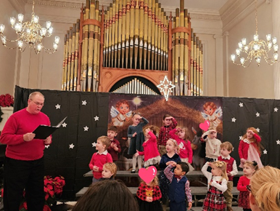

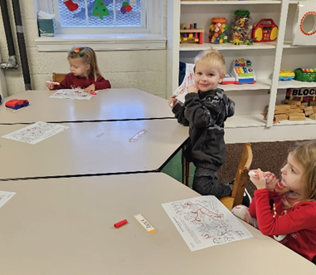

**WHAT MAKES US UNIQUE**

Part 7

The Presbyterian Church (U.S.A.) is distinctly a confessional and connectional church, distinguished by the representation of elders in the government.

**Sacraments**

“….The Reformed tradition recognizes the sacraments of Baptism and the Lord’s Supper…. as having been instituted by the Lord Jesus Christ through the witness of the Scriptures and sustained through the history of the universal church.” (W-3.0401)

**Lord’s Supper.** “The Lord’s Supper (or Eucharist) is the sign and seal of our communion with the crucified and risen Lord. Jesus shared meals with his followers throughout his earthly life and ministry – common suppers, miraculous feasts, and the covenant commemorations of the People of God. Jesus spoke of himself as the bread of life, and the true vine, in whom we are branches. On the night before his death, Jesus shared bread and wine with his disciples. He spoke of the bread and wine as his body and blood, signs of the new covenant, and told the disciples to remember him by keeping this feast. On the day of his resurrection, Jesus made himself known to his disciples in the breaking of the bread. The disciples continued to devote themselves to the apostles’ teaching, fellowship, prayers, and the common meal. As Paul wrote, when we share the bread and cup in Jesus’ name, ‘we who are many are one body.’ (Cor. 10:17)” (W-30409).

“The Lord’s Supper enacts and seals what the Word proclaims: God’s sustaining grace offered to all people. The Lord’s Supper is at once God’s gift of grace, God’s means of grace, and God’s call to respond to that grace. Through the Lord’s Supper, Jesus Christ nourishes us in righteousness, faithfulness, and discipleship. Through the Lord’s Supper, the Holy Spirit renews the Church in its identity and sends the Church to mission in the world.” (W3.0409).

“When we gather at the Lord’s Supper the Spirit draws us into Christ’s presence and unites with the Church in every time and place. We join with all the faithful in heaven and on earth in offering thanksgiving to the triune god, one another, and our neighbors in the world.” (W-3.0409).

“The opportunity to eat and drink with Christ is not a right bestowed upon the worthy, but a privilege given to the undeserving who come in faith, repentance, and love. All who come to the table are offered the bread and cup, regardless of their age or understanding. If some of those who come have not yet been baptized, an invitation to baptismal preparation and Baptism should be graciously extended. Worshippers prepare themselves to celebrate the Lord’s Supper by putting their trust in Christ, confessing their sin, and seeking reconciliation with God and one another. Even those who doubt may come to the table in order to be assured of God’s love and grace in Jesus Christ.” (W-3.0409).

“The Lord’s Supper shall be celebrated as a regular part of the Service for the Lord’s Day, preceded by the proclamation of the Word, in the gathering of the people of God. When local circumstances call for the Lord’s Supper to be celebrated less frequently, the session may approve other schedules for celebration, in no case less than quarterly. If the Lord’s Supper is celebrated less frequently than on each Lord’s Day, public notice is to be given at least one week in advance so that all may prepare to receive the Sacrament.” (W-3.0409

**SOME THOUGHTS FOR THE NEW YEAR**

* Always keep your words soft, just in case you have to eat them.
* Accept the fact that some days you’re the pigeon and some days you’re the statue!
* Always read stuff that will make you look good if you die in the middle of it.
* Drive carefully. It’s not only cars that can be recalled by their Maker.
* If you can’t be kind, at least have the decency to be vague.
* If you lend someone $20 and never see that person again, it was probably worth it.
* It may be that your sole purpose in life is simply to serve as a warning to others.
* Never buy a car you can’t push.
* Never put both feet in your mouth at the same time, because then you won’t have a leg to stand on.
* Nobody cares if you can’t dance well. Just get up and dance.
* Since it’s the early worm that gets eaten by the bird, sleep late.
* The second mouse gets the cheese.
* When everything’s coming your way, you’re in the wrong lane.
* Birthdays are good for you. The more you have, the longer you live.
* Some mistakes are too much fun to make only once.
* We could learn a lot from crayons. Some are sharp, some are pretty and some are dull. Some have weird names and all are different colors, but they all have to live in the same box.
* A truly happy person is one who can enjoy the scenery on a detour.
* Have an awesome day and know that someone has thought about you today.

**And Most Importantly**

* Save the earth. It’s the only planet with chocolate!



**Liturgists**

January 7 Betsy Ruehl

January 14 Bill Pannill

January 21 Jo Pannill

January 28 Cynthia Hoover



**REV PETTIT’S WORK SCHEDULE**

Monday – work at home

Tuesday and Thursday– onsite First Pres

Wednesday – visitation

Friday – off

 **January Birthdays**

6- Ann Epes, Michael Griffith

8- Bruce Bosselman

11- Jeanne Hashagen

24- Mary Jane Trimble

28- Celia Daggy

31- Randy Hypes

**Better Together Bible Study Resumes**

January 8 Second Presbyterian

January 15 Hermitage Presbyterian

January 22 Finley Memorial Presbyterian

January 29 First Presbyterian

**Study starts at 1pm; all are welcome**

**DO OVER**

*The Lord says “Forget what happened before and do not think about the past.*

*Look at the new thing I am going to do. It is already happening. Don’t you see it?*

*I will make a road in the desert and rivers in the dry land.”*

Isaiah 43:18-19 NCV

There is nothing quite as redemptive as a “do over”. A popular psychiatrist encourages parents to offer children an opportunity for a “do over” when a behavior needs correcting. The parent states, “That was not acceptable behavior. Would you like a ‘do over’?“ Almost without exception, the child gladly accepts a chance to make

things right.

We get some “do overs” in life. A new year is one of them. Without making a list of resolutions that you will forget about in a week, consider this: Where do you need a “do over”? Is there a relationship in your life that needs repair? Do your priorities need revision? If you haven’t been eating healthy, should you alter your grocery list?

Realize that no one is perfect. Take inventory, though, of the areas in your life that could benefit from a fresh start. Embrace the chance for a “do over”.

*Thank you, Lord, for a new year! Give me the discipline that it takes*

*to make necessary changes. I love You, Father. Amen*

(Day 1 of “Daily Devotions for a Woman of Faith”}



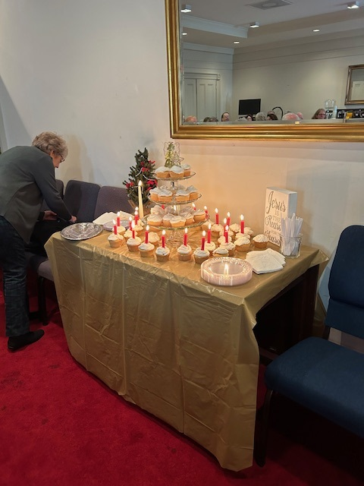

**The Christ Cake**

Members of Second Presbyterian Church joined us at First Pres for our 11:00 service on New Year’s Eve Sunday. Afterwards they shared their Christ Cake celebration in the Barksdale Room. Pictured above is a picture of the refreshment table.

A Christ Cake originated with their Youth Group which took its inspiration from a family in Florida who had become disenchanted at the way the birth of Christ was being treated by a large segment of those around them. They sat down as a family and wrote out what they considered to be important to the Christmas event. The Angel on the cake would symbolize the messengers who appeared to the Shepherds; the Star of David the birthplace of Christ - Bethlehem; the twenty- one candles the centuries since Christ’s birth; the three-tiered cake how God had revealed himself in three ways; the one white candle the birth of Christ – the light who came into the world as the Light of the World.

Why cake? The birth of Christ is a time for celebration – a time for joy and happiness. (Through the years the three-tiered cake has evolved into cupcakes, for ease in preparation and serving, arranged in the shape of a cake.)

Praise be to God! May joy and happiness over His coming be in all our hearts and minds.

**January Calendar**

**Thursday, January 4**

6-7:30 pm Food Bank

**Sunday, January 7**

11 am Worship Service

**Tuesday, January 9**

2:30 pm Session Meeting Room 212

**Thursday, January 11**

2-4pm Food Bank

**Sunday, January 14**

11 am Worship Service

**Thursday, January 18**

6-7:30 pm Food Bank

**Sunday, January 21**

11am Worship Service

**Thursday, January 25**

2-4 pm Food Bank

**Sunday, January 28**

11 am Worship Service

**Monday, January 29**

1-2 pm Better Together Bible Study

Mailing Address

P. O. Box 877

Waynesboro, VA 22980

Phone 540.949.8366

Fax 540.949.5750

E-mail: church@firstpresway.com

Website: www.firstpresway.org

Interim Pastor Music Director

Rev. Patrick S. Pettit Mr. Roger Daggy

[pspettit@gmail.com](mailto:pspettit@gmail.com) firstpreswaymusic@gmail.com

Administrative Assistant Music Assistant

Mrs. Colleen Cash Mrs. Kimberlea Daggy

ccash@firstpresway.com firstpreswaymusic@gmail.com

Preschool Director Audio/Video Technician

Ms. Tami Hemp Mr. Craig Cavenaugh

[preschool@firstpresway.com](mailto:preschool@firstpresway.com)

Maintenance Technician

Mr. Michael Griffith