Third Sunday after Epiphany January 21, 2024

PRELUDE Ein feste Burg ist unser Gott Buxtehude (1637-1707)

WELCOME & ANNOUNCEMENTS

INTROIT What Does the Lord Require Routley (1917-1982)

CALL TO WORSHIP
Leader: We gather in response to Christ's Call:
People: Come and follow me.
Leader: May we depart in response to the Spirit:
People: Come and follow me.
Leader: Let us worship God.

MORNING PRAYER

OPENING HYMN 275 A Mighty Fortress Is Our God Ein feste Burg

CALL TO CONFESSION
Merciful God, your call is ever before us, but mostly we turn away from that call. We are quick to give into fear, believing we can somehow run from you. Even when you have run us to the ground, we are slow to acknowledge the power in your promise. Forgive us, Lord, this and all our sin. Help us accept your way, even when it looks to be difficult, knowing you will empower us to follow wherever you lead.

SILENT PRAYER

ASSURANCE OF PARDON

*GLORIA PATRI 581 Greatorex

FIRST SCRIPTURE READING Psalm 62:5–12 p. 458

SPECIAL MUSIC Intermezzo Brahms (1833-1897)

SECOND SCRIPTURE READING Jonah 3:1-10 p.753

SERMON Somebody’s gotta do it. Patrick S Pettit, Interim Pastor

*AFFIRMATION OF FAITH Apostles’ Creed p.35

PRAYERS OF THE PEOPLE & THE LORD’S PRAYER

* HYMN 438 Rock of Ages Toplady

*CHARGE and BENEDICTION

POSTLUDE Ein feste Burg ist unser Gott Walcha (1907-1991)

*Please stand if able

Hearing devices are available for your convenience.
Please be aware that they do not function until after the service begins.

Today’s link is: https://www.youtube.com/watch?v=8RlJvuTUMQU

Shenandoah Nursing Home: Nancy Garber

Home: Mary Ultee, Mary Ann Maupin, Linda Sandquist, Mike &
Cathy Cunningham, Warner Sandquist, Charles Simpkins

Friends and Family: Bill Bromley, Jean Custen, Jerry Hughes, Sally McNeel,
Bill Metzel (Joyce Tipton), Col. Stuart Roberts (Mark Henderson),
Paul Watts, Kathleen Clements, (Colleen Cash), Josh Slonaker, Barb Ostrander
(Holly Bennett), Betsy Boswell (Curry)

Military: Carson Craig

Better together Bible study continues January 22. It will be at Finley Memorial, Stuarts Draft,
at 1pm.

Offering envelopes are available; contact Colleen.

FIRST PRESBYTERIAN CHURCH
WAYNESBORO, VIRGINIA

A community-minded congregation living out the love of Christ as we serve one another with humility, gentleness, and patience through God’s grace.

January 21, 2024 11:00 AM

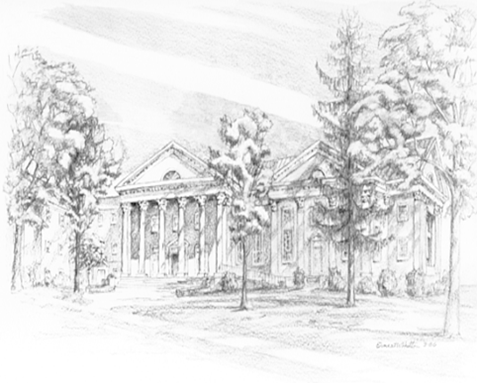

P.O. Box 877
249 South Wayne Avenue
Waynesboro, Virginia
(540) 949-8366
Church Website: www.firstpresway.org
Preschool Website: www.firstprespre.org
Email: church@firstpresway.com

