The Transfiguration of the Lord. February 11, 2024

PRELUDE Selected Hymns

WELCOME & ANNOUNCEMENTS

CALL TO WORSHIP
Mark 9:2-9
After six days Jesus took Peter, James and John with him. He led them up a high mountain. They were all alone. There in front of them his appearance was changed. ³ His clothes became so white they shone. They were whiter than anyone in the world could bleach them. ⁴ Elijah and Moses appeared in front of Jesus and his disciples. The two of them were talking with Jesus.
⁵ Peter said to Jesus, “Rabbi, it is good for us to be here. Let us put up three shelters. One will be for you, one for Moses, and one for Elijah.” ⁶ Peter didn’t really know what to say, because they were so afraid.
⁷ Then a cloud appeared and covered them. A voice came from the cloud. It said, “This is my Son, and I love him. Listen to him!”
⁸ They looked around. Suddenly they no longer saw anyone with them except Jesus.
⁹ They came down the mountain. On the way down, Jesus ordered them not to tell anyone what they had seen. He told them to wait until the Son of Man had risen from the dead.
MORNING PRAYER

OPENING HYMN 193 Jesus, Take Us To The Mountain Unser Herrscher

CALL TO CONFESSION
Holy God, your ways are not our ways; your goodness and mercy are far beyond our understanding. We try to make you small enough to comprehend; we restrict your wisdom and mercy to what we can understand. When confronted with your true splendor, we find ourselves paralyzed. Forgive us, Lord, this and all our sin. Open our eyes to see you more clearly; make us more faithful, that we may follow in faith, wherever you lead.

SILENT PRAYER

ASSURANCE OF PARDON

*GLORIA PATRI 581 Greatorex

FIRST SCRIPTURE READING Psalm 50:1-6 p. 451

SPECIAL MUSIC Suite Mattheson (1681-1764)

SECOND SCRIPTURE READING 2 Corinthians 4:3-6 p. 939

SERMON Seeing. Patrick S Pettit, Interim Pastor

*AFFIRMATION OF FAITH Apostles’ Creed p.35

PRAYERS OF THE PEOPLE & THE LORD’S PRAYER

* HYMN 662 Christ, Whose Glory Fills the Skies Ratisbon

*CHARGE and BENEDICTION

POSTLUDE Ratisbon Reprise

*Please stand if able

Hearing devices are available for your convenience.
Please be aware that they do not function until after the service begins.

Today’s link is: https://www.youtube.com/watch?v=RwAowkyEyiI

Shenandoah Nursing Home: Nancy Garber

Home: Mary Ultee, Mary Ann Maupin, Linda Sandquist, Mike &
Cathy Cunningham, Warner Sandquist

Friends and Family: Bill Bromley, Jean Custen, Jerry Hughes, Sally McNeel,
Bill Metzel (Joyce Tipton), Col. Stuart Roberts (Mark Henderson),
Paul Watts, Kathleen Clements, (Colleen Cash), Betsy Boswell (Curry)

Military: Carson Craig

Monday, February 12, Better Together Bible study continues at Second Presbyterian Church in Waynesboro at 1pm.

Offering envelopes are available; contact Colleen.

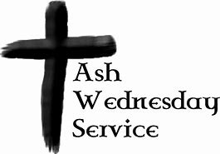
Ash Wednesday service will be held at Second Presbyterian Church in the fellowship hall.
Soup will be served; service starts at noon on February 14.
Westminster Presbyterian will have a 6pm service in their Sanctuary.

FIRST PRESBYTERIAN CHURCH
WAYNESBORO, VIRGINIA

A community-minded congregation living out the love of Christ as we serve one another with humility, gentleness, and patience through God’s grace.

February 11, 2024 11:00 AM

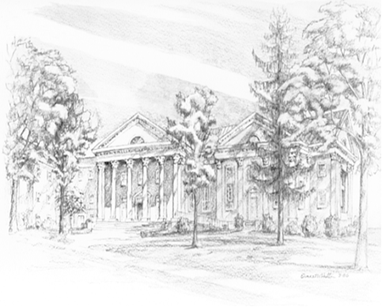

P.O. Box 877
249 South Wayne Avenue
Waynesboro, Virginia
(540) 949-8366
Church Website: www.firstpresway.org
Preschool Website: www.firstprespre.org
Email: church@firstpresway.com

